Draft for appraisal

KYRGYZ REPUBLIC

Regional Electricity Market
Interconnectivity and Trade (REMIT) Multiphase Programmatic Approach (MPA)

Environmental and Social Management Framework (ESMF)

2025
Bishkek

TABLE OF CONTENTS
LIST OF TABLES 4
LIST OF ABBREVIATIONS AND ACRONYMS 5
EXECUTIVE SUMMARY 6
1. INTRODUCTION 17
1.1 Context 17
1.2. Objectives of the ESMF 17
1.3. Desk review 19
1.4. Structure of the ESMF 20
2.0. PROJECT OVERVIEW 22
2.1. Project Description and Components 22
2.2. Project Beneficiaries 23
3.0. POLICY AND REGULATORY FRAMEWORK 25
3.1. Applicable Legal Framework – Environmental Protection and Environmental Safety 25
3.1.1 International context 28
3.2. Occupational Health and Safety 28
3.2.1. International Context or Treaties Signed/Agreed to by the Kyrgyz Republic 29
3.3. Protection of Historical and Cultural Heritage 30
3.3.1. International context 30
3.4. Legal Framework for Energy Conservation and Energy Security in the Electric Power Industry 31
3.5. Legal and Other Guarantees of Interested Parties 33
3.6. World Bank Environmental and Social Standards (ESS) 37
4.0 ENVIRONMENTAL AND SOCIAL ASSESSMENT APPROACH AND METHODOLOGY 49
4.1. Due diligence and Scoping 49
4.2. Understanding the laws and policies applicable to environment and social impact assessments 50
5.0. ENVIRONMENTAL AND SOCIAL BASELINES 53
5.1. Environmental Baseline 54
5.1.1. Brief description of natural environment 54
5.1.2. Climate 55
5.1.3. Rivers and Water Resources 55
5.1.4. Administrative-territorial division and demography 55
5.1.5. Land use structure 56
5.1.6. Real sector, industry and agriculture 58
5.1.7. Social facilities and education 58
5.1.8. Cultural heritage and tourism 59
6.0. ASSESSMENT OF SOCIAL AND ENVIRONMENTAL RISKS AND IMPACTS OF THE PROJECT 60
6.1 Overview of Potential Environmental Risks and Impacts 63
6.1.1. Soil/Forest/Vegetation 63
6.1.2. Impact on Water Sources 64
6.1.3. Impact on Wildlife/Avifauna 65
6.1.4. Air and Noise Pollution from Construction Work 66
6.1.5. Exposure to hazardous and other wastes 67
6.1.6. Greenhouse gas (GHG) emissions 67
6.2 Overview of potential social risks and impacts 68
6.2.1. Land acquisition and measures to mitigate the impacts of Involuntary resettlement 70
6.2.2. Temporary restriction of access to public places 71
6.2.3. Occupational Health and Safety 72
6.2.4 Community Health and Safety 74
6.2.5. Participation of women and other vulnerable groups in decision-making 75
6.3. Environmental and Social Management Plan (ESMP) 76
7.0. INSTITUTIONAL STRUCTURE 86
7.1 Project Cycle and Environmental and Social Risk Management 86
7.2 Capacity building and training 88
8.0. GRIEVANCE REDRESS MECHANISM (GRM) 89
9.0 CONSULTATION AND DISCLOSURE 95
10.0 MONITORING AND EVALUATION 96
10.1. Indicative budget for the implementation of the ESMF 97
11.0 CONCLUSION 99
12.0 APPENDICES 100
Appendix 1. Outline of the Environmental and Social Impact Assessment Report 100
Appendix 2. Environmental Social Screening Checklist 102
Appendix 3. Form of the record of public consultations 106
Appendix 4. Reconstruction of “Kristall Substation” in Tash-Kumyr and Reconstruction of “Torobaeva” Substation (Suzak Rayon) 107
Appendix 5. World Bank Environmental and Social Standards (ESS) 116
Appendix 6. EIA process as per national law 118
Appendix 7. Details of the meeting process with local authorities Tashkumyr 119
Appendix 8. Details of the meeting process Bishkek 122
Appendix 9. Lists of meeting participants 125

LIST OF TABLES

Table 1. Applicable Legal Framework – Environmental Protection and Environmental Safety National context 25
Table 2. Occupational Health and Safety -National context 28
Table 3. Protection of Historical and Cultural Heritage - National context 30
Table 4. Legal Framework for Energy Conservation and Energy Security in the Electric Power Industry 31
Table 5. Legal and Other Guarantees of Interested Parties 33
Table 6. Comparative analysis 37
Table 7. Potential risks 60
Table 8. Potential risks and impacts 68
Table 9. Negative consequences 75
Table 10. Framework environmental and social management plan (ESMP) 77
Table 12. Sample budget for ESMF implementation (annual) 97

LIST OF ABBREVIATIONS AND ACRONYMS
CAP – Corrective Action Plan
EHS – Environmental, Health, and Safety
EIS – Environmental impact statement
ES – Emergency situation
ESCP – Environmental and Social Commitment Plan
ESF – Environmental and Social Framework
ESIA – Environmental and Social Impact Assessment
ESMF – Environmental and Social Management Framework
ESMP – Environmental and Social Management Plan
ESS – Environmental and Social Standards
FL – Fuels and lubricants
FS – Feasibility Study
CC –complaints commission
GAP – Gender Action Plan
GBV – Gender-Based Violence
GHG – Greenhouse gas
GRM – Grievance Redress Mechanism
GRS – Grievance Redress Service
IR – Involuntary Resettlement
IUCN – International Union for Conservation of Nature
KPI – Key Performance indicators
KR – Kyrgyz Republic
LMP – Labor Management Procedures
MoE – Ministry of Energy
MPA – Multiphase Programmatic Approach
NEGK – National Electric Grid of Kyrgyzstan
NGO – Non-Governmental Organization
OHS – Occupational Health and Safety
OJSC – Open Joint Stock Company
PAP – Project affected person
PCB – Polychlorinated biphenyls
PCR – Physical cultural resources
PER – Public Environmental Review
PIU – Project Implementation Unit
RAP – Resettlement Action Plan
RPF – Resettlement Policy Framework
SEA/SH – Sexual Exploitation and Abuse / Sexual harassment
SEP – Stakeholder Engagement Plan
SER – State Environmental Review
SIA – Social Impact Assessment
SPZ – Sanitary Protection Zone
WB – World Bank

EXECUTIVE SUMMARY

The REMIT project represents a key step towards the formation and effective functioning of a regional energy market in Central Asia.
It aims to meet the growing energy demand in the region through the efficient use of available and cheaper energy sources and improved security and reliability of energy supplies. Straight The benefits will include meeting the growing demand for electricity in the region by increasing inter-regional transmission capacity through the expansion of existing transmission infrastructure, including the addition of new transmission corridors for the smooth exchange of electricity to meet the ever-growing demand for electricity. The regional electricity market will also facilitate commercial trading of electricity, allowing investment in the energy sectors of Central Asian countries, ensuring that the electricity grid is reliable enough to support growing trade volumes. Regional electricity market will enable development of trade in renewable energy sources and promote sustainable use of water resources. The project will also create new employment opportunities, improve the living conditions of local communities and increase household incomes.

The Environmental and Social Management Framework (ESMF) is an important document designed to ensure that the REMIT MPA project is implemented in line with international best practice and the specific environmental and social conditions of Kyrgyzstan. The ESMF provides a roadmap for managing risks, promoting sustainable development and advancing social equity. It reflects the commitment of the Government of Kyrgyzstan and the World Bank to achieving environmentally sustainable and socially inclusive outcomes, while being consistent with regional energy security and climate resilience goals. The ESMF ensures the integration of environmental and social considerations into the REMIT project planning and implementation processes and aims to prevent, minimize and mitigate environmental and social risks and impacts.

Framework approach and due diligence

Since the complete details of the subprojects are not yet known, carrying out subproject-specific Environmental and Social Impact Assessments (ESIA) and preparing project-specific Environmental and Social Management Plans (ESMP) is not possible at this stage. Therefore, a framework approach is being followed. The ESMF serves as the overarching document that sets out the processes and mechanisms to manage environmental and social risks across all subprojects.

For the implementation of the REMIT MPA project, it is not only mandatory to comply with applicable national legislations and regulatory frameworks on environmental and social issues but also to carry out due diligence in accordance with the World Bank's Environmental and Social Framework (ESF). The ESF outlines the requirements for sustainable development, ensuring that project activities are conducted in an environmentally and socially responsible manner. As the technical / feasibility studies, detailed designs) are underway, and specific intervention locations under the project are not finalized and their specific impacts are not known by project appraisal, a framework approach is adopted. In this context, in accordance with the ESS1, an Environmental and Social Management Framework (ESMF) has been prepared.

This ESMF defines the mechanisms for integrating environmental and social considerations into the planning and execution of the REMIT Project. It provides processes for planning, implementing, and managing environmental and social safeguards, and sets out the protocols for identifying, assessing, and mitigating risks at both the organizational and project levels. The ESMF provides guidance for assessing project-specific risks and impacts and includes triggers for specialized studies, such as ESIA, SIA/RAP, and Biodiversity Assessments, when required for more detailed attention.

Additionally, the ESMF includes guidelines and procedures to address issues related to gender, labor, and stakeholder engagement, along with the institutional mechanisms for monitoring environmental and social performance during both the project execution and operation phases. The primary purpose of the ESMF is to outline the expected environmental and social risks and impacts and to provide a system for monitoring and managing these impacts throughout the project lifecycle. The framework also details the institutional roles and responsibilities for risk management and describes the feedback and grievance mechanisms through which citizens and stakeholders can interact with the project implementation agency.

The Project being financed by the International Development Association will be implemented by the Ministry of Energy (MoE) of the Government of Kyrgyzstan through OJSC like NEGK.

Project overview

Regional Electricity Market Interconnectivity and Trading (REMIT) MPA project is structured to reflect the evolution from limited bilateral trading today to a fully-fledged regional electricity market in Central Asia in 3 phases/components. Most of the interventions at this stage are aimed at building/upgrading/digitising the existing transmission network, including internal networks and substation rehabilitation.
The components of the proposed REMIT MPA are grouped into the following three areas:
(i) Component 1: Pilot regional electricity market;
(ii) Component 2: Strengthening system interlinkages and resilience; and
(iii) Component 3: Strengthening the enabling environment and institutional capacity.
i . Component 1: Pilot Regional Electricity Market. This component aims to support the implementation of a pilot short-term market platform to promote regional electricity trade in Central Asia.
The proposed pilot project aims to have a strong demonstration impact on how a regional market can operate in Central Asia, ensuring that the region’s growing energy demand is met through the efficient use of cheaper energy, improving the security and reliability of supply and thereby stimulating economic growth and the green energy transition in the region.
ii. Component 2: Strengthening and digitalizing regional interconnections. The REMIT MPA will support the development of a regional market with soft and hard infrastructure. The project will also finance critical investments to improve regional electricity trade at both regional and national levels. Potential investments in Kyrgyzstan are summarized below:
• Reconstruction of “Kristall” substation
• Reconstruction of “Torobaeva” substation
• Construction of the new Kristall- Yulduz line (the option is not the final version and can be revised during further work)
iii. Component 3: Strengthening the Enabling Environment and Institutional Capacity. Since efficient cross-border trade depends on robust energy sectors at the domestic level, this component will support activities aimed at: (i) strengthening the financial viability and governance of domestic energy sectors (e.g. tariff reform); (ii) strengthening regulatory authorities – through training, capacity building, specific activities. This component will also support project supervision, management and coordination.

Project beneficiaries

The beneficiaries of the Project are electricity consumers, including industrial, commercial and domestic consumers. Reconstruction and modernization of substations and the reconstruction of the transmission line with replacement of conductors with increased capacity will increase the transmission capacity of the line, improve the reliability and continuity of electricity supply and ensure the stability of the power system for the integration of conventional and renewable energy sources. In addition, it is expected that the local population will derive some benefit from employment opportunities during the construction and reconstruction phases. It will also be ensured that in case of adverse impacts of the Project, all affected persons are provided with appropriate benefits such as compensation at replacement cost to all PAPs, including vulnerable, marginalized and disadvantaged groups, for any adverse impact in accordance with the RPFs and RAPs developed for specific households or sites. The implementing agencies will also benefit significantly from the capacity building and technical assistance they will receive, which will improve their ability to plan, develop, manage and maintain the existing infrastructure and deliver better, more reliable and cost-effective services.

Project locations
The subproject activities identified so far are located in the Jalal-Abad region. The transmission line so identified also originate from Jalal-Abad region in Kyrgyzstan and goes beyond country in the Yulduz substation in Uzbekistan.

Project implementation arrangements
The Project Implementation and Coordination Agency is the Ministry of Energy of the Kyrgyz Republic through a dedicated Project Implementation Unit (PIU) in NEGK. The PIU shall be responsible for all fiduciary functions (e.g., purchasing, financial management, preparation of annual reports, budgets, etc.). It will also be responsible for coordinating and supervising technical, and environmental and social (E&S) standards-related requirements of relevant components. It's expected that PIU will have a staff including environmental, social and OHS specialists capable to manage E&S risks and OHS, which will be also working closely with each of the Project beneficiary institutions. Meanwhile, MoE has instructed Joint Stock Company NEGK to support the project preparation including coordination and preparation of required project documents. PIU NEGK will also hire Environmental and Social Specialists, who will oversee the overall coordination of the implementation of project specific ESIA, ESMP, RAP etc., and will report to the MoE and the WB on the integration of E&S requirements into procurement documents and contracts.
To further strengthen project coordination and management capacity in the field, additional offices will be established in the project areas at the regional level to support effective oversight and coordination of the environmental and social management aspects of the project in accordance to Bank’s ESS and capacity building activities as per the REMIT ESMFagreed between the MoE and the Bank. This ESMFspecifies the main responsibilities and actions to be undertaken by MoE to ensure project, compliance with the WB ESSs.

Policy /regulatory framework
National Environmental and Social Laws and Regulations: Includes various laws and regulations aimed at protecting the environment and ensuring social equity. These documents set standards for assessing the environmental and social impacts of projects and define procedures for mitigating and compensating for negative impacts. Particular attention is paid to adhering to these standards in project planning and implementation, ensuring that the project complies with national requirements. The applicability of World Bank environmental and social standards to the components of the proposed project is determined, as well as any gaps in national or state regulation that need to be taken into account in formulating the ESMF.

Project Risk Assessment and Applicability of World Bank Environmental and Social Standards (ESS)
The project is being developed in accordance with the World Bank Environmental and Social Framework (ESF), which sets out the standards that must be met for environmental and social issues. Both the environmental and social risks are rated as Substantial, based on the project's potential impacts, and this overall rating guides the necessary environmental and social management measures. The relevant World Bank Environmental and Social Standards (ESS) applicable to this project include ESS 1, ESS 2, ESS 3, ESS 4, ESS 5, ESS 6, ESS 8 and ESS 10.
To minimize these risks, tools are provided, such as a social and environmental screening, which helps identify and assess potential negative impacts, and an environmental management plan, which details measures to prevent or compensate for damage. All activities must comply with World Bank standards and national legislation, including mandatory environmental impact assessment and public consultation.
The proposed activities are expected to bring economic, environmental, and social benefits:
(i) Economic benefits include stimulating economic growth through job creation and infrastructure development. The development of a regional electricity market will allow for more efficient utilization of energy resources, thereby improving regional competitiveness and attracting investment.
(ii) Environmental benefits include reducing pollutant emissions and decreasing dependence on coal-based energy sources. The development of regional electricity markets will increase the share of renewable energy sources in the energy mix, which in turn will reduce negative environmental impacts.
(iii) Social benefits include increased accessibility and reliability of energy supply for the population of the region. Infrastructure development and job creation will improve the quality of life of the local population and contribute to social stability
Potential negative impacts and risks cover a wide range of environmental, social, economic, and occupational health and safety concerns during both the construction and operational phases of the project.

Environmental risks include potential damage to ecosystems, such as habitat disruption, biodiversity loss, and soil erosion, particularly during construction activities. Pollution risks are also significant, with the possibility of contamination of air, water, and soil due to the use of heavy machinery, improper waste disposal, and other construction-related activities. During the operational phase, there are risks of chemical spills from transformers, which could lead to soil and water contamination. Fire hazards, especially near substations, are another concern due to potential equipment failure. Additionally, there is a risk of leakage of Sulfur hexafluoride (SF6), a potent greenhouse gas used in electrical equipment, which can have severe environmental consequences if released into the atmosphere. An important impact on natural ecosystems during reconstruction/construction of power transmission lines is the impact on birds - nesting, feeding and resting places, especially in mountainous and foothill areas. Changes in migration routes and loss of important habitats can threaten the survival of many bird species, including birds of prey and migratory birds. There is also a risk of collisions of birds with power transmission line wires, which can lead to injuries and death, especially when changing the height of power transmission line supports.

Social risks primarily concern the displacement of local populations due to the land acquisition required for building new infrastructure, such as substations and transmission lines. Resettlement can cause loss of livelihoods, housing, and access to local resources, which can lead to social tension and conflicts within affected communities. The construction process may disrupt the daily lives of local populations, leading to grievances, particularly if there is inadequate communication or compensation. Ensuring transparent resettlement procedures and engaging effectively with communities will be essential to mitigating these risks.

Economic risks stem from the possibility of cost overrun and increased financial burdens due to construction delays, regulatory hurdles, or changing market conditions. These delays could result in unforeseen expenses, affecting the financial viability of the project. Furthermore, shifts in the energy market, such as fluctuations in demand, price volatility, or changes in government policies, could impact the project’s financial outcomes. Long-term risks may arise if the infrastructure becomes outdated or inefficient due to advancements in technology, which could reduce its competitiveness in the regional energy market.

Occupational health and safety risks are critical, especially during construction. Workers face hazards such as accidents related to working at heights while installing transmission lines and operating heavy machinery in difficult terrain. Falls from heights pose a significant danger, and proper safety measures, including training and the use of protective equipment, are essential to minimizing these risks. The handling of hazardous materials, such as fuels and chemicals, could expose workers to toxic substances, respiratory issues, and burns. Even in the operational phase, risks such as electrical shocks, fire hazards, and equipment malfunctions persist, which could lead to serious injuries or fatalities. Ensuring that safety protocols are in place, conducting regular inspections, and providing personal protective equipment (PPE) will be crucial for safeguarding workers throughout the project.

Addressing these risks will require comprehensive planning and management, including thorough environmental and social impact assessments, strong occupational health and safety plans, and continuous monitoring throughout the project’s lifecycle. Effective public consultation and stakeholder engagement will also be essential in addressing social issues and ensuring that affected communities are well-informed and adequately compensated. In addition, sound financial planning must account for potential economic fluctuations and delays to secure the project’s long-term success.

Potential environmental & social impacts & mitigation measures
Screening of potential environmental & social risks & impacts of proposed project components has been undertaken considering the existing baseline environmental and social setting of project area. The proposed sub-projects are likely to create positive as well as negative impacts on the environmental and social setting.

The nature of impacts and extent of physical interventions will become clearer once the final designs of subprojects will be finalized. The following E&S instruments are being prepared by appraisal: (i) Environmental and Social Management Framework (ESMF), including generic ESMP; (ii) Resettlement Policy Framework (RPF); (iii) Stakeholder Engagement Plan (SEP); (iv) Labor Management Procedures (LMP) and (v) Environmental and Social Commitment Plan (ESCP). The ESMF will assess risks and impacts and guide appropriate mitigation measures to be taken for all components. The ESMF will include procedures to screen environmental and social risks of the subprojects and guide the preparation of subproject-specific ESIAs and ESMPs, including Biodiversity Assessment and Management Plans, if needed. It will include standard ESMP checklists, plans to manage hazardous waste, PCB waste, traffic management plans and other known E&S impacts and risks, as well as describe relevant legislations, institutional arrangements, and proposed capacity building measures. However, these likely impacts will be addressed through many measures including avoidance, minimization in that order of priority to the extent possible. The above listed risks are a key reason for classification of environmental and social risk of the project as Substantial.

On the other hand, the proposed activities and subprojects financing will also enhance sustainability of the energy supply, which in general combines the introduction of new technologies, policies and activities aimed to integrate socio-economic principles with environmental concerns to increase electricity transmission, and thus improve the quality of electricity in the regions of Kyrgyz Republic.

In the screening process as per ESS 1, scoping of key environmental and social risks and impacts of the Project has been undertaken and appropriate mitigation measures identified, as laid out in this ESMF. Sub-project specific ESIAs will be conducted prior to the implementation of activities. Specific risks and impacts are outlined in the ESMF and will be elaborated in the subsequent ESIAs and ESMPs. Sub-component activities will employ contracted workers who will be subject to the provisions of LMP, SEP, GRM and World Bank Group Environment, Health and Safety Guidelines in compliance of ESS 2. The Project will provide GRM for the community as well as to contracted workers. Additionally, each sub-project contractor will prepare a Construction-ESMP with labor protocol to address such issues. Measures to comply with ESS3 stipulations have been identified considering the construction activities proposed. These include measures to mitigate air pollution including noise, land and water pollution, management of construction wastes such as muck/debris as well as hazardous waste. All activities will be compliant with the applicable regulations and ESS 4. The legislations and policy related to land acquisition and resettlement as well as provisions of ESS 5 shall be implemented in accordance with provisions of RPF. To ensure that ESS6 requirements are met, additional studies will be undertaken as part of site-specific ESIAs, where required. The findings of the studies will inform the consequent ESMPs and relevant portions of the same will be integrated with the bidding documents and contracts. To facilitate compliance with ESS8, guidance on ‘chance find’ procedure, in line with Kyrgyz requirements are included to manage impacts on any artefacts found during construction / rehabilitation works.

The process of preliminary consultation has already commenced during the ESMF development to know the people’s opinion about project, which will be further expanded during finalization of ESMF. However, a detailed Stakeholder Engagement Plan (SEP) with mapping out all the different types of stakeholders, timings and modes of communication and consultation has also been prepared for implementation during ESIA and project execution. The Plan linked the GRM with the SEP to address the issue of transparency and feedback. ESS 10 recognizes the importance of open and transparent engagement vis-à-vis project stakeholders by the borrower.

Environmental and Social Management Framework (ESMF).
The Environmental and Social Management Framework (ESMF) is a tool that examines the issues and impacts associated with a project activity when the project consists of a programme and/or a series of sub-projects and the impacts cannot be determined until the details of the programme or sub-project have been established. The ESMF sets out principles, rules, guidelines and procedures for assessing environmental and social impacts.
The basic purpose of the ESMF is to design/formulate mitigative measures and plan for assessment and management protocol to address identified/potential environmental & social risk/impacts during implementation & operation stage. The ESMF is designed on the principles of avoidance, minimization & mitigation, including offsetting /compensating any residual issues to meet the requirement of sustainable development and compliance of Bank’s ESSs.

The nature of impacts and scope of activities will be clarified once the subproject designs under components 2 are finalized. Site specific ESIA will assess the risks and impacts and provide recommendations on appropriate mitigation measures to be performed for each site by results of which ESMP will be prepared. Moreover, vulnerable and aggrieved groups have been identified through the SEP, and will be consulted, and their concerns and views considered in ESIA, RAP, GAP and project design.

Grievance redress mechanism (GRM)
To facilitate timely, effective and efficient resolution of grievances and complaints to the satisfaction of all parties involved a multi-level Grievance Redress Mechanism is developed for the proposed project. The GRM provides a transparent and credible process for achieving fair, effective and lasting results. GRM also enhances trust and cooperation as an integral component of broader community consultation that promotes corrective action.

World Bank grievance redressal service
In addition to seeking resolution of their grievances through the GRM, communities and individuals who believe that they are being adversely affected by a World Bank (WB)-financed project may file complaints with existing project-level grievance mechanisms or with the WB’s Grievance Redress Service (GRS). The GRS ensures that complaints received are promptly addressed to resolve project-related issues. Project-affected communities and individuals may file complaints with the WB’s independent Inspection Panel, which determines whether harm has been or is likely to occur due to the WB’s failure to comply with its policies and procedures.
The complaints may be filed online on following web-based portals: http://www.worldbank.org/GRS and https://accountability.worldbank.org respectively.

Disclosure of information
The proposed Project will use existing channels to engage with citizens and receive complaints. A feedback system with institutional beneficiaries is available to the beneficiaries to collect a wide range of feedback from key project stakeholders. A separate and comprehensive Stakeholders Engagement Plan (SEP) is being developed by the Ministry of Energy of the Kyrgyz Republic (MoE) for the REMIT Project. The SEP is developed in accordance with the recommendations and requirements of the Environmental and Social Standard, ESS 10 of the World Bank and is a part of social and environmental assessment of the Project. The SEP, as one of the main project documents, will support the project management and its implementation. Along with measures to minimize adverse impacts of the Project, open social engagement is part of the Project's cohesive approach to maintaining positive relationships with the local community and other stakeholders under the Project.
The Stakeholder Engagement Plan (SEP) is a tool intended to provide practical guidance to support the public consultation and engagement activities undertaken by the PIU NEGK in relation to the development and implementation of the Project. The SEP aims to ensure that engagement activities are carried out effectively, fairly and transparently with all relevant stakeholders and that consultation methods are participatory and appropriate to local conditions. This requires communicating the project and relevant environmental and social data; providing useful and clear information to people affected by the project; conducting public consultations; and taking into account the views expressed during public consultations when implementing the project.
The public consultations will provide participants with the project objectives, planning activities, expected environmental and social impacts, as well as proposed mitigation measures, compensation measures in case of any impacts and a grievance mechanism. Based on the inputs received during the consultations, the ESMF and other environmental and social instruments, including the RPF, the LMP and the SEP, will be updated.
Public consultations will seek citizen feedback on the progress of the project. Comments received during the public consultations on the ESMF will be posted on the NEGK website for the public to see following the consultations.
Disclosure will provide citizen-oriented information on the policies and details of the subprojects, as well as the overall project implementation process. This will be in line with the World Bank’s ESS 10 “Stakeholder Engagement and Disclosure of Information” and the Kyrgyz Republic Law “On the Right to Access to Information”. The disclosure procedure will ensure that the PIU will have information regarding the safeguard documents for the activity available to the public, including a summary of all key documents in the local language without any confidentiality for wider dissemination of information. Ensuring sustainable management of the REMIT project, minimizing negative impacts and maximizing positive impacts for all stakeholders.

In accordance with the World Bank procedures and the national legislation of the Kyrgyz Republic, public consultations were organized and held on March 26, 2025 in Tash-Kumyr, Jalal-Abad region, and on April 17, 2025 in Bishkek, which were an important stage in the public participation process aimed at ensuring transparency of the project and taking into account the opinions of all stakeholders. The goal was to inform stakeholders about the social and environmental aspects of the REMIT project, discuss the prepared documents related to social and environmental safety issues. Public consultations were held at two levels: (1) local (Tash-Kumyr, Jalal-Abad region, March 26, 2025); (2) national (Bishkek, April 17, 2025)
Accordingly, to meet the requirements of the World Bank and national legislation on access to information, all draft ESF documents in Russian language were published on the websites of the following organizations: Ministry of Energy KR - https://minenergo.gov.kg/ru; JSC NEGK - http://www.nesk.kg/ru.
In addition, information on planning consultations was also disseminated through the consultants, implementing agency and local municipalities participating in the project.
Final ESMF incorporating comments will be submitted to World Bank. Once approved by World Bank, it will be disclosed on MoE website and the external website of the World Bank on its portal.

Monitoring and evaluation
The MoE/PIU NEGK will ensure the overall coordination of the Project. The PIU will be staffed with highly qualified specialists in environmental and social measures who will deal with ESMF/ESIA/ESMP implementation. The PIU would monitor the implementation of the environmental and social safeguards in all subprojects to ensure conformity to the requirements of the ESMF/ESIA and ESMP.
In addition, the PIU safeguards and engineering team will monitor compliance of environmental and social safeguards and submit regular quarterly monitoring reports on implementation of ESCP. The MoE / PIU NEGK will also comply with the provisions of any other E&S documents required under the ESF, such as Environmental and Social Management Framework (ESMF), Resettlement Policy Framework (RPF), Environmental and Social Management Plans (ESMP), Resettlement Action Plans (RAP), Labor Management Procedures (LMP) and Stakeholder Engagement Plan (SEP), and the timelines specified in those E&S documents.
Compliance to ESMP should be reported by contractors to the PIU NEGK, and then the PIU submits to the WB a semi-annual report. Environmental and social monitoring during implementation of subprojects should provide information on the key environmental and social aspects of subprojects, particularly its impact on the environment, social impacts of activities and the effectiveness of mitigation measures undertaken. This information will enable the PIU to assess the success of mitigation measures and monitoring under the Project, and will allow to update activities, if necessary, in a timely manner.
In addition to above, to ensure coordination and information sharing and timely decision-making on strategic and the program aspects at the highest level.

Capacity building and training
The project will provide specific training to ensure effective project implementation and a clear understanding of the environmental and social risk management requirements under the World Bank ESF. Given the relevance of the project and the wide range of activities, it is necessary to increase the capacity of the PIU NEGK to implement the requirements of social and environmental assessment in accordance with the WB requirements. The PIU will engage a consultant with knowledge of national environmental and social management requirements, as well as significant knowledge of the World Bank ESS requirements. Training topics will include the main World Bank requirements, implementation of ESS, ESMF, ESMP, ESCP, SEP, OHS, LMP and implementation of RAP, national rules and procedures for health and safety risk management.
PIU environmental and social staff will act as trainers for contractor environmental and social staff on environmental and social requirements and specific safeguard contract terms. In addition, the World Bank will provide project-wide training to relevant PIU and other involved agency staff during the first year of project implementation in order of relevance, and then at least annual refresher training as needed during project implementation. Contractors are also expected to provide training to project workers at the beginning of project worker recruitment, followed by at least one annual refresher training thereafter.

Institutional arrangements
The PIU will be responsible for all fiduciary functions (e.g. procurement, financial management, preparation of annual reports, budgets, etc.). It will also be responsible for coordinating and monitoring the technical, environmental and social standards requirements of the relevant components. The PIU is expected to have a staff including environmental, social and occupational health and safety specialists capable of managing E&S and OHS risks, who will also work closely with each of the project beneficiary institutions. The type and number of specialists to be hired as local staff and additional consultants (if necessary) will be determined during the project preparation phase, once the implementation arrangements have been finalized. The PIU will also hire environmental and social specialists who will oversee the overall coordination of the implementation of specific ESIAs, ESMPs, RAPs, etc. of the project, and will report to the WB on the integration of E&S requirements into procurement documents and contracts.

Contractors must operate in full compliance with national environmental and social legislation and in accordance with ESMP, LMP and OHS requirements that are consistent with the WB ESSs. In addition, contractors must comply with national legislation relating to road safety, occupational health and safety; life and fire safety; environmental protection; and public health and safety. All activities related to the ESMP will be funded by the contractors in accordance with the Contractors’ ESMP (C-ESMP), which will be prepared prior to commencement of works and approved by the nominated Supervision Engineer/Consultant for each sub-project. Contractors will also be asked to nominate a person responsible for environmental, social, health and safety issues and for the implementation of the ESMP.

Integration of ESMP and ESMF into design documentation
The ESMP requirements will be included in the Project Operational Manual and the ESMP requirements will be included in the construction contracts for all sub-projects, both in the specifications and in the bill of quantities, and contractors will be required to include the costs of implementing the ESMP in their financial projects. Based on the ESMP, the roles and responsibilities of all parties involved in the ESMP process will be outlined. Finally, based on the ESMP and ESMP requirements, monitoring and evaluation of the mitigation/prevention measures identified in the site-specific review and in the ESMP will become an integral part of the sub-project implementation, including the inclusion of binding contracts therein, and contractors will be forced to comply with environmental and social obligations during the construction works. In addition, all contractors will be required to use environmentally acceptable technical standards and procedures during the execution of the works. In addition, the terms of the contract should include requirements for compliance with all national building, health and safety procedures and regulations, as well as environmental requirements.

Budget for the implementation of the ESMF
The budget for the implementation of the ESMF will be allocated for the recruitment of a team of specialists of the PIU on safeguards, as well as for training and information, and for monitoring measures of the Implementing Agency. The present estimate in of USD 126000 for the preliminary annual costs for the implementation of environmental and social management (ESMF) measures within the framework of the REMIT project for the development of renewable energy sources in Kyrgyzstan. These costs are adapted taking into account local market conditions and cover work at the following sites: Kristall substation, Torobaeva substation and the Kristall Yulduz high-voltage line.
Of the total estimated budget of USD 126,000, approximately 10 % of expenditures, i.e. USD 13,000, is allocated for the preparation of the ESIA/ESMP, while the remaining 90 % is directed to monitoring activities, including the collection and laboratory analysis of soil samples, measurement of air pollution, noise and vibration levels, studies of flora, fauna and archaeological sites , as well as the organization of field inspections, transportation and travel expenses, reporting preparation and hiring of specialized experts (environmentalists, social specialists, legal consultants and occupational safety specialists) (see Table 12 on p. 82).

1. INTRODUCTION

1.1 Context
Central Asia possesses a highly complementary mix of regional energy sources and generation structure that can unlock significant benefits through regional energy cooperation. Jointly addressing the electricity needs of Central Asian economies is a more economically viable option than each country independently managing its energy requirements. Enhanced market integration among Central Asian countries will reduce the need for individual investments in new generating capacities by enabling the shared use of existing reserves.
Although the Central Asian power transmission systems are already interconnected, the current exchange of electricity remains limited and far below the transmission capacity of these networks. This is primarily due to inadequate governance, limited harmonization and synchronization of power systems, and a lack of coordination in generation, load distribution, and planning. In Kyrgyzstan, the rising demand for electricity has strained the system, causing frequent equipment overloads. Existing transformer capacities are proving insufficient, transmission lines struggle to meet demand, and outdated relay protection and automation systems lack the precision required for modern energy management. These challenges also hinder efforts to expand power transmission capacity between Kyrgyzstan and Uzbekistan.
REMIT’s direct benefits will include support in meeting the region's growing energy demand by optimizing the use of cost-effective energy sources, upgrading substations transformer substations, and enhancing the transmission capacity of the associated transmission line. substations and.
A functioning regional electricity market will enable greater commercial trade transactions and attract investment in the energy sectors of Central Asia, while ensuring the energy infrastructure is sufficiently prepared to support expanded trade.
Additionally, such a market will help the Central Asian countries’ transition to low-carbon, climate-resilient economies, while promoting increased trade in renewable energy and fostering the efficient use of shared water resources.
This report includes of three currently identified sub-projects, utilizing desk-based methodologies, with a focus on their impact on cross-border electricity throughput between Kyrgyzstan and Uzbekistan:
- Reconstruction of “Kristall” substation
- Reconstruction of “Torobaeva” substation
- Construction of the new Kristall-Yulduz line (the option is not the final version and can be revised during further work)
These project components are evaluated in the context of current and future network operations, including domestic generation expansion and other investments in the NEGK network. Key considerations include transmission capacity upgrades, reliability improvements, the physical condition of the facilities, and the project implementation approach.

1.2. Objectives of the ESMF
This ESMF sets out a framework for taking environmental and social considerations into account in the planning and implementation of a REMIT project. Its objective is to define processes and approaches for the effective management of environmental and social issues and the identification of safeguards. The ESMF has developed procedures that provide a framework for identifying, measuring and controlling environmental and social risks and impacts at the organizational and project levels. The ESMF therefore aims to prevent, minimize and/or mitigate environmental and social risks and impacts.
Since the full details of the sub-projects are not yet known, a sub-project specific Environmental and Social Impact Assessment (ESIA) and Environmental and Social Management Plan (ESMP) have been prepared in a framework format. The proposed REMIT MPA project requires not only compliance with applicable national environmental and social laws/regulations, but also due diligence on such matters in line with the World Bank's Environmental and Social Framework (ESF) to meet the overall sustainability requirements. This Environmental and Social Management Framework (ESMF) has been prepared to meet these requirements.
This ESMF defines the framework for integrating environmental and social issues into the planning and implementation of a proposed REMIT project. The ESMF therefore defines the processes for planning and implementing environmental and social safeguards management and sets out the management procedures and protocols for this purpose, which includes a framework for identifying, assessing and managing environmental and social issues at both the organizational and project/ sub-project levels in order to avoid, reduce/minimize and/or mitigate the environmental and social risks and impacts of the project. The ESMF provides guidance on the assessment of specific project E&S risks and impacts and also provides triggers for specialized studies, such as ESIA SIA/RAP and biodiversity assessments etc., to be undertaken when a sub-project faces such issues for more targeted attention/action. In addition, guidelines/procedures/plans to address gender, labor and stakeholder issues etc. including institutional mechanism for implementation/monitoring of E&S management during project execution and operation and maintenance phase have also been included in the ESMF for REMIT MPA in Kyrgyzstan.

Rationale and purpose of the ESMF
The purpose of the ESMF is to describe the expected environmental and social risks and impacts of a project and to provide a system for monitoring and managing such impacts during project implementation. In addition, the framework describes the institutional roles and responsibilities for managing environmental and social risks within the project, as well as the feedback and grievance mechanisms through which citizens and other stakeholders can interact with the project implementing agency.
An environmental and social management framework is a tool that examines the issues and impacts associated with a project consisting of a programmed and/or a series of subprojects, and the impacts cannot be determined until the details of the programmed or subproject have been defined. The ESMF sets out principles, rules, guidelines and procedures for assessing environmental and social impacts. It contains measures and plans to reduce, mitigate and/or offset adverse impacts and enhance positive impacts, provisions for estimating and budgeting the costs of such measures, and information on the agency or agencies responsible for addressing the impacts of the project.
Since the details of specific interventions for the REMIT MPA are not defined and their specific impacts are unknown at the time of project appraisal, the ESMF is prepared in accordance with ESS1. It sets out the rules and procedures for the interventions and for preparing the corresponding site-specific ESIA and ESMP.

Methodology for preparing ESMF
The ESMF was prepared in accordance with a standard methodology consisting of the following steps:
• Review of project details and meetings/discussions with NEGK management and its representatives and the WB team
• Review of policies and regulations
• Conducting a public consultation by a group of experts and an initial analysis and screening to identify key environmental and social parameters and aspects that are likely to be affected by the project activities.
• Collection and analysis of baseline environmental and social data through secondary literature review and field data collection
• Consultation with stakeholders, including beneficiaries/affected communities, and development of a consultation process
• Assessment of potential and probable consequences of project activities
• Preparation of an environmental and social management plan in accordance with the requirements of the adopted 10 ESSs of the ESF
• Preparation of individual thematic reports in ESMF

The ESMF has checklists to determine where and when Environmental and Social Impact Assessments (ESIAs)/Management Plans (ESMPs) and Resettlement Action Plans (RAPs) will be carried out - if required for a particular site (for resettlement, criteria are also specified in the RPF).
The ESMF was prepared in accordance with the following methodology, consisting of the following steps:

1.3. Desk review
The preparation of the Environmental and Social Management Framework (ESMF) included a comprehensive review of existing data and literature, as well as a review of the information obtained. The work included a detailed analysis of relevant national legislation and World Bank policies, as well as other relevant documents. Key documents reviewed included existing policies and regulations related to the Central Asia Regional Electricity Market Interconnectivity and Trade Project. Particular attention was paid to environmental and social issues, in particular environmental and compliance standards applicable to the proposed project.
In addition, best international practices and recommendations in the field of environmental and social management were analyzed, which allowed for a more complete assessment of potential risks and the identification of effective measures to minimize them. As a result of the analysis, a comprehensive strategy was developed, including specific actions to improve the environmental and social sustainability of the project. Consultations with stakeholders were also organized, which allowed for taking into account the opinions and proposals of local communities, NGOs and other participants in the process.
The following main documents were considered:
● National environmental and social laws and regulations: Includes various laws and regulations aimed at protecting the environment and ensuring social justice. These documents set standards for assessing the environmental and social impacts of projects and define procedures for minimizing and compensating negative effects. Particular attention is paid to compliance with these standards during the planning and implementation of the project, ensuring its compliance with national requirements.
● The World Bank's Environmental and Social Framework (ESF) and Environmental and Social Standards (ESS): Provide the framework for assessing and managing environmental and social risks in World Bank-financed projects. The ESF includes ten Essential Standards (ESS), which cover various aspects of sustainable development, such as environmental impact assessment, risk management, protection of workers' rights, biodiversity conservation, cultural heritage protection and stakeholder participation. These standards help ensure that projects contribute to sustainable development and do not harm the environment and society.
● World Bank Group Environmental and Health Safety Guidelines (2007): Provides detailed guidance on how to implement health and safety standards during project implementation. This guidance covers a wide range of topics, including hazardous materials management, emissions and waste control, workplace safety, and worker health protection. The manual serves as an important tool for preventing accidents and minimizing environmental impact, promoting a safe and sustainable working environment and can be accessed through following link https://www.ifc.org/content/dam/ifc/doc/2000/2007-electric-transmission-distribution-ehs-guidelines-en.pdf.

Public consultations
In accordance with national regulations and international standards, stakeholder engagement played a key role in the preparation of this Environmental and Social Management Framework (ESMF). The engagement process included careful analysis and planning of stakeholder participation, as well as consultation with them
The consultant organized consultations with a wide range of stakeholders in various regions. These consultations took into account the views and suggestions of representatives of local provinces, youth associations, women's committees and non-governmental organizations (NGOs). Particular attention was paid to interaction with disability associations to ensure inclusion and equality of all social groups in the planning and implementation of the project.
Additionally, public meetings and workshops were held to discuss the potential environmental and social impacts of the project. These events not only informed the public about the planned actions, but also collected valuable comments and recommendations that were taken into account in the final version of the ESMF.
An important part of the engagement was the creation of channels for continuous communication and feedback with stakeholders at all stages of the project. This included regular updates, publication of reports and further consultation as required. This approach ensured transparency and increased trust between project participants, and also contributed to more efficient and sustainable implementation.

1.4. Structure of the ESMF
The overall structure of this document has been prepared in accordance with the rules and guidelines prescribed by applicable national and state laws, regulations, and the World Bank's environmental and social standards. The structure of the framework is presented below.

Executive Summary
Chapter 1 – Introduction: This chapter describes the ESMF’s objectives, scope, purpose and structure.
Chapter 2 – Project Overview: This chapter provides project details, objectives, and description of project components.
Chapter 3 – Policy and Regulatory Framework: This chapter provides an overview of the policies that influence environmental and social impacts and management/mitigation measures. Policies and regulations include national and state laws, regulations and guidelines, as well as the World Bank ESS.
Chapter 4 – Approach and Methodology: This chapter describes the approach and methodology adopted in formulating the ESMF for the proposed project.
Chapter 5 – Environmental and Social Baseline Conditions: This chapter describes the environmental and social baseline conditions of the project area. The environmental and social baseline conditions of the project area have been assessed using both secondary data and supplemented by primary research where necessary.
Chapter 6 – Screening of Potential Environmental and Social Impacts and Mitigation Measures: This chapter provides screening of potential environmental and social impacts of the proposed project. The chapter also includes proposed mitigation measures and ESMPs to avoid/minimize potential impacts during the pre-construction, construction and operation phases of the proposed sub-projects.
Chapter 7 – Institutional Arrangements: This chapter describes the proposed institutional arrangements for implementation, supervision and monitoring mechanism during the project implementation phase. It also provides information on the required capacity building and training.
Chapter 8 – Grievance Redress Mechanism and Stakeholder Engagement Plan: This chapter presents the grievance redress mechanism and stakeholder engagement plan.
Chapter 9 – Consultation and Disclosure: This chapter sets out the plan for information disclosure and public consultation, and respective feedback mechanism.
Chapter 10 – Monitoring and Evaluation Plan: This chapter presents the monitoring and evaluation plan for implementation.

2.0. PROJECT OVERVIEW

2.1. Project Description and Components

REMIT aims to facilitate the expansion of electricity trade and support the transition to clean energy in Central Asia. The proposed Multi-Phase Programmatic Approach (MPA) framework comprehensively supports the development and growth of a regional energy market, starting with MPA Phase 1 (MPA1). This initial phase is focused on establishing and operationalizing a day-ahead electricity market for regional trading under bilateral Power Purchase Agreements (PPAs), investing in critical infrastructure to enable trade, and building institutional capacity to create an enabling environment for cross-border electricity trading. Phase 1 seeks to mainstream market principles into regional cooperation in Central Asia, fostering market confidence among participating countries.
The proposed project (MPA1) includes three key components: (i) Component 1: Regional Electricity Market; (ii) Component 2: Strengthening Energy System Interconnections and Resilience, and: (iii) Component 3: Strengthening the Enabling Environment and Institutional Capacity.
Component 1: Regional Electricity Market. This component aims to establish a short-term electricity market platform to promote regional electricity trade in Central Asia. The proposed project will demonstrate how a regional energy market could operate in Central Asia, ensuring that growing energy demands are met through the efficient utilization of cheaper energy sources while improving security and reliability of supply. This would ultimately stimulate economic growth and support the region’s green transition. Such a market can be created within a relatively short period of time (within 6–12 months) and have an initial operational period of 2 years. The project will integrate additional market participants and countries over time, with potential connections to external electricity markets in the future.
Component 2: Phase 1. Strengthening and digitalizing regional interconnections. The REMIT MPA will support the development of a regional market with soft and hard infrastructure. This component will finance key investments to expand regional electricity trade at both regional and national levels. In parallel, a potential list of key investments needed to strengthen regional systems has also been identified based on country proposals and their priority investment programmers. The investments will be selected based on the following key criteria: (i) contribution to the achievement of project objectives and expansion of energy trade in the region; ( ii ) technical and economic feasibility in terms of urgency and potential impact; and ( iii ) readiness for implementation, including environmental and social aspects. As part of Phase 1 following sub-projects have been prioritized to meet the objectives of enhancing the transfer capacity and reliability between Kyrgyz Republic and Uzbekistan :
- reconstruction of Kyrgyz section of cross border 220 kV line Kristall (KR) -Yulduz (UZ);
- (ii) rehabilitation of the 220 KV Kristall substation;
- (iii) modernizing the control and communication system of the 220 kV Torobaeva substation, and
- (iv) implementation of frequency stability equipment to balance generation and demand for reliable grid operation.
following sub-projects have been prioritized to meet the objectives of enhancing the transfer capacity and reliability between Kyrgyz Republic and Uzbekistan :
- reconstruction of Kyrgyz section of cross border 220 kV line Kristall (KR) -Yulduz (UZ);
- (ii) rehabilitation of the 220 KV Kristall substation;
- (iii) modernizing the control and communication system of the 220 kV Torobaeva substation, and
- (iv) implementation of frequency stability equipment to balance generation and demand for reliable grid operation.

Component 3: Strengthening the enabling environment and institutional capacity. Since efficient cross-border trade depends on robust energy sectors at the domestic level, this component will support activities aimed at: (i) strengthening the financial viability and governance of national energy sectors (e.g. tariff reform); ( ii ) strengthening regulatory authorities – through training, capacity building, specific activities. This component will also support project oversight, management and coordination.

Implementing Agency: The project implementation mechanisms will be based on the existing agreements within the Project. REMIT and the developed documents ESMF, ESMP, etc. In NEGK, a Project Implementation Unit (PIU) was created with a staff of employees who will work on a permanent basis. PIU will attract additional consultants on social and environmental issues on a contract basis.
It is expected that the PIU will have the capacity to additionally hire personnel for the project implementation, including environmental, detailed and occupational health and safety specialists capable of managing E&S and occupational health risks, who will also work closely with each of the project beneficiary institutions. The type and number of specialists to be hired as local staff and additional consultants (if necessary) will continue during the project phase, once the implementation arrangements have been finalized. The PIU will also hire environmental advisers and provide advisers who will oversee the implementation of coordination, such as ESIA, ESMP, RAP, etc. of the project, and will report to the WB on compliance with environmental and social requirements in procurement documents and contracts.

2.2. Project Beneficiaries

The beneficiaries of the Project are electricity consumers, including industrial, commercial and domestic consumers. Reconstruction and modernization of substations and reconstruction of the transmission line with replacement of conductors with increased capacity will increase the transmission capacity of the line, improve the reliability and continuity of power supply and ensure the stability of the power system for the integration of conventional and renewable energy sources. In addition, it is expected that the local population will derive some benefit from employment opportunities during the construction and reconstruction phases. It will also be ensured that in case of adverse impacts of the Project, all affected persons are provided with appropriate benefits such as compensation at replacement cost for all PAPs, including vulnerable, marginalized and disadvantaged groups, for any adverse impact in accordance with the RPF and RAPs developed for specific households or sites. The PIU will also ensure that no person or community is disproportionately impacted, as far as possible, and that all feasible measures are implemented in accordance with the mitigation hierarchy as prescribed in the ESMF. Implementing agencies will also benefit significantly from the capacity development and technical assistance they will receive, which will improve their ability to plan, develop, manage and maintain existing infrastructure and deliver better, more reliable and cost-effective services.

3.0. POLICY AND REGULATORY FRAMEWORK

General Overview of the Legal and Political System of the Kyrgyz Republic
The Kyrgyz Republic (Kyrgyzstan) is an independent, sovereign, democratic, unitary, secular and social state, governed by the rule of law (Article 1 of the Constitution).
The Constitution has supreme legal force and direct application in the Kyrgyz Republic (Article 6 of the Constitution).
The Constitution serves the basis for the adoption of constitutional laws, laws as well as other regulatory legal acts.
Generally recognized principles and norms of international law, as well as international treaties that have entered into force in accordance with the legislation of the Kyrgyz Republic, are an integral part of the legal system of the Kyrgyz Republic.
The procedure and conditions for the application of international treaties and generally recognized principles and norms of international law are determined by law.
The political system of the country has a unique public institution, which is the People's Kurultai (Article 7 of the Constitution). The People's Kurultai is a deliberative, supervisory assembly, making recommendations on areas of social development
Legal relations in environmental protection, environmental safety, sustainable natural resource management are regulated by the Constitution, laws and other statutory instruments of the Kyrgyz Republic.

3.1. Applicable Legal Framework – Environmental Protection and Environmental Safety

Table 1. Applicable Legal Framework – Environmental Protection and Environmental Safety National context
Constitution of the Kyrgyz Republic, 5 May 2021 | Everyone is obliged to protect and treat with care the natural environment, flora and fauna."  Article 12, paragraph 1. Recognizes the diversity of forms of ownership and ensures equal legal protection of private, state, municipal and other forms of ownership.  Article 12, paragraph 2. Property is inviolable. No one may be deemed deprived of their property. The acquisition of property may be applied against the will of the owner of the right only by a court decision.  Article 15, paragraph 2. The acquisition of property for public needs, as provided for by the Basic Law, may be carried out by a court decision with fair and prior provision for compensation for the cost of this damage and other losses caused as a result of alienation.  Article 16, paragraph 3. Land, with the exception of pastures and forests, may be in private and municipal ownership.  - Article 16  The land, mineral resources, air space, waters, forests, pastures, flora and fauna, and other natural resources are the exclusive property of the Kyrgyz Republic. Land and natural resources are used as the basis of life and activity of the people of the Kyrgyz Republic in order to maintain a unified ecological system and sustainable development and are under the control and special protection of the state.  - Article 49  Everyone has the right to an ecological environment favorable to life and health.  Everyone has the right to compensation for damage caused to health or property by actions in the field of environmental management.  Article 49 of the Constitution on the rights and obligations of citizens:  1. Everyone has the right to an ecological environment favorable for life and health.  2. Everyone has the right to compensation for damage caused to health or property by actions in the field of subsoil use.  3. Everyone is obliged to protect and preserve the natural environment, flora and fauna.
Law of the Kyrgyz Republic  "On Environmental Protection", 16 June 1999 | Establishes the general principles and procedure for environmental protection and sustainable natural resource management.
Law of the Kyrgyz Republic "On Environmental Review", 16 June 1999 | Regulates legal relations in the field of environmental assessment to prevent negative environmental impacts arising from economic and other activities.
Law of the Kyrgyz Republic “General Technical Regulations for Environmental Safety in the Kyrgyz Republic”, 8 May 2009 | Provides key provisions of technical regulation in the field of environmental safety and establishes general requirements for environmental safety that should be addressed when designing and implementing activities at business facilities and other facilities engaged in production, storage, transportation and disposal of products.
Law of the Kyrgyz Republic “On Industrial and Domestic Waste”, 15 August 2023 | Regulates relations arising in the process of generation, collection, storage, processing, neutralization, transportation and disposal of production and consumption waste (hereinafter referred to as the Waste), as well as government’s administration, supervision and control in the field of waste management.
Procedure for Industrial and Domestic Waste Management in the Kyrgyz Republic, #559, 5 August 1999 | Regulates issues related to industrial and domestic waste management by legal entities and individuals regardless of their form of incorporation, establishes environmental requirements for waste disposal and waste disposal facilities, determines the procedure for drafting waste generation standards and waste disposal limits.
Law of the Kyrgyz Republic “On Protection and Use of Flora”, 20 June 2001 | Establishes the legal framework for effective protection, rational use and reproduction of plant resources.
Law of the Kyrgyz Republic “On Specially Protected Territories”, 3 May 2011 | Regulates relations arising in development, government regulation and control, and use of specially protected territories.
Law of the Kyrgyz Republic “On Biosphere Territories in the Kyrgyz Republic”, 9 June 1999 | Establishes the legal framework for creating and operating biosphere territories in the Kyrgyz Republic to:  -preserve, restore and utilize areas with rich natural and cultural heritage,  - support long-term, sustainable economic and social development of territories, which includes utilizing them for recreational purposes, while also seeking to preserve and restore natural resources,  - ensure long-term environmental control, monitoring and research, as well as environmental awareness building and mindset development.
Forest Code of the Kyrgyz Republic, 8 July 1999 | Regulates relations in the field of conservation, protection and restoration, rational and sustainable use of forests (both included and not included in the state forest fund), as well as the use of lands of the state forest fund not covered with forest vegetation.
Law of the Kyrgyz Republic “On Fauna”, 17 June 1999 | Establishes legal framework to regulate protection, use and restoration of wildlife resources.
Water Code of the Kyrgyz Republic, 12 January 2005 | Establishes legal framework to regulate use, protection and development of water resources for the purpose of guaranteed, sufficient and safe water supply to the population of the Kyrgyz Republic, environmental protection and rational development of the republic’s water resources.
Law of the Kyrgyz Republic “On Water”, 14 January 1999 | Establishes legal framework to regulate use and protection of water resources, prevent environmentally harmful impacts of economic and other activities on water bodies and water management structures and improve the condition thereof, while strengthening the rule of law in the field of water relations.
Rules for Protection of Surface Waters of the Kyrgyz Republic, #128, 14 March 2016 | Regulates protection of surface waters from pollution, clogging and depletion, when water users (regardless of their legal incorporation) carry out various types of economic activities that have or may have an adverse impact on surface waters, and regulates the procedure for implementing measures aimed at protecting surface waters.
Law of the Kyrgyz Republic “On Protection of Atmospheric Air”, 12 June 1999 | Determines measures to protect atmospheric air, prevent and reduce harmful physical effects on the atmosphere that have adverse environmental impact on the population, as well as ensure environmental safety.
Regulation on the Procedure for Conducting Environmental Impact Assessments in the Kyrgyz Republic, #60, 13 February 2015 | Establishes the procedure for assessing potential impact of proposed activities on the environment (hereinafter referred to as the ESIA).  Environmental Impact Assessment Documentation is a set of documents prepared as a deliverable of the ESIA of the planned economic operations and other types of activities.
Regulation on the Procedure for Conducting State Environmental Review in the Kyrgyz Republic, #248, 7 May 2014 | Establishes the procedure for preparation and implementation of state environmental reviews by the authorized state body for environmental protection in order to determine the level of environmental risk and potential danger of planned investments, the implementation of which may directly or indirectly affect the condition of the environment and natural resources.
Wildlife Act 1999 (2003, 2014, 2015) | Establishes that the animal world is the property of the national state. Regulates the protection of wildlife in design and construction, including habitats of fauna species, migration routes, nesting and breeding sites.  Promotes the identification of wildlife, rare and endangered species, wildlife conservation and the use of wildlife.

3.1.1 International context

- Convention on Biological Diversity, 1992 (Law of the Kyrgyz Republic on accession to that Convention, #40, 26 July 1996).
- Ramsar Convention on Wetlands of International Importance especially as Waterfowl Habitat, 1971 (Accession Law of the Kyrgyz Republic, #54, 10 April 2002).
- Convention on the Conservation of Migratory Species of Wild Animals of 1979 (Law of the Kyrgyz Republic on accession to that Convention, #205, 22 November 2013).

3.2. Occupational Health and Safety

Table 2. Occupational Health and Safety -National context
Constitution of the Kyrgyz Republic, 5 May 2021 | - Article 42  1. Everyone has the right to freedom of labor, the right to dispose of their abilities to work, to choose a profession and occupation, the right to protection and working conditions that meet health and safety requirements, and the right to receive wages that at least match the subsistence minimum established by law.  2. Everyone has the right to rest.  3. The maximum working hours, minimum weekly rest and paid annual leave, as well as other basic conditions for the exercise of the right to rest are determined by law.  - Article 28  1. Slavery and human trafficking are not allowed in the Kyrgyz Republic.  2. Exploitation of child labor is prohibited.  3. Forced labor is prohibited, except in cases of war, clean-up operations related to natural disasters and other emergency circumstances, as well as in the execution of a court decision.  Involvement in military, civil alternative (non-military) service is not considered forced labor.”
Labor Code of the Kyrgyz Republic, 4 August 2004 | Establishes state-guaranteed labor rights and freedoms, determines the methods and procedure for protecting the rights and interests of employees and employers. Defines the general principles for implementation of labor rights and the procedure for employer-employee relations.
Law of the Kyrgyz Republic “On Labor Protection”, 1 August 2003 | Establishes the legal framework to regulate relations in labor protection between employers and employees and seeks to create working conditions that meet the requirements of preserving the life and health of workers in the process of work.
Construction standards "Construction Safety Requirements", 23 July 2018 | Establish uniform regulatory requirements for managing occupational safety in organizations, implementing safe work practices, ensuring safety in execution of intersectoral works that are common to construction sector and the building materials sector.  Applies to general construction and special construction works carried out during new construction, expansion, reconstruction, demolition, retrofitting, major repairs of buildings and structures, production of building materials, as well as production of building structures and products, regardless of the form of ownership and departmental affiliation of organizations performing these works.

3.2.1. International Context or Treaties Signed/Agreed to by the Kyrgyz Republic

On 31 March 1992, the Kyrgyz Republic became a member of the ILO, and confirmed that ILO conventions ratified by the former USSR continue to apply.
- Forced Labor Convention, 1930.
- Convention on Freedom of Association and Protection of the Right to Organize, 1948.
- Convention on the Right to Organize and Collective Bargaining, 1949.
- Equal Remuneration Convention, 1951.
- Convention on the Abolition of Forced Labor, 1957 (Law of the Kyrgyz Republic on ratification of this Convention, #22, 19 March 1998.
- Discrimination (Employment and Occupation) Convention, 1958.
- Minimum Age Convention, 1973.
- Convention on the Prohibition and Immediate Action for the Elimination of the Worst Forms of Child Labor, 1999 (Law of the Kyrgyz Republic on ratification of this Convention, # 244, 30 December 2003).
- Convention on the Elimination of Violence and Harassment at Work, 2019 (Law of the Kyrgyz Republic on ratification of this Convention, #59, 28 February 2024).
- Protocol of 2014 to the Forced Labor Convention, 1930 (Law of the Kyrgyz Republic on ratification of this Protocol, #53, 16 January 2020).
- Supplementary Convention for the Abolition of Slavery, the Slave Trade and Institutions and Practices Similar to slavery, 1957 (Law of the Kyrgyz Republic on accession to this Convention #53, 26 July 1996).

3.3. Protection of Historical and Cultural Heritage

Table 3. Protection of Historical and Cultural Heritage - National context
Constitution of the Kyrgyz Republic, 5 May 2021 | - Article 15  Historical and cultural landmarks, architectural, archaeological sites and finds are state property, which receive special protection by law.  - Article 21  The state protects the historical, material and spiritual heritage of the people of Kyrgyzstan.
Law of the Kyrgyz Republic “On Protection and Use of Historical and Cultural Heritage”, 26 July 1999 | historical and cultural heritage sites on the territory of the Kyrgyz Republic, which have unique value to the people.  Regulates social and legal relations in protection and use of historical and cultural heritage by:  - determining legal status of historical and cultural landmarks,  - regulating the rights and social responsibility of public authorities, business, institutions and organizations, public associations and individuals in preserving historical and cultural heritage,  - establishing the mandate of state bodies for protecting historical and cultural heritage,  - determining measures of responsibility for actions or inactions that cause direct or indirect damage to historical and cultural heritage.

3.3.1. International context
- Convention Concerning the Protection of the World Cultural and Natural Heritage, 1972.
- International Convention for the Safeguarding of the Intangible Cultural Heritage, 2003 (Law of the Kyrgyz Republic on ratification of the Convention, #116, 19 July 2006).

3.4. Legal Framework for Energy Conservation and Energy Security in the Electric Power Industry
Table 4. Legal Framework for Energy Conservation and Energy Security in the Electric Power Industry
Law of the Kyrgyz Republic “On Energy”, 30 October 1996 | Establishes the basic principles of organizing and regulating economic activities in the fuel and energy complex to increase economic efficiency and reliability of the fuel and energy complex, while protecting the interests of consumers and producers.
Law of the Kyrgyz Republic “On Electric Power Industry”, 28 January 1997 | Regulates reliable, safe and uninterrupted supply of electricity and heat, improvement of services provided to all consumers, creation of a competitive environment and formation of an energy market, while encouraging the development of the private sector and attracting investment.
Law “On Renewable Energy Sources in the Kyrgyz Republic”, 13 September 2024 | Establishes legal, organizational, economic and financial framework and mechanisms for regulating relations between the state, producers, suppliers and consumers of renewable energy, production equipment, installations using renewable energy sources.
Fundamental regulatory legal and technical documents  - Fire Safety Rules in the Kyrgyz Republic, approved by the Resolution of the Government of the Kyrgyz Republic #381, 22 August 2018.  - Rules for the Use of Electrical Energy, approved by the Resolution of the Government of the Kyrgyz Republic #576, 22 August 2012.  - Rules for Investigation and Registration of Violations by Organizations that Produce, Transmit and Distribute Energy in the Kyrgyz Republic, approved by Resolution of the Government of the Kyrgyz Republic #696, 3 November 2011.  - Industry regulations and technical standards.  - Standard of OJSC “National Electric Grid of Kyrgyzstan” 22862713-03-293.1-2007 “General Requirements for Standard Instructions on Labor Protection for Blue-Collar Jobs. Development, Approval and Revision".  - Standard of OJSC “National Electric Grid of Kyrgyzstan” 22862713-03-293.1-2010 “Collection of Standard Instructions on Labor Protection when Performing Work at Energy Enterprises”.  - Standard of OJSC “National Electric Grid of Kyrgyzstan” 22862713-03-34.1-2018 “Norms for the Free Issue of Special Clothing, Special Footwear and Other Personal Protective Equipment to Workers Working in Harmful and/or Dangerous Working Conditions, as well as Engaged in Work Performed in Special Temperature Conditions or Associated with Pollution, and Requirements for PPE".  - Standard of OJSC National Electric Grid of Kyrgyzstan 22862713-03-34.3-2019 “Regulation on Organizing ‘Safety Days’ at Enterprises of OJSC NEG of Kyrgyzstan”.  - Standard of OJSC National Electric Grid of Kyrgyzstan 22862713-03-34.4-2019 “Regulation on ‘Personnel Awareness Days’ at the Enterprises of OJSC NEG of Kyrgyzstan”.  - Standard of OJSC National Electric Grid of Kyrgyzstan 22862713-03-34.5-2019 “Regulation on Conducting Surprise Inspections of the Workplace at the Enterprises of OJSC NES of Kyrgyzstan”.  - Standard of OJSC National Electric Grid of Kyrgyzstan 22862713-03-34.7-2019 “Regulation on the Occupational Safety Management System in OJSC NEG of Kyrgyzstan”;  - Standard of OJSC “National Electric Network of Kyrgyzstan” 22862713-01-29.8-2019 “Maintenance and Repair of 110-500 kV Overhead Power Lines”.  - Standard of OJSC “National Electric Network of Kyrgyzstan” 22862713-01-29.8-2019 “Methodology for Determining the Auxiliary Electricity Requirements at 110-500 kV Substations”.  - Instruction on the Procedure for Applying the Rules for Compensation of Harm Caused to Employees by Injury, Occupational Disease or Other Damage to Health Associated with the Performance of Their Job Duties, approved by the Resolution of the Ministry of Labor and Social Protection of the Kyrgyz Republic #10 of 02 November 1994, and the Board of the Federation of Trade Unions of the Kyrgyz Republic # 27-2г of 10 March 1994.  - Labor Protection Instructions, Production Instructions.  - Regulation on Investigation and Registration of Industrial Accidents, approved by Resolution of the Government of the Kyrgyz Republic #64, 27 February 2001.  - Regulation on the Procedure for Testing Knowledge of Rules, Norms and Instructions by Managers, Specialists, Working Personnel, Legal Entities and Individuals (regardless of their Organizational and Legal Form of Ownership), Operating in Energy Production, approved by the Resolution of the Executive Board of the State Energy Agency under the Government of the Kyrgyz Republic #144-П, 19 December 2020. | These documents establish the key organizational and technical measures to prevent exposure of people to hazardous production factors in existing electrical installations.  The rules establish the classification of protective equipment; determine technical requirements for such equipment; specify the scope, methods and standards of tests performed in relation to operation and acceptance of such equipment; establish the procedure for their use and maintenance; as well as define standards for providing electrical installations and crews with protective equipment.  These Rules apply to all enterprises and organizations in the energy industry, as well as consumers of electricity (legal entities and individuals who own electrical installations), who carry out any works (construction, installation, adjustment and repair) in industrial electrical installations.

3.5. Legal and Other Guarantees of Interested Parties
Table 5. Legal and Other Guarantees of Interested Parties
Constitution of the Kyrgyz Republic, 5 May 2021 | - Article 15  In the Kyrgyz Republic, private, state, municipal and other forms of property shall be equally recognized and protected.  Property is inviolable. No one shall be arbitrarily deprived of their property.  The alienation of property against the will of the owner is allowed only by a court decision in accordance with the procedure established by law.  The alienation of property for public and state needs, as defined by law, shall be made by court order by providing a fair and prior security for compensation for the value of the property and the losses caused by the acquisition of the property.  The conversion into state ownership of property owned by citizens and legal entities (nationalization) is carried out on the basis of law with compensation for the cost of this property and other losses.  - Article 16  The land, its subsoil, airspace, water, forests, pastures, flora and fauna, and other natural resources are the exclusive property of the Kyrgyz Republic.  Land and natural resources are used as the basis for the life and activities of the people of the Kyrgyz Republic; to preserve a unified ecological system and sustainable development, they are under the control and special protection of the state.  Land, with the exception of pastures and forests, can be in private and municipal ownership.  Land may not be privately ownedby foreign citizens or legal entities with foreign participation.  - Article 23  Human rights and freedoms are inalienable and belong to everyone from birth. They are recognized as absolute, inalienable and protected by law and by courts against infringement by anyone.  Human rights and freedoms are among the highest values ​​of the Kyrgyz Republic and may be restricted by the Constitution and laws in order to protect national security, public order, health and morals of the population, and the rights and freedoms of other persons. Such restrictions may also be imposed taking into account the specifics of the military or other state services. The restrictions imposed must be proportionate to the stated goals.  - Article 24  The Kyrgyz Republic shall respect and ensure protection of the rights and freedoms of all persons within its territory and jurisdiction.  No one shall be subjected to discrimination on the basis of sex, race, language, disability, ethnicity, religion, age, political or other opinion, education, origin, property or other status, or other circumstances.  Persons who commit discrimination are liable in accordance with the law.  Special measures established by law and aimed at ensuring equal opportunities for various social groups in accordance with international obligations do not constitute discrimination.  2. In the Kyrgyz Republic, everyone is equal before the law and the court.  3. In the Kyrgyz Republic, men and women have equal rights and freedoms and equal opportunities for their implementation.  - Article 33  Everyone shall have the right to freely seek, receive, store, use and disseminate information orally, in writing, or by other means.  Everyone shall have the right to receive information about the activities of national governmental bodies, local self-government bodies and their officials, legal entities with the participation of the national and local governmental bodies, as well as organizations financed from the state and local budgets.  Everyone shall be guaranteed access to information held by national and local governmental bodies and their officials.  - Article 35  Everyone shall have the right to state compensation for harm caused by unlawful actions/inaction of state and local self-government bodies and their officials in the performance of their official duties.
Civil Code of the Kyrgyz Republic, 8 May 1996 | - Article 10  Infringed civil rights and disputed rights shall be enforced by a court having jurisdiction over the matter, as established by the Law of Procedure or by the contract  - Article 14  A person whose right is violated may claim full indemnification for losses incurred by him, unless the law or a contract which complies with the law provides otherwise.  - Article 15  Losses incurred by a citizen or legal entity as a consequence of illegal actions (or inactivity) of state agencies, bodies of local self-government or officials of these bodies, including issuance by a state body of an act that does not comply with legislation, are subject to indemnification by the state, as well as local authorities in cases provided by law.  - Article 23  Objects of civil rights may be freely alienated or transferred from one person to another by means of the procedure for universal succession (inheritance, reorganization of a legal entity) or by other means, unless, in accordance with legislation, they have been withdrawn from civil circulation or restricted in civil turnover. Those types of civil rights objects which are not admitted to civil turnover (objects withdrawn from the turnover) must be directly indicated in law  Those types of civil rights objects which may belong only to definite civil turnover participants or which may be admitted to the civil turnover only with special authorization (objects with restricted transferability) shall be determined in accordance with the procedure established by legislation  Personal non-material benefit and rights shall not be subject to alienation or transfer, unless otherwise is established by law.  Land plots may be alienated or transferred from one person to another to the extent that their circulation is permitted by the land legislation of the Kyrgyz Republic.  - Article 25  The ownership right and other property rights to immovables, including restrictions, emergence, transfer and cessation of rights shall be subject to state registration in the uniform state register.  The following shall be subject to registration: ownership right, right of economic management, right of operative administration, right of a life-long inherited ownership, right of permanent use, mortgage, easements, as well as other rights as provided by this Code and other laws  - Article 1007  Legal entities and individuals whose activity is associated with the excessive danger for others (use of vehicles, mechanisms, electric power of high voltage, explosives, strong poisons etc., construction and other activity related thereto etc.) shall indemnify the harm inflicted by the source of excessive danger, unless they prove that the harm emerged as the result of force majeure or the intention of the injured person.  Obligation to indemnify the inflicted harm shall be placed on the legal entity or individual who have the source of excessive danger on the right of ownership, right of economic management or right of operative management, or on any other legal grounds (right of lease, power of attorney to drive the transport vehicle, by virtue of the instruction issued by the appropriate body on the transfer of the source of excessive danger to him/her, etc.).
Land Code of the Kyrgyz Republic, 2 June 1999 | Regulates land relations in the Kyrgyz Republic, the grounds for their occurrence, the procedure for exercising and terminating rights to land and their registration, as well as is aimed at creating land market relations in the conditions of state, municipal and private ownership of land and rational use of land and its protection.
Law of the Kyrgyz Republic “On Protection of the Health of Citizens in the Kyrgyz Republic”, 12 January 2024 | Establishes legal, economic, social and medical framework, guarantees and measures to protect the health of citizens in the Kyrgyz Republic.
Law of the Kyrgyz Republic “On State Registration of Rights to Real Estate and Transactions with Real Estate”, 22 December 1998, #153 | Establishes the legal framework and procedure for a unified system of state registration of rights to real estate and transactions with it throughout the territory of the Kyrgyz Republic. The purpose of the registration system is to recognize by the state the real rights to real estate and transactions with it and property relations registered in accordance with this Law, as well as to promote the development of the real estate market.
Law of the Kyrgyz Republic “On Guarantees and Freedom of Access to Information”, 5 December 1997 | Regulates the relations arising in the process of implementing the universal right to freely and unimpededly seek, receive, research, produce, transmit and disseminate information.  Everyone is guaranteed the right to access information.  The state protects the rights of everyone to search, receive, research, produce, transmit and disseminate information.  Restrictions on access and dissemination of information may be established exclusively by law.  The basic principles of freedom of access to information are public accessibility, objectivity, timeliness, openness and reliability of information.  - Article 6  Access to information is provided by:  1) publishing and distributing relevant materials,  1¹) carrying out awareness campaigns in the media on socially significant decisions, including regulations that impose new responsibilities on citizens and legal entities, establishing or increasing liability,  2) providing information based on a request,  3) publishing information about its activities,  4) providing direct access to documents and materials,  5) providing direct access to open meetings of state bodies and local elf-governments,  6) any other methods not prohibited by the legislation of the Kyrgyz Republic.
Law of the Kyrgyz Republic “On Local State Administration and Local Self-Governments”, 20 October 2021 | Establishes the procedure for organizing the activities of local state administration and local self-governments, defining their objectives, functions and powers, as well as the order of relationships between them.
Law of the Kyrgyz Republic “On the Procedure for Considering Public Appeals”, 4 May 2007 | Establishes legal framework to regulate relations arising during the implementation of the universal right to appeal to state bodies and local self-governments, enshrined in the Constitution of the Kyrgyz Republic, as well as the procedure for considering public appeals by state bodies, local self-governments and officials.
Sanitary and Epidemiological Rules and Standards “Sanitary Protection Zones and Sanitary Classification of Enterprises, Structures and Other Facilities”, 11 April 2016, #201 | Establishes criteria for the safety and/or harmlessness of environmental factors for humans and requirements for ensuring favorable living conditions. Applies to the placement, design, construction and operation of newly constructed, reconstructed and existing industrial facilities and production facilities, transport, communications, agriculture, energy, experimental production facilities, public utility facilities, sports, trade, public catering, etc., which might have chemical, physical, biological impacts on the environment and human health. Sources of impact on the environment and human health are the facilities that generate pollution, the levels of which beyond the industrial site exceed 0.1 of the maximum permissible concentrations and/or maximum permissible levels.

3.6. World Bank Environmental and Social Standards (ESS)
The Project Implementation Agency from the KR will take meaningful measures and actions to implement the Project in accordance with environmental and social standards (ESS). Meaningful measures/actions, specific documents/plans, and the timeframe for each of these documents will be identified in the Environmental and Social Commitment Plan (ESCP).
The provisions of any other environmental and social documents required by ESS, such as the Environmental and Social Management Plan, Labor Management Procedures (LMP) and Stakeholder Engagement Plan (SEP), will also be followed, and timeframes specified in these documents will be observed.
The description and provisions of different ESSs are placed at Appendix-5.

All works to be financed under this Project will comply with national laws and other regulations on environmental protection, land acquisition and labor protection, as well as with applicable environmental and social standards and guidelines of the World Bank. A detailed comparative analysis is presented in Table 6.
Table 6. Comparative analysis
ESS | ESF targets | National requirements | Gaps | Environmental and social risks and adverse  impact | Recommended actions
ESS 1: Assessment and management of environmental and social risks and impacts
 | Identify, assess and manage environmental and social risks and impacts of the project in accordance with the ESS.  This standard uses a mitigation system approach to:  a) anticipate and avoid risks and impacts,  b) in case the risks/impacts are unavoidable, minimize or reduce risks to the environment in the Kyrgyz Republic,  c) share the benefits and development opportunities arising from the project.  Utilize national environmental and social institutions, systems, laws, regulations, and procedures in the assessment, development, and implementation of projects, whenever appropriate.  Contribute to improved environmental and social performance in a way that recognizes and expands opportunities. | Law of the Kyrgyz Republic “On Environmental Protection”, 1999  Law of the Kyrgyz Republic “On Environmental Review”, 1999  Regulations on the Procedure for Conducting State Environmental Assessment in the Kyrgyz Republic, 2014  Regulations on the Procedure for Conducting Environmental Impact Assessments in the Kyrgyz Republic, 2015 | National legislation defines environmental risks by determining the degree of danger of economic activity, and also has a closed list of types of activities subject to mandatory environmental impact assessment (EIA).  Energy facilities: high-voltage power lines and substation reconstruction, are listed as economic activities that are subject to mandatory environmental impact assessment (EIA). As these facilities are associated with Substantial impact, they will require all 3 stages of the environmental impact assessment.  ESF classifies risks based on due diligence and the judgment of the Bank team, but some ESS1 provisions are not reflected in national legislation (i.e. assessment of social risks, identification of vulnerable and disadvantaged groups and application of differentiated measures so that adverse impacts do not fall disproportionately on the disadvantaged or vulnerable).  National legislation does not contain requirements for other types of assessment and mitigation of social risks (i.e. public health and safety), although some of these aspects are reflected in other sectoral regulations, in particular, regulations on air pollution, water pollution, and food safety. | Environmental and social risks are assessed as Substantial.  Potential environmental risks and impacts may lead to changes to the landscape, impact the quality and morphology of the ecosystem, damage biodiversity. They are also associated with pollution and waste discharge during the construction, vibration impacts from heavy equipment.  Potential social risks could lead to land alienation and Involuntary resettlement resulting from  (a) construction of a substation and overhead lines,  (b) transition from power system manual control to automated dispatch control and emergency automation,  (c) social exclusion risk – the project will be so designed as to take into account the interests of vulnerable and disadvantaged groups to ensure that they have equal access to the project benefits and are not disproportionately negatively impacted by the project. | To address these issues, the following tools have been prepared: (i) Environmental and Social Management Framework (ESMF): (ii) Stakeholder Engagement Plan (SEP); (iii) Resettlement Action Plan (RAP); (iv) Labor Management Procedures (LMP), (v) Environmental and Social Commitment Plan.  The ESMF covers the applicable ESF Standards and the World Bank Group's EHS Guidelines. Under the ESF, national or WB group regulations will apply, whichever is stricter. The ESMF offers checklists for determining where and when site-specific Environmental and Social Impact Assessments (ESIAs)/Management Plans (ESMPs) and Resettlement Action Plans (RAPs) for specific sites are required.  An analysis of the key environmental and social risks and impacts of the Project has been carried out and appropriate mitigation measures have been identified as set out in this ESMF. Aiming to address the biophysical and socio-economic issues associated with the Project, the ESIA process, as described in the ESMF, relies on broad stakeholder consultation in the preparation of the Project.  Before concluding contracts, subproject-specific ESIAs will be conducted to inform activity implementation.  This project will apply appropriate waste management guidelines to all relevant activities.  An assessment of the cumulative impacts of plants and associated facilities will be carried out prior to implementation of site-specific ESIA.
ESS 2 - Labor and working conditions
 | ESS2 recognizes the promotion of occupational safety and health and fair treatment, non-discrimination and equal opportunity for project workers  This standard recognizes the protection of project workers, including vulnerable workers such as women, persons with disabilities, children (of working age in accordance with this ESS) and migrant workers, contract workers, public workers and primary supply workers, depending on the circumstances.  ESS2 prevents the use of all forms of forced and child labor and upholds the principles of freedom of association and collective bargaining for project workers in accordance with national law and provides accessible means for project workers to raise concerns in the workplace. | Labor Code of the Kyrgyz Republic, 2004  Law of the Kyrgyz Republic “On Labor Protection”, 2003  Law of the Kyrgyz Republic “On Guarantees and Freedom of Access to Information”, 1997  Law of the Kyrgyz Republic “On the Procedure for Considering Public Appeals”, 2007 | Being a fundamental normative act in the field of regulation and protection of labor relations, the Labor Code establishes state guarantees of labor rights and freedoms, promotes favorable working conditions, and determines the procedure for protecting the rights and interests of workers and employers.  Taken together, the legislative acts adopted in the country cover many of the goals and requirements of ESS2.  The procedure for filing, registering grievances and procedures for their redress are defined in the different regulations; while they are common to all persons affected by the project, they do not define a specific grievance resolution process for project employees, as required in ESS2. | Risks and adverse impacts of the substation reconstruction and high-voltage lines relate to occupational health and safety (OHS) hazards associated with working at height during installation of supports and tensioning, electrical installation work, health exposure to low levels of electromagnetic radiation associated with the operation and disposal of hazardous materials such as transformer oils, and the possibility of polychlorinated biphenyls (PCBs) in older transformers. | The project should be implemented in accordance with applicable ESS2 requirements in a manner acceptable to the World Bank by implementing appropriate health and safety measures, including emergency preparedness and response measures, establishing communication mechanisms with project workers, and incorporating labor requirements to specifications, procurement documents and contracts with contractors and supervisory firms.  Project workers will be subject to minimum wage. The project will establish community-level and employee-level GRMs. In addition, each subproject contractor will prepare an ESMP with a labor protocol.  In accordance with ESS 2 and relevant national legislation, the Project prohibits the use of forced labor. Based on the requirements of ESS2, an LMP was prepared defining direct workers, contractors and subcontractors.  Direct Workers: comply with national labor laws and practices. Temporary staff are not government employees as they are contracted to provide a wide range of services. There will be two types of employment contracts: one-year employment contracts and short-term employment contracts. Direct workers are permanent employees who have entered into an employment contract for a period of one year with a fixed monthly wage rate. All personnel procedures are documented and stored in folders. Monthly time sheets are also neatly filed and stored.  Contractors: Contractors are guided by the legal norms of the Labor Code of the Kyrgyz Republic. They will hire local staff and enter into labor and service contracts with the hired staff. Contractors will be required to comply with health and safety regulations, which include, but are not limited to, strict adherence to established health and safety rules and procedures, which depend on the type of work being performed, the use of personal protective equipment, training activities and monitoring.  Subcontractors: Subcontractors (including local private firms) will be hired by contractors to carry out project work at project sites. They are required to comply with local labor laws and regulations during the implementation of the subproject.  The ESMF includes sections of the General Health and Environment Guidelines, including specific tools that must be prepared by the client or contractor before commencing the works (health and environment checklists, codes of conduct, safety training, etc.). Construction contracts will include social and environmental mitigation measures based on the WB Environmental, Health, and Safety Guidelines and the ESMF. All construction contracts will include industry standard codes of conduct that include measures to prevent gender-based violence/sexual exploitation and abuse (GBV/SEA). A local grievance redressal mechanism (GRM) will be created specifically for contract workers.
ESS 3 - Resource efficiency and pollution prevention and management
 | ESS3 recognizes sustainable use of resources including energy, water and raw materials. This standard helps to avoid or minimize adverse impacts on human health and the environment by avoiding or minimizing pollution from project activities; avoid or minimize project-related emissions of short-lived and long-lived climate pollutants, and the formation of hazardous and non-hazardous waste; as well as minimize and manage the risks and impacts associated with the use of pesticides. | Law of the Kyrgyz Republic “On Environmental Protection”, 1999.  Law of the Kyrgyz Republic “On the Protection of Surface Waters”, 2009.  Law of the Kyrgyz Republic “On Production and Consumption Waste”, 2001.  Law of the Kyrgyz Republic “General Technical Regulations for Ensuring Environmental Safety in the Kyrgyz Republic”, 2009. | National legislation on safe use of natural resources and pollution prevention prioritizes protection of public health and establishes permissible concentrations of pollutants for people.  Environmental Safety Regulations require calculation of expected emissions (including noise) and discharges as part of the ESIA to ensure that the proposed project meets the established thresholds. | Reconstruction of substations and power lines may have direct adverse environmental impacts during the construction and implementation phase.  Such risks are associated with i) increased pollution from construction waste; (ii) generation of dust, noise and vibration due to the movement of construction equipment; (iii) disturbance and pollution of natural ecosystems and biodiversity; (iv) spills of fuels and lubricants during construction; (v) landscape disturbance. | The ESMF covers resource efficiency, pollution prevention and control, and requires that scope of work and Contractors’ ESMP, as applicable, should include ESIA surveys and proposed mitigation measures associated with relevant ESS3 requirements, including raw materials, water use, air pollution, hazardous materials and hazardous waste.  All project stages must comply with national legal norms, and international technical regulations and standards.  The Project will develop and implement measures and procedures for managing waste and hazardous materials during the project construction and operation phases.  Contractors will prepare a waste management plan covering all types of waste, including manure and garbage, domestic waste, and hazardous waste.
ESS 4 - Community health and safety
 | ESS4 recognizes that the project anticipates and prevents adverse impacts on health and safety of communities affected by the project during the life of the project from both normal and unusual circumstances.  This standard promotes quality, safety, and climate change considerations in the design and construction of infrastructure, including dams, to avoid or minimize public exposure to project-related traffic and road safety risks, diseases, and hazardous materials, and also provides for effective measures to eliminate emergency situations.  ESS4 ensures that the safeguarding of personnel and property is carried out in a manner that avoids or minimizes risks to project-affected communities. | Law of the Kyrgyz Republic “On Labor Protection”, 2003.  Law of the Kyrgyz Republic “On Environmental Protection”, 1999. | The general and fundamental principles of protecting the health and safety of citizens and communities are enshrined in the Constitution of the Kyrgyz Republic and other laws and regulations. Life safety legislation determines that everyone has the right to an ecological environment favorable to life and health, i.e. everyone has the right to live in a natural environment that does not harm their life and health.  In this regard, the legislation establishes threshold values that determine the limits and admissibility of human exposure to hazardous environments based on several physical, chemical and biological parameters. | Community health and safety is threatened during construction work and through violation of traffic rules, as well as unauthorized entry into construction sites, leading to accidents associated with operation of trucks, construction equipment, use of building materials, etc. | While the Project aims to improve the lives of people in selected urban and rural areas, it is important to make sure that Project activities do not cause any unintended negative consequences for the population, primarily during the construction period. A specific health and safety management plan will be developed.  REMIT will take a number of actions (including requiring contractors to develop a health and safety plan as part of the C-ESMP) to address the impact of moving construction equipment on local communities; measures and actions to assess and manage the specific risks and impacts set out in the ESMF and subsequent ESMPs. All activities will comply with applicable national regulations and ESS4.  Threats to community health and safety risks through traffic violations and unauthorized entry into construction sites leading to accidents associated with operation of trucks, construction equipment, use of construction materials, etc., will be mitigated through ESMP, which will include appropriate measures, such as fencing the construction sites, placing warning signs and information on construction sites, conducting educational and demonstration activities, etc.  As stated in the ESMF, the project involves civil works that require mostly local labor supply - the level of labor influx is expected to be low due to the nature and scale of the activity, so the associated risks are low and manageable.  Evacuation plans must be posted in a visible place. When the main lighting is cut off, the evacuation plans must be illuminated using backup autonomous power sources.
ESS 5 - Land acquisition, restrictions on land use and involuntary resettlement
 | ESS5 recognizes that the project avoids involuntary resettlement or, when unavoidable, minimizes involuntary resettlement by exploring alternative project implementation options and avoids forced displacement.  ESS5 mitigates the inevitable adverse social and economic consequences of land acquisition or restrictions on land use by:  (a) providing timely compensation for loss of assets at replacement cost; and (b) assisting displaced persons in their efforts to improve or at least restore their livelihoods and standards of living, in real terms, to pre-displacement levels or levels prevailing before the start of the project, whichever is higher.  This standard improves the living conditions of poor or vulnerable people who are physically displaced by providing them with adequate housing, access to services and amenities, and security of tenure.  In addition, this standard views and implements resettlement activities as sustainable development programs by providing sufficient investment resources helping displaced persons to directly benefit from the project as required by the nature of the project.  ESS5 ensures that resettlement activities are planned and implemented with appropriate disclosure, meaningful consultation and informed participation of affected people. | Constitution of the Kyrgyz Republic, 2021.  Civil Code of the Kyrgyz Republic, 1996.  Land Code of the Kyrgyz Republic, 1999 (Articles 49, 66, 68, 78)  Labor Code of the Kyrgyz Republic, 2004  Law of the Kyrgyz Republic “On Labor Protection”, 2003.  Law of the Kyrgyz Republic “On State Registration of Rights to Real Estate and Transactions with Real Estate”, 1998.  Resolution of the Government of the Kyrgyz Republic #217 of 3 April 2006 “Real Estate Valuation Standard”. | The Land Code of the Kyrgyz Republic establishes that alienation of land should be an exceptional measure of terminating the right to land plot. While the Constitution and several laws and regulations require provision of compensation for alienated land plots, there is no legislative procedure for preparing appropriate action plans for land acquisition or resettlement.  In accordance with the national legislation of the Kyrgyz Republic, persons affected by the project include:  Individuals who have formal legal rights to land or property and/or have a right to the land or property recognized under national law.  The latter mainly concerns land rights allocated by the relevant authorities, but not yet registered in the manner prescribed by law.  Thus, land users or owners without proof of such a recognizable claim are not entitled to compensation.  This is one of the main legal gaps between national legislation and the ESF.  National legislation does not require the restoration and improvement of housing conditions of project-affected households, nor the need for special attention and additional assistance to vulnerable persons. | Potential land acquisition or land use restrictions associated with the project may result in physical displacement (resettlement, loss of residential land, or loss of housing), economic displacement (loss of land, assets, or access to assets, resulting in loss of income or other sources existence).  The term "involuntary resettlement" refers to these impacts.  Experience and research indicate that physical and economic displacement, if left unchecked, can lead to serious economic, social and environmental risks:  - loss of production,  - increased poverty (due to the loss of a source of income and livelihoods, people may be moved to an environment where their productive skills are less applicable and competition for resources is higher),  - weakened public institutions,  - severance of social and family ties,  - loss of cultural identity and tradition. | If the acquisition of private land cannot be avoided, it will be carried out on the principles of “ willing buyer and seller” and “willing transfer of title to land”, as provided in ESS5 and the land purchase policy of the Kyrgyz Republic (Civil Code, Part II), chapter 23 “Purchase and Sale”). When voluntary land acquisition is not possible and to address the problems associated with forced land acquisition, appropriate steps for preparation and implementation of Resettlement Action Plans (RAPs) are prepared. The framework includes resettlement principles, organizational arrangements to be prepared during Project implementation.  Project activities that will result in physical and/or economic displacement will not begin until such specific plans are completed and approved by the Bank.  Social screening is carried out to identify possible social consequences and involuntary resettlement (IR). A template for testing potential social impacts and involuntary resettlement (IR) is provided to the ESMP prior to the assessment of each subproject. current informal occupiers, including informal land use included and addressed in the LMP.
ESS 6 - Biodiversity conservation and sustainable management of living natural resource
 | ESS 6 protects and conserves biodiversity and habitats.  This standard applies the mitigation hierarchy and precautionary approach to the design and implementation of projects that may have a biodiversity impact.  ESS6 promotes sustainable management of living natural resources and supports the livelihoods of local communities, including indigenous peoples, and inclusive economic development through the adoption of practices that integrate conservation needs and development priorities. | Water Code of the Kyrgyz Republic, 2005.  Law of the Kyrgyz Republic “On Specially Protected Natural Areas”, 1999.  Law of the Kyrgyz Republic “On Biosphere Territories in the Kyrgyz Republic”, 1999.  Law of the Kyrgyz Republic “On the Protection of Atmospheric Air”, 1999.  Law of the Kyrgyz Republic “On the Protection and Use of flora,” 2001.  Rules for the Protection of Surface Waters of the Kyrgyz Republic, 2016.  Red List of Threatened Species of Kyrgyzstan | The Kyrgyz Republic has adopted a sufficient number of regulations that provide legal framework for protection, conservation and restoration of biodiversity, which includes accession to international standards in the field of environmental protection.  However, the legal framework for the sustainable use of living natural resources is inadequate.  Unfortunately, the growth of social needs of forest-dependent communities prevents maximization of benefits from their economic use and preservation of forest ecosystems, and prevents forest degradation and depletion of its resources.  National legislation focuses on regulating protection and conservation of endangered plant or animal species and, to a lesser extent, on conservation of their habitat.  The Red Book, as a list of specially protected and endangered flora and fauna species, prohibits any activity that harms the habitats that support protected species, meaning that any proposed activity in such habitats must demonstrate that the proposed mitigation measures are sufficient to fulfill this requirement. | Potential environmental risks and impacts may change the morphology of the ecosystem in areas where temporary roads are being built and power line supports are being replaced, which could harm biodiversity. Additional risks include pollution and waste discharge during the construction, vibration impacts from heavy equipment and waste storage. | The ESIA will assess potential Substantial biodiversity risks for each sub-project and, where necessary, appropriate mitigation measures will be included in the ESMP in accordance with the mitigation hierarchy. All activities/sub-projects located in natural habitats (including wetlands, forests, montane grasslands, etc.) will only be eligible for project funding if the requirements of ESS6 are met.  ESS6 requires that project activities are reasonably designed to conserve biodiversity and habitats, using measures to mitigate risks and impacts. In particular, if necessary, a separate Biodiversity Action/Management Plan should be prepared for sub-projects.  The scope of feasibility studies and environmental and social studies within the subcomponents will also take into account these aspects of the ESS6.
ESS 8 - Cultural heritage
 | ESS8 protects cultural heritage from the adverse impacts of project activities and supports its conservation, and considers cultural heritage as an integral aspect of sustainable development.  This standard promotes meaningful consultation with stakeholders regarding cultural heritage and promotes the fair distribution of benefits arising from the use of cultural heritage. | Constitution of the Kyrgyz Republic, 2021.  Law of the Kyrgyz Republic “On the Protection and Use of Historical and Cultural Heritage”, 1999. | National legislation comprehensively covers aspects related to historical and cultural heritage and establishes that historical and cultural landmarks, architectural, archaeological objects and finds are state property and are especially protected by law.  The state establishes a system for the protection of objects of local, national and international historical or cultural significance. | Project activities may include land development and the possible discovery of cultural heritage sites not previously identified or included in the national heritage catalogue. | Since project activities may involve land development and the possible discovery of cultural heritage, the ESMF includes a section on protection of cultural heritage, as well as appropriate 'chance finds' procedures, which should be included in the ESIA/ESMP and site-specific checklists. Although in general the proposed activities will not have direct physical impacts on heritage sites, indirect impacts from project-funded activities will be carefully considered and mitigation measures included in the ESMF will be integrated.  The document also provides for the application of national requirements specified in the Law of the Kyrgyz Republic “On the Protection and Use of Historical and Cultural Heritage,” which establishes legal aspects for protection and use of tangible historical and cultural heritage on the territory of the Kyrgyz Republic. At the same time, the law determines that when construction work begins before the adoption of a new regulation, it is advisable to include it in the requirements for tender documentation. A management plan should be prepared to prevent damage to existing landmarks/cultural heritage sites. The Contractor must comply with and establish protective zones, procedures, management plans in accordance with the plan and must be agreed with the Ministry of Culture.
ESS 10 - Stakeholder engagement and information disclosure
 | This ESS establishes a systematic approach to stakeholder engagement that will help identify stakeholders and build and maintain constructive relationships with them (in particular, with project-affected parties).  This standard assesses the level of stakeholder interest and support for a project and allows for stakeholder views to be taken into account in project design and environmental and social performance.  ESS10 promotes and provides tools for effective and inclusive engagement with project-affected parties throughout the project life cycle on issues that potentially affect such parties, and ensures relevant project information on environmental and social risks and impacts is disclosed to stakeholders in a timely and understandable manner and in the prescribed format.  This standard also provides project-affected parties with accessible and inclusive means to submit grievances and complaints, and to respond to and resolve such complaints. | Law of the Kyrgyz Republic “On Guarantees and Freedom of Access to Information”, 1997.  Law of the Kyrgyz Republic “On the Procedure for Considering Public’ Appeals”, 2007.  Law of the Kyrgyz Republic “On Local State Administration and Local Self-Governments”, 2021. | The current national legislation of the Kyrgyz Republic sufficiently regulates the process of filing and considering appeals from stakeholders.  The national legislation does not contain special procedures and rules regarding participation of vulnerable or disadvantaged individuals and groups in public consultations and project activities.  Provisions for disclosure of information and meaningful consultation with project-affected persons are not reflected. | In the absence of an active civil society and a sufficient civil society mandate, government agencies and investors have to rely on what they have at hand to engage the population in the decision-making process - this is an imitation of participation. | The project's priority is to identify stakeholders who may be positively and negatively impacted by project activities (particularly, their lives and the sustainability of livelihoods).  While this consultation process began at the ESMF preparation stage to get community’s views on the project, a detailed Stakeholder Engagement Plan (SEP) has also been prepared for implementation stage, outlining all types of stakeholders, timeframes and channels of communication and consultation. During project preparation stage, extensive stakeholder mapping should be carried out to identify directly or indirectly affected individuals and groups, vulnerable groups and other stakeholders such as government agencies/authorities and NGOs, which may vary between subprojects. The plan linked the GRM to the SEP to ensure transparency and enable feedback.

World Bank Environmental and Social Risk Classification

The World Bank’s Environmental and Social Risk Classification for the project is rated as Substantial Risk, reflecting the scale of construction activities, such as reconstruction of the substations, as well as the power transmission line operating in the Jalal-Abad region of Kyrgyzstan and substation modernization, and their associated environmental and social impacts. While risks include land acquisition, biodiversity impacts, and community health and safety concerns, these are considered manageable through the mitigation measures outlined in the ESMF, RPF, SEP, and other supporting documents. The Environmental, Health, and Safety (EHS) instructions, referenced in the Environmental and Social Management Plan (ESMP), further ensure alignment with best practices and robust risk management. refer to World Bank EHS Guidelines.

4.0 ENVIRONMENTAL AND SOCIAL ASSESSMENT APPROACH AND METHODOLOGY
Within the financial sub component framework, every project and sub project undergoes a comprehensive social and environmental assessment that runs in parallel with the national EIA process and World Bank standards: the PIU engages both Environmental and Social Safeguards Specialists and commissions a licensed consulting firm to oversee the full cycle—from environmental and social screening and development of the ESMP (see Appendix 1) through public consultations (Protocol in Appendix 3) and risk monitoring. The safeguards specialist conducts a step by step evaluation of potential environmental impacts and involuntary resettlement, completing the social screening checklist (Appendix 2) to assess threats based on project scale, ecosystem sensitivity, cultural and social assets, population density, and then classifies each sub project into national Categories I–IV according to “substantial risk” criteria—ranging from large scale site disturbance and wetland alteration to involuntary displacement—thereby defining whether a full ESIA or only an ESMP is required. When new components are added or designs modified, land acquisition and resettlement screening is performed by overlaying the project map onto cadastral and/or Google Earth imagery to delineate parcel boundaries, safety and buffer zones, roads and utilities; reviewing land use documentation; conducting site visits; formalizing servitude restrictions; and exploring avoidance through route or design adjustments. Concurrently, applicable national and state laws and directives from state owned power companies on planning, reconstruction and operation of substations and new 220 kV lines were analyzed to identify gaps in the regulatory framework addressed in the Environmental and Social Protection Framework, and zones of influence are delineated by parameters such as topography and surface waters, geology, flora and fauna, forest and shrubland, soil type and quality, climate and air quality, noise pollution, water resources and land use, while social parameters include demographics, education, economic status, employment, income and infrastructure access. This process is anchored by Kyrgyzstan’s ratification of key international agreements.
The EIA process in accordance with national legislation is presented in Appendix 6.

4.1. Due diligence and Scoping
The ESMF has been prepared generating information through both primary and secondary sources including consultations and library research. Detailed activities planned under each sub-project were identified and listed. This information has been primarily collected from initial discussions with the identified project implementation team of REMIT along with representatives of MoE and its OJSCs and other stakeholders. Secondary data sources such as preliminary detailed project reports, sample site survey and assessment sheets, identified investment planning and related project schedule plans provided by the MoE and its NEGK were also used. In addition, preliminary impact assessments for sub-projects/schemes identified and environmental and social documentation for similar previous projects undertaken by MoE have also used the preparation of ESMF.

The basic approach broadly involved following:
➢ Review of environment & social baseline information from secondary sources;
➢ Review of existing national & state specific legislations and policy and guidelines and Environmental & Social Standards of World Bank;
➢ Review of project related documents; and
➢ Stakeholders’ consultations.

4.2. Understanding the laws and policies applicable to environment and social impact assessments
A review of applicable national and state laws and regulations has been undertaken to understand the applicability of these laws to the proposed projects. Additionally, the relevant guidelines by the state power utilities, for planning, construction and operations of the substations and distribution lines were also reviewed.
The World Bank’s Environmental and Social Standards applicability for proposed project components has been identified and gaps in national or state regulations to be considered while formulation of ESMF.
Identification of Area of Influence
The area of influence for each of the sub-projects will be identified considering nature and type of activities proposed to be undertaken under REMIT, once the designs are available for assessment.
Establishing Environmental & Social Baseline
For the ESMF, on the basis of available secondary data as well as spot verifications made during field visits, environmental and social baseline of project area has been established for elaboration in the site specific ESIAs.
The prime parameters for environmental baseline include:
➢ Topography and Drainage
➢ Geology
➢ Flora & Fauna (Bio-diversity)
➢ Forest & Protected Area
➢ Soil type/ Quality
➢ Climate & Air Quality
➢ Noise Pollution
➢ Water Resource
➢ Land Use Pattern

Parameters for the social baseline include:
➢ Demography [population, age, gender, literacy, occupation, economic status, income level and employment]
➢ Basic amenities &infrastructure facilities
Screening of Potential Environmental & Social Impact and Mitigation Plan
Screening of potential environmental & social risks & impacts of proposed project components have been undertaken considering the existing baseline environmental and social setting of project area.
The methodology adopted to identify the potential environment and social impacts is based on experience gained from implementation of similar projects and baseline assessments of work activities anticipated in this proposed project. The methodology takes in to account wide range of receptors:
➢ Physical & chemical environment (e.g. water, soil, etc.);
➢ Biological environment (forest, animals, birds, etc.); and
➢ Communities, social groups and individuals (loss of land, loss of agricultural production, tribal, vulnerable groups (women and backward classes), socio-economic condition, health and safety risks).
The proposed sub-projects are likely to create positive as well as negative impact on the environmental and social setting in two distinct phases during the construction phase, which may be regarded as temporary or short term; and during the operation phase that may be long-term effects.
A detailed and generic Environmental and Social Management Plan (ESMP) has been formulated for management of potential E&S issues/impacts to be implemented during project execution and subsequently in O&M stage as established during scheme specific ESIA.
These covers:
Gender Action Plan (GAP)
GAP has been formulated to ensure the gender specific needs (for both men and women), which are to be considered while assessing and managing the impacts of the proposed project.
Labor Management Procedure (LMP)
The LMP has been formulated to identify the main labor requirements and risk associated with the project along with resources necessary to address project labor issues.
Stakeholder Engagement Plan (SEP)
The SEP has been formulated for transparent engagement with project stakeholders to improve the environmental and social sustainability of project. An effective SEP will help to identify the main stakeholders of the project and mechanism for public consultation and information disclosure as well as grievance redress system.
Resettlement Policy Framework (RPF)
The RPF has been developed to provide guidelines for resettlement and restriction on land use under Component 3 in cases where the private land for transmission tower is acquired in accordance with the requirements of the World Bank’s Environmental & Social Standard (ESS-5) - Land Acquisition, Restrictions on land use and Involuntary Resettlement. The endeavor of RPF shall be to ensure compensation at replacement cost with total transparency including applicable resettlement measures to all eligible land owners/Project Affected Persons (PAPs). Based on information provided by the NEGK, resettlement and restriction on land use issue may be involved under Component 2. Whereas no such issues are envisaged in component 1 &3.
Biodiversity Management Plan
During screening, if it is found that proposed sites are located inside any protected areas (Wildlife Sanctuaries, National Parks, Biosphere Reserves, etc.) or any notified / recognized migratory path / fly path is encountered in spite of utmost care/optimization, a separate biodiversity assessment study shall be carried out as part of the Environment & Social Assessment to develop a detailed Biodiversity Management Plan to address such issues.
Grievance Redress Mechanism
The grievance redress mechanism has been evolved to provide a time bound process to address all grievances/issues/non-compliances that will be brought to notice of Committee during project implementation stage.
Consultation
Consultations with key stakeholders including affected community, local & state government entities and key ministries at the state level were undertaken to know views and concerns about environmental and social issues/concerns of the project. This activity ensured appropriate participation and gathering views from the environment and social perspective of all the stakeholders, which is integrated in this ESMF to be adopted during different stages of the project implementation.
Monitoring and Evaluation Plan
The Monitoring and Evaluation Plan has been formulated to ensure the effective implementation of provisions of ESMF while carrying out ESIA and subsequently at different phases of project execution/O&M.
Disclosure
Once the framework for environment and social management is finalized, the framework would be disclosed to the public including Executive Summary in local language.
Capacity Building & Training
Special trainings will be conducted by the project to ensure effective project implementation and a clear understanding of the environmental and social risk management requirements under the World Bank's ESS. The broad training topics will include the basic requirements of the World Bank’s ESS, ESIA, ESMP, OHS Plan and RAP implementation etc including exposure to best international practices on E&S management. The budget provision of USD 13,000 has also been made in ESMF for same. The trained E&S staff of PIU shall act as trainer for E&S staff of Contractors on E&S requirements and specific contract conditions on safeguards.
This would facilitate effective monitoring of the environment and social issues and ensure mitigation measures are being implemented appropriately.
Budget Estimates
The costs to be incurred to implement the various requirements of the ESMF have been budgeted. The broad cost estimates have been provided for capacity building, training and implementation of the ESMF and mitigation measures.

5.0. ENVIRONMENTAL AND SOCIAL BASELINES
The currently identified sub-projects are located in Jalal-abad Oblast in the eastern part of the country, bordering Uzbekistan and Tajikistan. The ESMF has been developed using information regarding the current conditions of environmental and social receptors for the Oblast (and some more details are in Appendix 4). It is anticipated that as sub-project details are finalized, the site specific tailored instruments like ESIA, ESMP, RAP etc. in line with this ESMF will be prepared and implemented during the subsequent stages of the REMIT MPA.
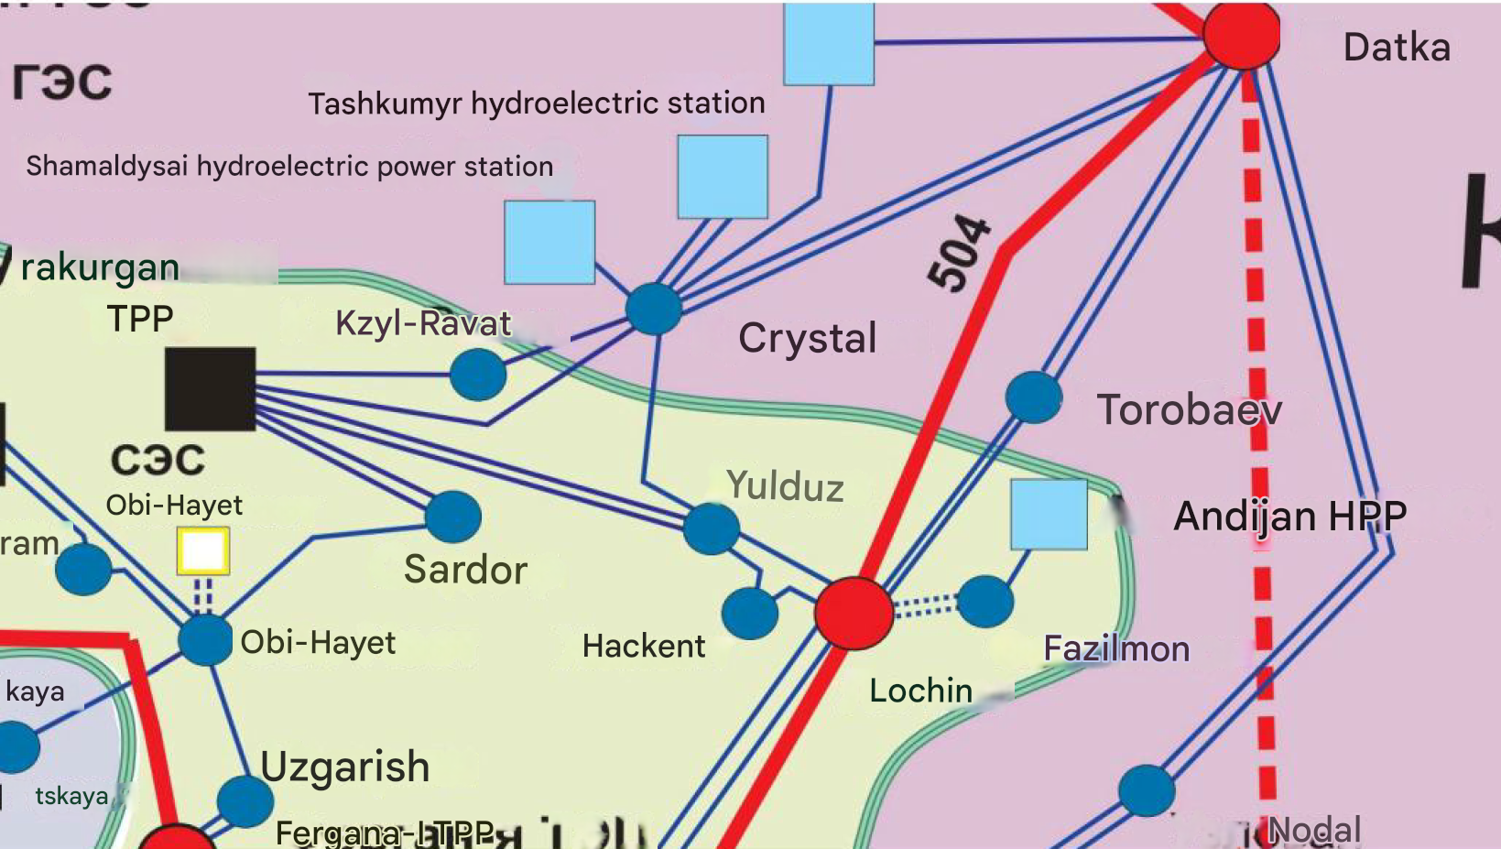
Figure 2: Regional network of Kristall Substation
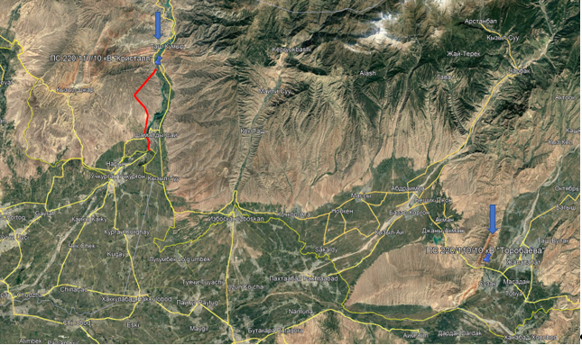
Figure 3: Map of the location of the Crystal substation, the Torobavevo substation and the red line part of the Crystal-Yulduz line (on the Kyrgyz side)

5.1. Environmental Baseline

5.1.1. Brief description of natural environment
Jalal-Abad Oblast has a wide variety of landscapes, including gently sloping foothill plains, adyrs, intermontane troughs, as well as mid-altitude and high-altitude ridges. Adyrs and mountain spurs are separated by intermontane troughs at the altitude of 900 to 3000 meters above sea level.
At the middle altitude, Jalal-Abad Oblast has standalone mountain ranges and contiguous mountain masses. In higher areas (from 3000 m above sea level) there are deep and narrow mountain valleys with steep slopes, cliffs, rocky outcrops and glacial fields. Ridge crests have cirques, carts and glacial formations.
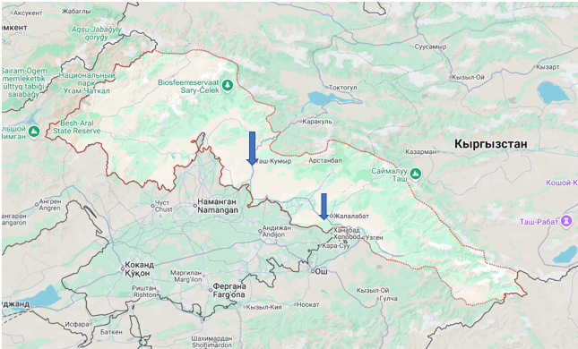
Figure 4: Map of Jalal-Abad region

In the north-west, there are Chatkal Ridge, the south-eastern slopes of Pskem Ridge and Chatkal Trough. At low altitudes (from 800 to 1200 m above sea level), there are smaller troughs such as Ala-Buka-Karavan Trough, Pishkaran Trough and Airytam Trough.
Fergana Ridge starts at the northern end of Chatkal Ridge. In the northeast, it rises on average to 3300-3500 meters above sea level. The northeast slopes are short; the southwest slopes form undulating spurs. The foothills Fergana Range has adyrs. Between adyrs (at altitudes from 800 to 1400 m), Kugart Valley is located. At the foot of the northwestern part of the ridge, there is the valley of Naryn River, as well as the noticeable Kara-Unkur aggraded plain.
The territory of Jalal-Abad Oblast also spills into the peripheral parts of the intermountain Fergana Valley, as well as intermountain troughs, such as the Ketmen-Tyube and Toguz-Toro.
The proposed substation and high-voltage line reconstruction works will be carried out in Aksy district. “Torobaeva” substation reconstruction works will be carried out in Suzak district.

5.1.2. Climate
Jalal-Abad Oblast forms a part of climatic region of Southwestern Kyrgyzstan that has a warm and humid climate. Unlike other areas, this region has a significant amount of precipitation during the cold season, which is associated with southern cyclones.
The climate of the Oblast within Fergana Valley has subtropical features, meaning that it has high temperatures in the warm season and little precipitation in winter, although winters here are colder than in typical subtropics. Fergana Valley is characterized by mild winters with little snow and dry hot summers in the lower regions, as well as moderately cold and cold winters at higher altitudes.
The annual precipitation is 300-500 mm; on the slopes of the Fergana Range, it reaches 900-1050 mm. On the lower and middle altitudes, precipitation mainly falls in the cold period of the year, while in the upper zone precipitation mostly occurs in the warm period. The main maximum precipitation occurs in March-April, the secondary maximum is observed in November, while the minimum precipitation happens in August-September. The snow cover in the lower zone is low, reaching about 10-25 cm and staying for 1.5-2 months, while in the upper zone it can stay for up to 4 months.
The warm period (when the average daily temperature exceeds 10°C) lasts 200-210 days in the lower zone, and 150-170 days at an altitude of 2500 m above sea level. The average July temperature in the lower zone is 25-27°C, in the foothills – 22-23°C, at an altitude of 2500-3000 m above sea level – 10-12°C.

5.1.3. Rivers and Water Resources
Naryn River flows through Jalal-Abad Oblast. This river is a key source of water resources and accounts for 31% of the total surface runoff of the Kyrgyz Republic. In addition, Jalal-Abad Oblast has some other important rivers such as Kara-Darya, Kek-Art, Kara-Unkyur, Chatkal, Padysha-Ata, Mailuu-Suu, Changet, Tentek-Sai and Kara-Suu. These rivers are used to irrigate significant land areas.
The rivers originating from Fergana Range and Chatkal Range are mainly fed by snow and glaciers, which causes early spring floods. To promote sustainable use of water resources in Jalal-Abad Oblast, a network of reservoirs was created, and canals were built. Hosting a cascade of hydroelectric power plants, the energy resources of Naryn River are used especially intensively.

5.1.4. Administrative-territorial division and demography
Jalal-Abad region was formed in 1990, is the second largest in terms of population ( 18.6% of the population of the Kyrgyz Republic ) and the third largest in terms of area ( 17% of the territory of the Kyrgyz Republic ) region of the republic. It consists of 8 administrative-territorial districts, including Aksy, Ala-Buka, Bazar-Korgon, Nooken, Suzak, Toguz-Toro, Toktogul and Chatkal. There are 9 cities in the region, including Jalal-Abad, Tash-Kumyr, Mailuu-Suu and Kara-Kul, as well as 4 cities of district subordination and 4 urban-type settlements, 6 7 ayil aimaks (possibly decreased after the administrative-territorial reform carried out in 2023-2024) and 4 61 rural settlements. The administrative center The city of Jalal-Abad, with a permanent population of 129.3 thousand people.
The total population is 1,335,841 people, of which 47.5% are men and 52.5% are women, 73.9% live in villages, and 26.1% in urban settlements. The population density is 34.7 / km² . Currently, the Kyrgyz are the most numerous ethnic group in the region and the republic, the main part is Sunni Muslims. The ethnic composition of the region: the Kyrgyz make up 71.8%, Uzbeks 24.8%, Russians 0.9%, Turks 0.58%, Tajiks 0.56%, Tatars 0.37%, Uyghurs 0.32% and other ethnic groups 0.67%. The overall fertility rate is 23.3 per thousand, the mortality rate in the territory is 4.1 per thousand . Life expectancy at birth, both sexes 71.5, women 75.2, men 68.4. The poverty rate of the population in the Kyrgyz Republic has increased from 25.6% (2017) to 33.3% (2022) of which 62.2% are residents of rural areas. In the Jalal-Abad region, it increased from 37.2% (2020) to 43.2% (2022) . External migration of population across the territory The number of arrivals was 1,680 people and the number of departures was 489, the influx was 1,191 people. Internal (interregional) migration of the population across the territory by arrivals was 1,437 people and the number of departures was 2,652 people, the outflow was 1,215 people.
The working-age population of the region is 449.3 thousand people, including 286.5 thousand men and 162.6 thousand women. Of these, the employed population is 396.4 thousand people, and 384.1 thousand people are not part of the labor force. The labor force participation rate is 53.9%, the employment rate is 47.6% and the unemployment rate is 11.8%. The number of unemployed people registered with employment services looking for work was 24,256 people. The official status of unemployed is 16,039 people (66.1 percent of the total number of unemployed citizens). The average wage (men and women) for January-March 2024 was 29,947 soms .

5.1.5. Land use structure
Most of the region's land is used for agriculture, and pastures occupy the bulk of agricultural land, as is the case throughout the country. Forests cover only a small part of the territory, and logging is also a problem here. The total area of the region is 33.7 thousand square kilometers. There are 1,838,594 hectares of agricultural land, of which 165,603 hectares are arable land, 9,064 hectares are perennial plantings, 5,965 hectares are fallow land, 47,745 hectares are hayfields, and 1,610,217 hectares are pastures . Pastures are not distributed evenly between the aiyl okmots. After various stages of land and agrarian reform, agricultural land is almost entirely in the hands of private owners.
The main land use problems in the region are soil erosion and salinization, especially on lands with insufficient irrigation. In Jalal-Abad, as elsewhere in Kyrgyzstan, many farmers face financial insecurity and uncertainty over land ownership. As a result, they often invest in traditional farming such as livestock, which exacerbates the problem of overgrazing and land degradation. According to the land cadastre, in the Jalal-Abad region, as in the country as a whole, there are four main categories of landowners and users: state, municipal, private individuals and individuals with long-term leases of state land.

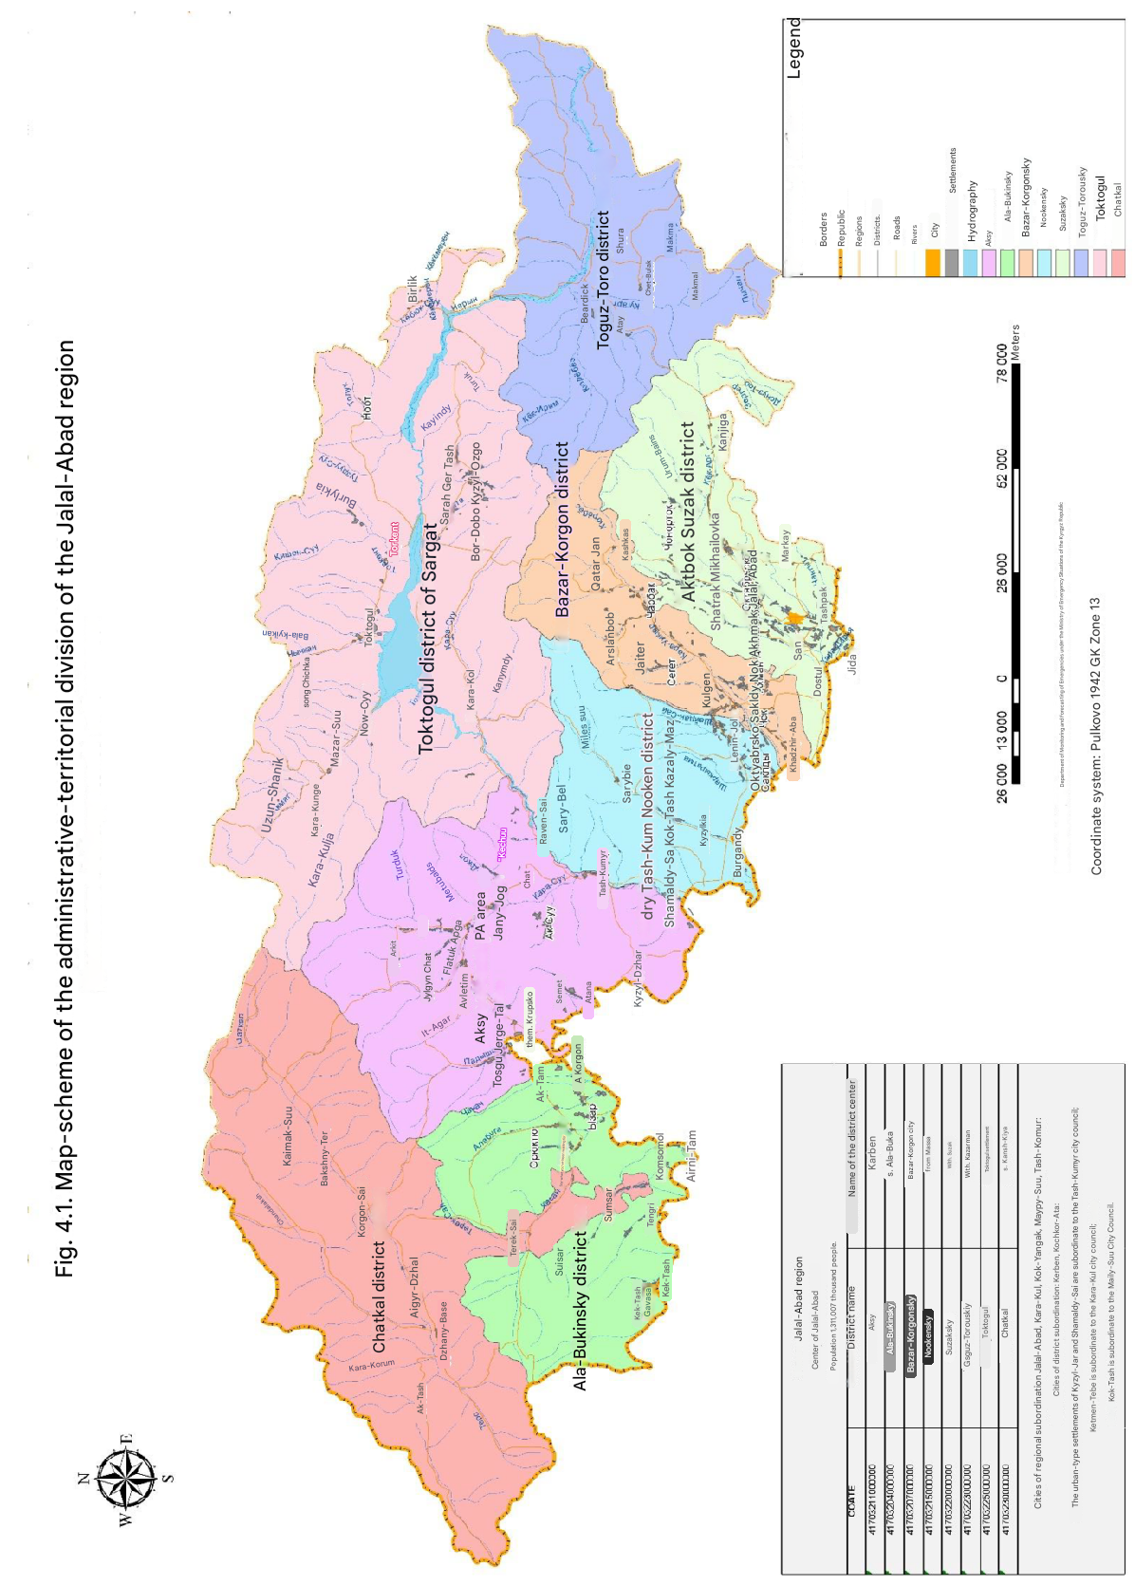
Figure 5. Administrative Division of Jalal-Abad Oblast

5.1.6. Real sector, industry and agriculture
in the region, both legal entities and individuals, of which 15.6 thousand business entities are legal entities. The largest share of 21.9% falls on business entities operating in the agricultural sector. Of these, with state ownership, 4.0% municipal and 86.0% with private ownership . Large functioning and budget-forming industrial enterprises of the republic are located on the territory of the Jalal-Abad region.
The share of the contribution of the Jalal-Abad region to the total volume of agricultural production is about 20%. However, the region does not fully utilize its agricultural export potential. The gross output of agriculture, hunting, forestry and fisheries in current prices amounted to 5,879.4 million soms. In the region, there are only 3 state farms, 116 collective farms, 107,328 peasant (farming) households and individual, and 23 fish farms. Agricultural products include grain (257,095.7 tons), potatoes (123,204.0 tons), vegetables (300,639.9 tons), meat (70,462.2 tons), eggs (72,373.0 thousand pieces), milk (355,500.5 tons), as well as livestock and poultry, consisting of cattle (361,533), pigs (27), sheep and goats (1,364,547), horses (88,091) and poultry (1,171,722) .

5.1.7. Social facilities and education
In the region, the number of medical personnel is 1,631 people, and the number of mid-level medical personnel is 6,127. The number of hospital beds is 4,001. The main causes of death of the population are diseases of the circulatory system (54.5% of all deaths in 2022), neoplasms (8.8%), then injuries, poisoning and some other consequences of exposure to external causes (4.5%), then diseases of the respiratory system (4.7%), diseases of the digestive system (6.2%), infectious and parasitic diseases (5.1%). In each locality, there are feldsher-midwife stations (213 FAPs) designed to provide primary health care to rural residents. In the field of social and health facilities, 2,371 cultural employees and 824 people in physical education and sports work.
As of 2023, there are 311 preschool organizations, 482 general education organizations, 19 vocational educational institutions, 18 educational organizations of secondary vocational education, and 3 educational organizations of higher vocational education in the region. The number of students (at the beginning of the school year) in general education organizations was 271,803 students, 16,156 teachers work. In preschool institutions, there are 35,296 children, 2,270 teachers work. There is a difference in the quality of education in rural and urban schools. Secondary vocational education in the region is represented by 19 institutions, where about 18,232 students study and 1,716 teachers work, as well as 3 universities, where 6,518 students study and 878 teachers work.

5.1.8. Cultural heritage and tourism
The region has preserved many historical and architectural monuments: ancient hunters' camps, burial grounds, settlements, rock paintings, ancient settlements, mausoleums, mosques, caravanserais, fortresses, etc. Shah Fazil Mausoleum (11th century), mosque (18th and 19th centuries), Alamberdar and Safed-Bulan mausoleums (19th century), and the so-called cave of the holy hermit. Shah Fazil Mausoleum is unique in its origin and significance, as it is one of the rare architectural monuments left from the Karakhanid era, Arslanbob walnut forests, Saimaluu -Tash petroglyphs, numbering more than 90,000 images, are the largest collection of petroglyphs in Central Asia and one of the largest in the world (Saimaluu Tash 1 with an area of about 1.3 square kilometers and Saimaluu -Tash 2 with an area of about 1 square kilometer), 2 natural parks, reserves (Sary -Chelek , Besh -Aral), as well as Padysha State Park Ata . Tourism is therefore a promising sector for economic development in the region due to its ability to generate jobs and income, and because it is one of the few industries that has expanded in the post-independence period. The region has recorded a total of 184,290 visitors, 71,385 domestic tourists. There are 35 hotels and 12 recreation and tourism organizations ( 3,788 beds ) in the region . However, this potential is currently only partially exploited due to (i) the country's remoteness from major markets and limited access to regional markets; (ii) underdeveloped transport and tourism infrastructure; and (iii) insufficient hospitality skills and marketing efforts.

6.0. ASSESSMENT OF SOCIAL AND ENVIRONMENTAL RISKS AND IMPACTS OF THE PROJECT

Overview of environmental and social risks
This section considers the potential environmental and social risks and impacts that may arise as a result of the Project. Measures are proposed to mitigate them at all stages of project activities, including design, construction/modernization and subsequent operation. All proposed measures to avoid or mitigate potential adverse construction impacts will be incorporated by the PMG into the tender or contract documents, becoming mandatory elements of the construction and construction supervision contracts. In addition to the outlined risks, gender-specific risks and socioeconomic impacts have been identified. These include restricted access to Project benefits for women and ethnic minorities, gender-based wage discrimination, and limited participation in decision-making processes. Specific mitigation strategies, such as gender-sensitive facilities, training programs, and collaboration with local NGOs, will be implemented to address these risks. In general, the following potential risks and impacts may arise from Project activities.

Table 7. Potential risks
Potential risk | Description
Soil erosion, changes in engineering and geological conditions | Deterioration of soil quality, loss of agricultural potential, drainage and water disposal problems, reduced construction safety.
Possible relocation | Forced displacement of local residents, loss of property and sources of income, social tension.
Risks of disproportionate impact on vulnerable groups | Vulnerable groups may lose access to important resources, worsening their social status.
Damage to monuments, violation of cultural values | Violation of cultural values, project delays, legal issues.
Land loss, land use change | Loss of land, possible conflicts with local residents, deterioration of land conditions for agriculture.
Negative impact on assets of project affected persons | Loss of income and livelihoods for displaced persons, social tension.
Transfer of lands to industrial, transport and communications lands | Loss of agricultural land, ecosystem changes, potential environmental and social impacts.
Violation of legislation, delays in project implementation | Delays in project implementation, possible legal problems, violation of environmental standards.
Exhaust emissions, dust formation, noise | Air pollution, deterioration of the quality of life of the population, possible problems with air quality.
Accident risks, fire and electrical safety | Losses and injuries among workers, accidents, impact on the environment in case of accidents.
Negative impact on the health of staff and local population | Increased risk of disease, deterioration of the psycho-emotional state of the population and workers.
Impact on the ecosystem | Disruption of biotopes, deterioration of animal migration routes, reduction of biodiversity. Risks for rare species of flora and fauna, requiring additional research and measures.
Pollution of soil, air and water resources | Potential contamination of soil and water bodies with oil products, chemicals, construction waste. Risks to water body ecosystems, soil erosion, deterioration of water body quality, threats to the health of local populations and wildlife.
Sound pollution | Impairment of quality of life for local residents, deterioration of health (headaches, insomnia), impact on wildlife, stress in animals.
Impact on flora and fauna | Destruction of rare species of plants and animals, reduction of biodiversity, disruption of ecosystems, threat to the life and health of local animals.
Impact on cultural and natural sites | Destruction of cultural monuments and natural objects, threat of loss of historical value. Archaeological and ecological research is required to prevent destruction.
Impact on soil, forest, vegetation | Destruction of ecosystems, deterioration of soil quality, loss of forest resources. Possible soil erosion, deterioration of conditions for agriculture. Deforestation, reduction of biodiversity.
Impact on water resources | Risks of pollution of water bodies and canals, deterioration of water quality, disruption of the hydrological regime, mechanical damage to water bodies during installation of supports and laying of lines.
Impact on wildlife, avifauna | Destruction of bird and animal habitats, changes in migration routes, risk of bird collisions with wires, stress on animals and damage to ecosystems.
Air and noise pollution | Air pollution with harmful substances (carbon dioxide, sulfur dioxide, nitrogen dioxide), deterioration of human health (respiratory diseases, stress), impact on wild animals and the ecosystem.
Exposure to hazardous and other waste | Pollution of soil and water bodies, leakage of toxic substances (oil, SF6 gas, PCBs), danger to human health and ecosystems, disruption of ecosystems due to improper waste disposal.
Greenhouse gas emissions | Emissions of CO2 and other greenhouse gases from construction equipment, vehicles, and building materials production. Contribution to climate change and air pollution.

The Project's modernization and construction activities may also have positive environmental and social impacts, including:
- Reduced emissions and improved energy efficiency;
- Improved availability and reliability of energy supply;
- Job creation;
- Improved infrastructure.
However, in the preliminary assessment of potential impacts, environmental and social risks are assessed as moderate and are covered by ESS 1, ESS 2, ESS 3, ESS 4, ESS 5, ESS 6, ESS8 and ESS 10. The environmental and social risks of the project are determined by the scale of the project, which covers the districts of Suzak and Aksy. These risks are primarily related to changes in the natural environment, land allocation, impacts on water resources, effects on local communities, and concerns regarding the safety and health of the population, as well as waste and pollution management. Comprehensive mitigation measures, guided by the applicable Environmental and Social Standards, will be implemented to address and manage these risks effectively.

Chance Findings Procedures

It is anticipated that during construction and renovation projects at existing sites, minor excavations, land movements or other changes to the physical environment may occur, during which material cultural heritage may be unexpectedly discovered. To address this issue, all ESMPs of such sub-projects will have special provisions in all contracts for civil works on “chance find procedure”, which will set out how chance finds associated with the subproject will be managed. These will specify the following: (a) do not disturb any chance find further until an assessment by competent professionals is made and actions are identified; (b) notify relevant authorities of found objects or sites by cultural heritage experts; (c) to fence-off the area of finds or sites to avoid further disturbance; (d) to conduct an assessment of found objects or sites by cultural heritage experts; (e) to identify and implement actions consistent with the requirements of the ESS 8 – Cultural Heritage and national law; and (f) when needed, to train project personnel and project workers on chance find procedures.

Ensuring occupational health and safety (OH& S)
All incidents on-site — from accidents and fatalities to near misses and unsafe conditions — must be logged and analyzed. In addition to reporting events with actual harm, the Contractor is required to record and submit to the PIU all near miss events and any deviations from established procedures. This information is included in the regular reports to the OHS authority and the World Bank, and is used to develop corrective actions that address identified hazards before they can escalate into an actual accident.
Occupational health and safety (OHS) reporting should cover all aspects of supervision and monitoring. This includes verifying that the contractor adheres to relevant OHS standards, as well as ensuring that all employees receive the necessary training on these issues. It is also necessary to determine the presence of incidents, check logs, as well as the presence and use of protective and preventive equipment.
Accordingly, the safeguards sections of all progress reports should include statements confirming that health and safety issues and related procedures have been reviewed and whether serious incidents or fatalities have occurred. Likewise, it is necessary to ensure that appropriate health and safety provisions are included in the project kick-off workshop and operating manual.
Any accidents or incidents occurring at project sites or as a part of the activities supported by the project should be reported immediately, for example to the contractor's employer and then to the appropriate health and safety authority. All incidents must be reported to the World Bank no later than in 24 hours from the time they were discovered. Details on whether or not any incidents have occurred will be provided in regular progress reports to both OHS authority and the World Bank.
An Incident is defined as an accident, incident or negative event resulting from failure to comply with established protective measures or conditions. Examples of such incidents include fatalities, serious accidents, serious environmental pollution and others.
The document includes the following six stages of the incident management and reporting process:
Stage 1. Initial incident response: The contractor and inspector inform the PIU, local authorities, the World Bank and the public about the incident, provide medical care and organize safety of workers. All necessary measures are taken immediately, and data on the incident is collected: its scale, threat to health and the environment, location and cause of occurrence, duration and proposed actions to resolve the situation.
Stage 2. Incident severity assessment: The contractor must promptly provide the WB with information about the incident and its severity level.
Stage 3. Notification: The contractor prepares an incident notification to the World Bank as required by the contract.
Stage 4. Incident investigation: The contractor provides all the information requested by the WB and does not interfere with the investigation, which includes causes analysis and information recording. The investigation must be completed within 10 days after the incident. The findings of the investigation should be used to develop corrective actions and draw up a corrective action plan and should be submitted to the WB.
Stage 5. Corrective Action Plan: The Contractor develops a CAP with specific actions, responsibilities, implementation dates and monitoring program and discusses it with the WB. In the event of serious incidents, measures are jointly developed to eliminate the causes of the sources of incidents. CAP includes actions, responsibility for their implementation and may include various measures such as training and compensation.
Stage 6. CAP implementation control: The Contractor performs the CAP, monitors execution of individual CAP items and provides a report on implementation to the WB.
All project participants are required to report serious incidents within 24 hours, and the PIU may use the OHS Audit Checklists to monitor the project's compliance with safety and health standards.

6.1 Overview of Potential Environmental Risks and Impacts
The reconstruction of the “Kristall” and “Torobaeva” substations and the 220 kV “Kristall–Yulduz” line (poles 1–63) may alter landscapes, disrupt ecosystems, affect flora and fauna, and trigger social impacts from infrastructure works. To manage these risks, an Environmental and Social Management Framework (ESMF) was established to avoid, minimize, mitigate, and compensate adverse effects throughout all project phases—from construction through operation—implementing targeted interventions when significant impacts are identified. The ESMF follows the hierarchy of “Avoid, Minimize, Mitigate and Compensate”, with priority given to preventing negative impacts in the first place.“avoid, minimize, mitigate, compensate,” with prevention as its primary focus.

6.1.1. Soil/Forest/Vegetation
During the reconstruction of the substations and the high-voltage line, one of the main environmental impacts will be the change in the area of land required to accommodate new supports and expand substations (if necessary). This will entail additional use of land and may result in an impact on natural ecosystems, including soil, vegetation and forest resources. Laying power lines and reconstructing substations (with expansion or change in the area of substations) may contribute to the destruction of ecosystems and deterioration of soil quality, which is especially relevant in mountainous and foothill areas.
Construction work aimed at reconstructing substations and replacing supports/building a new line may have a significant impact on the soil structure. In particular, when excavating or moving soil, there is a risk of destroying its structure and losing the fertile layer, which will lead to deterioration of the soil quality and a decrease in the soil's ability to recover. In mountainous and foothill areas, the likelihood of erosion processes increases, which can worsen the condition of the soil and, as a result, affect agriculture, since the loss of the fertile layer reduces the possibilities for farming.
Also, reconstruction of the power line with replacement of supports/new construction will lead to an impact on the local flora, especially in the areas where the supports are located. If the power line and access roads pass through forest areas or ecosystems where protected plant species grow during the reconstruction, this may lead to their loss or damage. It is important to note that the impact on flora may cause a reduction in biological diversity and changes in natural ecosystems, which in turn will affect the overall environmental stability of the region.
Deforestation is another significant environmental risk associated with the reconstruction and installation of power lines. The removal of rare and valuable tree species, in particular, can cause irreversible damage to natural ecosystems. Forests play a crucial role in maintaining water balance, preventing soil erosion, and ensuring the sustainability of ecosystems. Furthermore, the loss of forest resources profoundly impacts wildlife that relies on these ecosystems for survival.
Minimization of the impact on soil and vegetation requires specific measures. Any works should be preceded by environmental surveys of the area to assess the current state of flora and fauna and identify rare and protected plant and animal species. This will help determine protection measures. Second, completed construction projects should be followed by land reclamation to restore ecosystems. Soil restoration and planting of native plants will help restore lost ecosystem services and improve the state of the environment.
In addition, compensatory measures are required where valuable trees are cut down. Such measures may include planting new trees of similar species in other places or restoring forest ecosystems in damaged areas. Particular attention should be paid to compliance with legislation on logging and protection of natural resources, including the Law of the Kyrgyz Republic “On Forests Protection”.
To protect soil from erosion in the exposed areas, various methods can be used, such as planting vegetation, creating protective barriers, and soil stabilization. These measures will help prevent further destruction of ecosystems and maintain environmental sustainability in the long term.
All activities must be coordinated with state environmental authorities and comply with environmental standards, including ESS6 (Biodiversity conservation and sustainable management of living natural resources). These measures will help to minimize the negative impact of the project on nature and preserve ecosystems throughout the entire reconstruction cycle.

6.1.2. Impact on Water Sources
During reconstruction with replacement of supports/construction of the high-voltage line, there may be an impact on water resources, especially in areas near water sources.
Work related to the installation of new supports or reconstruction of existing ones must be carried out in compliance with the protection zones of water bodies and exclude their pollution.
An assessment of the impact of reconstruction/construction works on water sources will be carried out within the framework of the ESIA for each reconstruction/construction site at the stages of development of the feasibility study and development of the construction project. In addition to measures to mitigate the consequences and protect against erosion, the ESMF provides for the implementation of a set of additional measures. These include the development and implementation of a system of temporary water-insulating barriers and drainage systems to control the runoff of surface water in the areas of construction work, which will minimize the risk of pollutants entering water sources. It is also planned to use sediment control methods, such as the installation of protective grids and geotextile materials, which further reduces the likelihood of coastal destruction and changes in the hydrological regime. In addition, a set of measures will be introduced to organize rapid response to emergency situations, including the development of plans for the elimination of spills and leaks, as well as strict control over the storage and transportation of construction materials. Regular monitoring of water quality in the immediate vicinity of work sites is carried out in order to promptly identify and eliminate potential negative impacts. Interaction with local water management authorities and environmental services will allow for adjustment of protection measures and ensure the safety of water bodies at all stages of the project.

6.1.3. Impact on Wildlife/Avifauna
During the reconstruction of the substations and the power transmission line, one of the significant environmental impacts is the impact on wildlife, including avifauna. The reconstruction/construction of substations and power transmission lines may lead to the destruction of natural habitats for many animal species, including birds, which poses a serious threat to the conservation of biodiversity in these regions.
One of the key factors that affects the avifauna is the possible change in migration routes and habitats of birds. During the construction of the new power transmission line, especially in mountainous and foothill areas, the most important ecosystems used by birds for nesting, feeding and resting may be destroyed. This is especially true in areas with a high density of birds, such as predatory species or migratory birds, for which a change in habitat may threaten their survival.
One of the most significant risks to avifauna during the reconstruction/construction of power transmission lines and substations is the impact on birds flying within the area of the installation of supports and wires. There are known cases where birds, in particular large species such as eagles and cranes, may collide with wires, resulting in injury and death. In conditions of active construction work, birds may also be forced to leave their usual habitats, which affects their populations.
In addition, the destruction of vegetation in construction and reconstruction areas also has an indirect impact on wildlife by reducing food sources and nesting sites. Construction activities, including the use of construction materials and equipment, can cause stress to animals and birds, which affects their behavior and health.
Thus, the reconstruction of substations and power lines can seriously affect avifauna and wildlife in general, creating threats to their habitat and safety.
Another important aspect is the migration routes of birds, which pose additional risks to power lines. Migration routes cross an area where birds such as storks often build nests on top of high-voltage pylons. This can lead to birds accidentally coming into contact with the wires, causing short circuits.
Birds actively use power lines as a place to rest or nest, especially in certain parts of their route. Insulators on these lines are often contaminated with bird droppings, which increases the likelihood of arcing.
Considering that the migration routes and habits of birds cannot be changed, and the presence of nests already affects the condition of the insulator garlands, it is necessary to conduct additional ornithological studies of the power transmission line route before starting design work. To minimize risks, it is recommended to install protective structures: fences, repellents or spikes to discourage birds from the supports and prevent pollution.
Mitigation measures
Detailed flora and fauna surveys will be carried out to establish ecological baseline and potential impacts will be assessed as part of the ESIA for each site. Mitigation measures will be recommended in accordance with the mitigation hierarchy described in ESS6 and included in relevant tender and contract documents and work protocols. As part of integrated environmental risk management, it is recommended to include measures aimed at preventing the negative impact of reconstruction on the avifauna. First of all, detailed ornithological studies of the power transmission line route and construction sites should be carried out to identify the main migration routes, nesting and resting places of birds. Based on the research results, it is proposed to install protective structures, such as fences, spikes and special bird scaring devices, to minimize the possibility of birds coming into contact with power lines and substation equipment. These measures will help reduce the risk of contamination of insulators with bird droppings, as well as reduce the likelihood of accidents associated with short circuits due to the presence of birds. In addition, comprehensive monitoring of the state of the local ecosystem and regular inspections of the installed protective systems must be integrated into the project management structure. It is important to ensure timely maintenance and replacement of protective structure elements, as well as organize personnel training on environmental protection and wildlife risk management. Such measures will allow us to quickly respond to changes in the behavior of the avifauna and ensure compliance with environmental standards as part of the implementation of the reconstruction project for the facilities.
Avoiding the installation of lines in areas of intensive use by migratory birds and in areas where they land or settle near water bodies will significantly reduce the risk of bird collisions with infrastructure elements. This will not only minimize the negative impact on migration routes, but also help preserve the natural behavior and safety of birds.
The creation of artificial safe perches, nesting sites, as well as the installation of fences and deflectors in vulnerable areas are the following important measures. These measures reduce the likelihood of accidental contact of birds with dangerous objects, creating favorable conditions for their habitat and maintaining the stability of populations.
Maintaining a minimum distance of 1.5 meters between live components and grounded equipment, or using appropriate coatings and insulating materials, is an important measure to prevent electric shock. This ensures safety for both birds and service personnel, reducing the risk of emergency situations and contributing to the reliable operation of the entire infrastructure.

6.1.4. Air and Noise Pollution from Construction Work
During the reconstruction of the substations and the possible construction of a new high-voltage line, one of the significant impacts on the environment is the emission of pollutants into the atmosphere and an increase in noise levels, which poses a danger both to the local population and to the ecosystem as a whole.
Air pollution associated with the construction process can occur due to the use of construction equipment, vehicles, and generators, which result in emissions of carbon dioxide, nitrogen oxides, sulfur dioxide, and other harmful particles. These pollutants can have a negative impact on air quality in the immediate vicinity of construction sites, worsening human health conditions, causing respiratory problems, and increasing the incidence of illness. In addition, dust emissions from excavation work can reduce visibility and pollute the surrounding environment, including water bodies and soils.
Noise pollution is also a major issue during reconstruction. Construction work, including the use of large machinery (bulldozers and excavators), concrete mixers and other heavy equipment, creates high levels of noise that can disturb the peace of local residents. Constant noise can also have health effects, causing headaches, insomnia and increased stress levels.
In addition, noise and air pollution can impact local wildlife, including birds and other animals, which may become stressed or forced to leave their natural habitats due to disruption to ecosystems.
Given the nature of most of the activities, these impacts are expected to be short-term with moderate risk and can be mitigated by implementing the measures recommended by the WB ESS, which provide a summary of potential environmental risks and impacts along with general mitigation measures.
Mitigation measures
The Contractor will implement the measures developed in the ESMF for each project to prevent pollution in accordance with the general measures included in the tender documents.

6.1.5. Exposure to hazardous and other wastes
During the reconstruction of the substations and the construction of the power transmission line, various types of waste may be generated, including both hazardous and non-hazardous waste. These wastes must be taken into account when developing environmental measures and safe handling to avoid negative impacts on the environment.
Non-hazardous waste will be generated during most construction activities, including general construction waste such as scraps and scrap materials, packaging, and wood waste. Although not considered hazardous, improper disposal of such waste can result in soil and water pollution, poor air quality, and poor landscaping. Waste may also include used welding rods, sealants, and packaging materials, which must be disposed of in accordance with local environmental standards.
Hazardous waste such as transformer oil, SF6 gas, and polychlorinated biphenyls (PCBs) are generated during the operation and dismantling of equipment. These substances can pose serious health and environmental risks if not handled properly. For example, SF6 gas is a gas used in some types of equipment that is highly toxic and can cause air pollution if leaked. Transformer oil containing chemicals can contaminate soil and water if leaked or improperly disposed of.
asbestos -containing waste is also important, as this material can be found in old equipment used in substations. Asbestos poses a health hazard to humans, as its fibers can cause severe lung disease when inhaled. Asbestos disposal requires strict protocols, using specialized methods and authorized landfills.
Mitigation measures
In accordance with contractual obligations, the contractor, along with the activities reflected in the ESMF, must fulfill the obligations of a waste generator - this should include keeping records of all waste, proper storage and disposal of materials. This may include the installation of waste collection containers, training of personnel in safe methods of handling hazardous materials, and regular inspections for compliance with environmental standards. Particular attention should be paid to the disposal of waste, such as transformer oil and SF6 gas, using appropriate technologies that minimize their impact on the environment.

6.1.6. Greenhouse gas (GHG) emissions
During the reconstruction of the substations and the high-voltage line, greenhouse gas (GHG) emissions are possible, both during construction work and as a result of the operation of the facilities after completion of the reconstruction.
One of the main sources of greenhouse gas emissions during the construction phase is the use of construction equipment and vehicles. Car and construction machinery engines that run on hydrocarbon fuels emit carbon dioxide (CO2) and other greenhouse gases such as methane (CH4) and nitrogen oxides (NOx ). These emissions occur at all stages of the work, including the transportation of materials and the movement of equipment around the construction site.
In addition, a significant amount of GHG emissions are associated with the production and use of building materials. For example, the production of cement, which can be used in the construction of substations and line reconstruction, is one of the most carbon-intensive industries. Its production requires high temperatures, which leads to the release of CO2 into the atmosphere. Emissions can also occur from the production of other building materials, such as steel or asphalt.
When operating reconstructed substations and lines, it is possible to use SF6 gas, a powerful greenhouse gas. Leakage of this gas from equipment such as transformers or cells can significantly increase GHG emissions, as SF6 has a high global warming potential. In order to ensure timely detection of greenhouse gas leaks, concentration monitoring sensors scheduled equipment checks and technical inspections are carried out periodically, as well as comprehensive testing of sealing systems and process control. This allows for prompt detection and elimination of equipment malfunctions both at the construction stage and during operation of reconstructed facilities. Specialized tanks and units designed to operate under negative pressure are used for safe storage of greenhouse gases, which significantly reduces the risk of unauthorized release. Additionally, measures are implemented for emergency pressure reduction, prompt response to leaks, as well as regular equipment maintenance and personnel training, which ensures comprehensive protection of the environment from the effects of high-potential pollutants.
In general, greenhouse gas emissions can occur both during the construction and operation stages of facilities, and it is important to take them into account when developing measures to minimize climate impact.
As part of the individual ESIAs, an appropriate GHG analysis will be carried out to identify possible measures to reduce such emissions.

6.2 Overview of potential social risks and impacts
Among other risks, gender-specific risks and socio-economic impacts were identified. These include limited access of women to jobs in the reconstruction/construction of the project, gender-based wage discrimination and limited participation in decision-making processes. Specific mitigation strategies will be implemented to address these risks, such as the establishment of gender-sensitive regulations, training programmers and collaboration with local civil society. Overall, the following potential risks and impacts may arise as a result of project activities.
Table 8. Potential risks and impacts
Potential social risks and impacts | Description
(i) Risks associated with land acquisition/transportation, Involuntary resettlement, installation of substation and overhead power transmission line supports, impact on agriculture, and the introduction of automated dispatch and emergency systems. | - Involuntary resettlement may cause discontent among the local population, which may lead to delays in the implementation of the project.  - The resettlement of people can negatively affect their quality of life and agriculture, especially if the new living conditions or compensation are insufficient.  - The movement of people, machinery and equipment through various areas, including agricultural fields, carries the risk of damage to soil and crops.  - Local residents may oppose construction due to concerns about their health, reduced land value, or deterioration of the aesthetic appearance of the area.  - The introduction of new systems may be accompanied by disruptions in operation, which may lead to temporary outages that may impact the local population in terms of the reliability of the power supply.
( ii ) Risks associated with economic and physical displacement that may disrupt livelihoods, require the restoration of economic activity and, possibly, the reduction of personnel. | - The displacement of people from their usual places of residence can lead to a deterioration in the quality of life, loss of access to social infrastructure (schools, hospitals, transport) and the breakdown of social ties.  - Displacement can deprive people of their traditional sources of income (e.g. agriculture, small business), especially if the new conditions do not allow them to continue their previous activities.  - Resettlement can cause stress, insecurity and loss of identity among local populations, especially vulnerable groups (elderly people, children, the poor).  - Displacement may result in the destruction of local traditions, loss of cultural heritage or sacred sites, which will lead to resistance from communities.  - Investments will be required to create conditions in the new location. The new conditions may not provide the same level of income, which will lead to a decrease in the standard of living and an increase in poverty.  - Job loss will lead to a decrease in family income, which can negatively impact the family and the local economy.
( iii ) Risks associated with the organisation of work, including ensuring fair working conditions, occupational health and safety (OHS), and the creation of safe and effective camps for workers; | - Occupational health and safety (OHS) violations by workers can result in unsafe working conditions that increase the risk of injury, occupational illness, or even death due to non-compliance with safety regulations.  - Violations of labor laws and breaches of contract may result in Involuntary labor, delayed wages, dissatisfaction, decreased motivation, complaints, staff turnover, legal costs, and conflicts. The use of children on construction sites exposes them to increased risks of injury, illness, and psychological trauma.  - Poorly organized camps for workers can lead to the spread of diseases (clean water, sanitation, ventilation, etc.), tension and increased conflicts within the team, etc.  - The influx of workers, especially from other regions, can contribute to an increase in crime, competition for resources (water, housing, work), and dissatisfaction with the behavior of workers can cause tension and conflict.  -Women on construction sites may face harassment, discrimination and physical violence from co-workers or management.  -Opaque procedures for hiring local workers can contribute to corruption, low wages, poor working conditions and discontent in the local community. –  - The influx of cheap labor could lower wages for local workers or take their jobs away, causing discontent and social tension.
(iv) Risks associated with health and safety in the community, particularly construction and the influx of labour; | - Construction work can lead to air pollution (dust, emissions from equipment), water (chemical runoff, waste) and soil, which negatively affects the health of local residents.  - Construction sites and temporary worker camps may create dangerous conditions for children and other vulnerable groups (e.g. risk of injury, exploitation or violence).  - Lack of clean water, sanitation and ventilation in workers' camps can lead to outbreaks of infectious diseases that can spread to the local community.  - Workers who are not trained in safety precautions may cause accidents or incidents that may also affect the safety of local residents (e.g. collapse of structures, fires).
(v) Risks associated with social exclusion, requiring consideration of the interests of vulnerable and disadvantaged groups, including women, ethnic minorities and socially disadvantaged individuals, to ensure equal access to project benefits. | - Vulnerable groups may be under-informed about the project, its objectives, potential benefits and opportunities for participation.  - Women, ethnic minorities and other vulnerable groups may be excluded from consultation and decision-making processes, resulting in their interests being ignored.  - Vulnerable groups may not have equal access to new opportunities created by the project, such as jobs, training, infrastructure or social services. For example, women may be excluded from high-paying jobs due to gender stereotypes or lack of necessary skills.  -The project may unintentionally exacerbate existing inequalities if the benefits are not distributed equally.

6.2.1. Land acquisition and measures to mitigate the impacts of Involuntary resettlement
The project takes into account the need to minimize the impact on households and local communities during the installation of new supports and the relocation of infrastructure, taking into account all possible risks and socio-economic consequences.
To mitigate the socio-economic impact, the following measures will be taken:
Careful route alignment of proposed transmission line by optimizing the route/study of alternatives to avoid/minimize likely impact on agriculture land/activities.
Use of innovative tower design like narrow base compact towers or pole type towers to reduce land requirement for tower base.
- at the organizational stage before the start of construction - payment of compensation to all persons who will be resettled in connection with the project, before the land is occupied, buildings are moved or demolished, if any, or in case the project activity causes damage to land or agricultural crops, in accordance with the developed and adopted RAP, compensation will be paid.
- At the construction stage, designers/contractors are assigned to clearly defined areas of the territory, ensuring compliance with the necessary technical and environmental safety standards, and compliance with local rules of conduct and traditions.
- If it is necessary to acquire land for the installation of supports, the project will provide for the implementation of all legal procedures, including compensation to land owners. To ensure access to the supports, without the need to acquire land, it is possible to establish an easement, which will preserve the rights to the land for the owners and minimize the impact on their usual way of life.
- All issues related to the distribution of local resources will be agreed upon with the local population and stakeholders. Where necessary, the project will include measures to mitigate social risks and take into account the peculiarities of traditional land tenure, especially in the Jalal-Abad region, where traditional rights to land and water resources are important.
- Given the frequent risks of mudflows and landslides in the region, the project will develop measures aimed at minimizing the negative impact on agriculture, livestock farming and other traditional economic activities. If necessary, compensatory measures will be proposed, such as tree planting, if logging cannot be prevented. Tree planting will be carried out at a specific time of year (spring or autumn), and each tree will meet quality standards.
- The project will take into account local traditions and values in order to avoid social tension and conflict, ensuring harmonious interaction with local communities.
Thus, the project will provide a comprehensive approach to social and environmental safety, taking into account the interests of all parties and minimizing possible negative impacts on the traditional way of life of local residents.

Impact on agriculture
The installation of supports and the laying of transmission lines may require the movement of people, machinery and equipment through various areas, including agricultural fields, which carries the risk of damage to soil and crops. To mitigate these consequences, the following measures are envisaged:
- Carrying out construction work during the lean season - if possible after harvesting, to minimise the impact on Crop damage.
- Use of existing rural roads and embankments between fields for movement of equipment and workers where possible, reducing the risk of crop damage.
- Compensation for damage - if crop damage cannot be avoided, farmers will receive full compensation, the amount of which will be assessed by the relevant authorities.

6.2.2. Temporary restriction of access to public places
The project activities may cause certain inconveniences to the population, the ESMF prepared within the project, mitigation measures will be included, where necessary, to reduce potential risks through consultation with local authorities prior to commencement reconstruction / construction works and prior notification of residents before each action that causes such restrictions. Considering that energy supply is the basis for the functioning of public infrastructure such as water supply, sewerage and partly heating for residents, the project will take all measures to reduce risks.
These measures will include the following key actions:
- Consultation with local authorities - prior to the commencement of construction work, consultations will be held with local authorities to agree on an action plan and take into account all local characteristics and needs. This will allow potential problems to be identified in advance and ensure active participation of local authorities in the project implementation process.
- Advance public information - local residents will be informed in advance of upcoming restrictions and potential disruptions due to construction or renovation work. This may include information about temporary road closures, changes to transport routes or access restrictions to certain sites.
- Minimizing the impact on public services - the project will pay special attention to the protection and uninterrupted operation of important public infrastructures, such as water supply, sewerage and heating. In the event that the project affects these systems, temporary measures will be developed to ensure their continuity of operation and minimize negative consequences for the population.
- Measures to reduce environmental and social risks - the ESMP will also include specific measures to reduce environmental and social risks. This may include regular consultation with residents to ensure timely responses to emerging issues, as well as providing alternative solutions to reduce the impact on their daily lives.
The project will therefore aim to ensure effective interaction with the local population and minimize any potential disruption associated with its implementation, while ensuring the continued operation of key public services and infrastructure.
- In the event of temporary road or route closures for construction, the PIU will inform local communities in advance of temporary changes and suggest alternative routes. This will help to minimize disruption and ensure access to homes and land.

6.2.3. Occupational Health and Safety
1. Reconstruction of substations and power transmission lines (PTL) may pose health and safety risks to workers. Key risks include injuries caused by the use of faulty machinery, tools or equipment, falls from height, accidental collisions, electrical shock, injuries from blasting debris, and adverse working conditions due to confined spaces, exposure to hazardous materials or underground construction. Additional hazards are created by the use of heavy equipment and vehicles, even if workers are not involved in their operation or maintenance.
Risk mitigation measures:
To minimize such risks, measures will be developed in line with national requirements and the World Bank Group Environmental, Health, and Safety (EHS) guidelines, taking into account more stringent standards. The General Guidelines for the Extraction of Construction Materials, Transmission and Distribution of Electricity will be used as a reference.
Contractors are required to comply with occupational health and safety regulations, including:
- Strict compliance with established standards and procedures for occupational health and safety, depending on the type of work. Providing workers with appropriate instructions on the safe use of equipment and machines.
- Use of personal protective equipment (PPE), including hard hats, safety glasses, gloves, work boots, and special clothing.
- Conducting training and regular monitoring of working conditions.
- Informing workers about the rules for working with hazardous materials such as asbestos.
In addition, contractors must provide workers with adequate living conditions, including access to safe drinking water, laundry facilities, rest areas and other necessary amenities.
2. Labor risks associated with Involuntary and child labor. The project excludes the use of child and Involuntary labor, strictly following the requirements of national legislation, in particular, the Labor Code of the Kyrgyz Republic.
Risk mitigation measures:
- All contractors are required to sign an agreement confirming compliance with labor laws and standards regarding the prohibition of child and forced labor.
- All employment contracts will contain clear provisions regarding working hours, pay and working conditions, including compensation for overtime.
- Mandatory compliance with transparent labor recruitment procedures, taking into account local regulations and requirements.
3. Risks associated with the influx of temporary workers. The influx of temporary workers can create difficulties in managing and monitoring compliance with occupational safety standards and respect for labor rights.
Risk mitigation measures:
Development and implementation of Construction Environmental & Social Management Plan C-ESMP by all contractor to ensure compliance with measures listed in ESMP.
- Contractors will be required to ensure compliance with all occupational safety standards, including the use of personal protective equipment and adherence to working hours standards.
- It is important to conduct public consultations and inform local communities about plans to use temporary workers to avoid social conflicts.
- Instructing employees on compliance with the code of conduct and rules - employees will be required to adhere to professional and ethical standards.
- Signing a Code of Conduct - Before work commences, all contractor employees will be required to sign a Code of Conduct, which is part of the LMP developed for the project. The Code will be mandatory for all stages of construction.
- Strict control over wages and respect for the labor rights of all workers, including local residents, and ensuring transparency in hiring.
4. Gender-based violence (GBV) and sexual exploitation. Gender-based violence and sexual exploitation are important social risks, particularly in the construction/reconstruction context where the workforce is predominantly male and such issues may be more acute.
Risk mitigation measures:
- A risk assessment of gender-based violence will be carried out and all violence prevention measures will be integrated into the LMP.
- All contractors are required to adhere to/implement the Code of Conduct, which includes measures to prevent gender-based violence, sexual exploitation and abuse (GBV/SE).
- Workers will be required to undergo training, including on measures to protect against sexual harassment and violence, with channels for filing complaints and safe procedures for responding to such incidents established.
- Bidders for construction work are required to express their willingness to implement/comply with the LMP (Labour Management Procedures) to prevent gender-based violence and other labour rights violations.
5. Non-transparent labour recruitment procedures. High unemployment may contribute to risks associated with non-transparent recruitment procedures and possible disputes between workers and local authorities.
Risk mitigation measures:
- All recruitment procedures must be transparent and comply with the rules set out in the project to avoid social tensions.
- Information about the recruitment process should be accessible to local residents, with clear instructions and opportunities for feedback.
- Ensuring compliance with local laws, including labor regulations, and ensuring fair working conditions for all workers.
6. Occupational Health and Safety Measures. According to the "Safety Rules for the Construction of Power Lines and Electrical Installation Work" All contractors are required to comply with strict occupational health and safety standards, including:
- Compliance with safety standards at all stages of construction, modernization, operation and decommissioning of facilities.
- Regular safety and health training for workers.
- Ensuring the availability and functioning of medical and emergency services in the construction area.
These measures are aimed at ensuring safety, health and decent working conditions for all project workers, as well as reducing social risks and preventing violence.

6.2.4 Community Health and Safety
Reconstruction may cause certain difficulties for local residents, especially in the village of Qom. The movement of heavy equipment may damage or deteriorate roads inside the village. In addition, the transportation of construction materials requires careful planning. Other potential risks include the release of pollutants, such as oils and lubricants, during the construction of power lines. When renovating substations and high voltage lines, it is important to consider the health and safety of the community.
will be applied for this purpose:
- Strict compliance of provisions of sanitary protection zones (SPZ) requirements as specified in National regulations.
- selection of routes that minimize proximity to residential areas, schools, hospitals and other socially significant facilities.
- installation of temporary fencing and warning signs at work sites. At night, signal lights and reflective tapes will be placed around construction sites during the reconstruction of the facilities.
- compliance with safety measures for waste disposal and prevention of pollution, such as oils that may be released during work. Waste containers will be equipped with lids to prevent their spreading. Measures will also be observed to prevent possible environmental risks.
- noise and excavation management, contractors will set pre-determined time slots for noisy work to enable residents to plan their activities in advance, taking noise impacts into account.
- Existing outdoor toilets must be closed or fenced to prevent access by children and accidents.
- Residents will be informed in advance of potential risks and changes associated with the project. In particular, they will be warned of possible inconveniences such as temporary road closures, changes in traffic flows or working time windows in order to prepare and minimize inconvenience.
All contractors will be required to follow a strict code of conduct, which will include requirements for maintaining safety in the workplace and around sites. These measures will be integrated into the ESMP and will provide a comprehensive approach to mitigating the impacts of the project on local residents and the environment.
There will also be adequate lighting and fencing at all critical areas of construction sites to minimise the risk of accidents. All contractors will be required to follow a strict code of conduct, which will include requirements for maintaining safety at work and around the site.
These measures will be integrated into the ESMP and will provide a comprehensive approach to mitigating the impacts of the project on local residents and the environment.

6.2.5. Participation of women and other vulnerable groups in decision-making
To ensure equal participation of women, ethnic minorities and other vulnerable groups from local communities in public consultations and decision-making with local authorities, and to create appropriate conditions for women workers, the following measures will be taken to mitigate the consequences:
- Conducting inclusive consultations taking into account the needs of vulnerable groups and their active involvement in the decision-making process.
- Organizing information campaigns targeting vulnerable groups, taking into account their specific needs.
- Gender advocacy and women’s participation. Conduct formal and informal group consultations with women to ensure their active participation in project implementation and decision-making. This will help create space for women to express their opinions and needs.
  - Ensuring gender equality in employment, including creating conditions for women to work. Creating conditions for women on construction sites, appropriate safety measures will be provided for women workers, including: separate toilets for women.
  - Developing education and training programmes for vulnerable groups so that they can participate in the project on an equal basis.
  - Taking into account the interests of vulnerable groups when planning social programs and compensatory measures.
  - Implement a zero-tolerance policy on discrimination and provide mechanisms for filing complaints.
  - Conducting training for employees and contractors on gender equality, cultural sensitivity and inclusivity.
  - Inclusion of indicators related to social inclusion in the project effectiveness assessment system.
These measures will help ensure the inclusiveness of the project and support women's participation both in the implementation process and in improving working conditions on construction sites.
Table 9. Negative consequences
N | Influence | Type of impact | Scale of impact
1 | Labor risks associated with the influx of temporary workers, possible disputes with local communities | direct | moderate
2 | In community health and safety surveys during renovation/construction works | direct | moderate
3 | Temporary restriction of access to public places, possibly homes, social infrastructure | direct | Low
4 | Influencing land use, conducting easement procedures or possible land acquisition. | direct | moderate
5 | Impact on agriculture during the installation of supports/Towers | direct | moderate
6 | Temporary increase in demand/competition for local resources during site renovations/construction | indirect | minor
7 | Temporary impact on traditional ways of life of local communities due to land use, pastures, resettlement issues, which may lead to tensions | indirect | minor
8 | Temporary problems in the power supply may affect the living conditions of local residents and also affect their businesses. | indirect | minor

6.3. Environmental and Social Management Plan (ESMP)

The Environmental and Social Management Plan (ESMP) and Monitoring Plan are integral components of the Environmental and Social Management Framework (ESMF), building upon the environmental and social risk identification, mitigation strategies, and institutional responsibilities outlined in the previous chapters. The ESMP operationalizes the mitigation measures identified in the Environmental and Social Impact Assessment (ESIA) and ensures their systematic integration into project activities. Meanwhile, the Monitoring Plan establishes mechanisms to assess the effectiveness of these measures, ensuring compliance with the World Bank’s Environmental and Social Standards (ESS) and national regulations throughout the project lifecycle. Together, these tools provide a structured approach to manage and monitor environmental and social impacts, ensuring that the project adheres to sustainability principles at every stage.
The basic purpose of the ESMF is to design/formulate mitigative measures and plan for assessment and management protocol to address identified/potential environmental & social risk/impacts during implementation & operation stage. The nature of impacts and scope of activities will be clarified once the subproject designs are finalized. ESIA will assess the risks and impacts, and provide recommendations on appropriate mitigation measures to be performed. Accordingly, the following table below presents generic ESMP to address the potential environmental and social risks and impacts during the design, construction and operation stages for component 2 and the recommended general measures to be included in the project to mitigate negative impacts to a minimum. Subsequently, for each subproject, ESIA must be conducted and corresponding ESMPs must be prepared, which will identify appropriate specific measures.
The following ESMP in general identifies the mitigation, monitoring and institutional strengthening measures that will be implemented during project implementation to avoid or reduce adverse environmental impacts. For this project, an ESMP can be an effective way to summarize the measures needed to effectively mitigate environmental impacts. For each impact, mitigation measures are identified and listed. The generic ESMP also identifies institutional commitments for the installation and operation of mitigation devices and techniques. The generic ESMP also include a brief description of routine mitigation and monitoring measures for control of recurrent impacts and a few specific plans, which may include, without limitation, Traffic management Plan, Biodiversity Action Plan, Cultural Heritage Management Plans, Emergency Preparedness and Response Plans, Material Supply plan, OHS Plan, Waste Management Plan and RAP. In order to track the requirements, obligations and monitoring costs for the implementation of mitigation measures identified during the environmental assessment analysis, a monitoring plan must also be prepared. In addition to recording information to track performance and establishing relevant operational controls, the monitoring plan will require the use of dynamic mechanisms, such as inspections and audits, where relevant, to verify compliance and progress toward the desired outcomes.

Table 10. Framework environmental and social management plan (ESMP)
No. | Activity | Potential negative impact | Mitigation Measures/Best Management Practices | Mitigation Target Result | Responsibility
1. Pre-construction stage
1.1. | Installation of new wires | Risks of injury/death to birds due to electrocution/collision  Potential EMF exposure | Provide measures to protect birds from electrocution/collision (nesting areas, bird fences/deflectors in identified vulnerable areas)  Compliance with water protection zones and permissible gaps and distances according to the sanitary regulations of the Kyrgyz Republic | Availability of measures in accordance with PP KR No. 60  SN KR 12-02:2017 "Organization of construction"  Rules for the protection of surface waters of the Kyrgyz Republic, approved by Resolution of the Government of the Kyrgyz Republic No. 128 of 14.03.2016 (as amended by Resolution of the Government of the Kyrgyz Republic No. 813 of 15.12.2017) | NEGK  PIU
1.2 | Technical modernization of substations | Discharge of pollutants and environmental pollution | Measures to localize oil, lubricants and fuel spills (oil pan), installation of drainage systems and wastewater removal systems.  Exclusion of the use of PCBs. | Availability of an oil spill containment system and equipment for their elimination.  The PCBs exclusion has been adopted.  SN KR 40-02:2023 "Water drainage and wastewater treatment systems"  SN KR 12-02:2017 "Organization of construction"  SP 32.13330.2012 "Sewerage. External networks and structures"  Technical regulations "On handling equipment and waste containing PCBs (biphenyls)", approved by the Resolution of the Government of the Kyrgyz Republic (2010)  SN KR 40-02:2023 "Water drainage and wastewater treatment systems"  SN KR 12-02:2017 "Organization of construction"  SP 32.13330.2012 "Sewerage. External networks and structures"  Water Code of the Kyrgyz Republic (Code "On Water"), Law of the Kyrgyz Republic No. 160 of 02.08.2016 "On Industrial Safety of Hazardous Industrial Facilities", Law of the Kyrgyz Republic No. 151 of 08.05.2009 "General Technical Regulations for Ensuring Environmental Safety in the Kyrgyz Republic" | NEGK  PIU
 |  | Explosions/Fires | Use of modern fire-fighting equipment that complies with fire safety standards. | Compliance with fire safety standards. Law of the Kyrgyz Republic No. 160 of 02.08.2016 "On industrial safety of hazardous production facilities"  Law of the Kyrgyz Republic No. 118 of 13.12.2022 "On Fire Safety"  TR EAEU 043/2017 "On requirements for fire safety and fire extinguishing equipment" | NEGK  PIU
1.3 | Land use (temporary use)/possible acquisition of land for a substation | Loss of land/income, change in social status, etc.  Social displacement and environmental degradation caused by poorly planned routes | In case of compulsory acquisition, compensation and other measures shall be extended to the affected persons in accordance with the RPF/RAP  Avoid problem areas/sites and minimize social inconvenience. Make maximum use of existing roads | Provide compensation in accordance with the provisions of the RPF/RAP  Selecting the optimal route that minimises social and environmental impacts, ensuring compliance with ESS1, ESS5 and ESS8 standards. | NEGK  PIU
1.4 | Implementation of environmental and social standards (implementation of ESMF, RPF and other design decisions)  Selection of contractors | - Environmental impact and safety of project implementation in compliance with regulatory requirements | - Appoint key environmental and social officials  - Implementation of contractor labor resource management procedures  - Implementation of established standards and procedures for labor protection and safety  - Inclusion of ESMP and LMP and GAP in tender documents | Availability of sufficient personnel to implement/monitor ESMP  - Employment of workers in accordance with the Labor Code of the Kyrgyz Republic of 2025 (non-discrimination, equal opportunities, income, etc.)  - Safety rules for the construction of power transmission lines and electrical installation work (to the order of the Ministry of Energy of the Kyrgyz Republic dated August 3, 2023 No. 01-13/160)  Compliance with LMP, GAP | NEGK  PIU
2. Start of construction works
2.1 | Access to facilities (construction of roads, access roads) | Creating interference with nearby settlements and other social facilities  Temporary inconvenience, restricted access to roads during construction work | Use of existing roads to access construction. | Minimizing social tension, observing LMP, GAP  Maintaining access roads at a proper level.  Construction zones exclude water protection zones. | Contractor
 |  |  | Compliance with water protection zones.
2.2 | Noise | Increased noise exposure during construction work | Compliance with noise level standards  Use of serviceable equipment that meets approved standards | The implementation of the project will comply with the LAW OF THE KYRGYZ REPUBLIC dated December 6, 2024 No. 194 "On Silence", SANITARY RULES AND REGULATIONS "Noise in workplaces, in residential premises, public buildings and on the territory of residential development" noise sources will be reduced to a minimum | Contractor
2.3 | Soil and water pollution | Pollution of soil and water with petroleum products as a result of the use of equipment. During the construction period, the impact is accompanied by the following activities:  - earthworks;  - operation of construction equipment;  - the formation of household waste. | Compliance with building codes and regulations applied during construction.  Checking equipment for oil leaks; storage areas for construction and solid waste.  Ban on burning solid waste. | The project implementation will comply with the standards of the Law of the Kyrgyz Republic "On Environmental Protection" dated June 16, 1999, the Law of the Kyrgyz Republic "General Technical Regulations for Ensuring Environmental Safety in the Kyrgyz Republic" dated May 8, 2009, the Law of the Kyrgyz Republic "On Production and Consumption Waste" dated August 15, 2023, sources of soil and water pollution will be minimized | Contractor
2.4 | Dust pollution of atmospheric air | Pollutant emissions:  - from motor vehicles and construction equipment  - during excavation work | Dust suppression measures include the use of shelter and fencing of the construction site.  Restriction of the speed of vehicles near sensitive receptors (schools, hospitals, kindergartens, etc.).  Prohibition of burning construction and household waste. Burial and removal of solid waste by a specialized organization  Compliance with pollutant standards at the level of 0.5 MAC. | Dust sources will be minimized  Compliance with the standards of the Law of the Kyrgyz Republic "On Environmental Protection" No. 53 of 16.06.1999, SN KR 12-02:2017 "Organization of Construction Production"  Resolution of the Government of the Kyrgyz Republic No. 447 of 20.07.2011 "On the Road Traffic Regulations of the Kyrgyz Republic"  Law of the Kyrgyz Republic "On Production and Consumption Waste" No. 181 dated 08/15/2023  Hygienic standards GN 2.1.6.1338-03 "Maximum permissible concentrations (MPC) of pollutants in the atmospheric air of populated areas" | Contractor
2.5 | Occupational Health and Safety | Failure to comply with occupational health and safety standards may pose a threat to the health and safety of workers. - | Strict compliance with established occupational health and safety standards and procedures  Strict adherence to the established Kyrgyz Republic and World Bank occupational health and safety standards and procedures;  Identification, assessment, and control of occupational health and safety risks at all project stages;  Provision of personal protective equipment (PPE), tools, and working conditions that meet safety standards;  Transparent hiring practices, written contracts, fair wages, prohibition of child and forced labor, and prevention of gender-based violence;  Regular safety briefings, training in safe work methods, and information on rights and codes of conduct;  Establishment of grievance mechanisms, incident investigations, and corrective and preventive measures. | Minimization of occupational risks and compliance with labor legislation on occupational health and safety in accordance with the requirements of the Kyrgyz Republic and the World Bank;  Adherence to the LMP and GAP. | Contractor
2.6 | Carrying out construction works | Social tension, safety of local residents and temporary inconvenience. | - Installation of warning signs, fences and information boards around hazardous areas.  -Control of access of unauthorized persons to the work site.  - Advance notification of residents and local authorities about the schedule and duration of construction work. | Security is ensured, social tension is reduced | Contractor
2.7 | Organization of the construction site: warehouse, camp and dismantling of the site after completion of construction work | Violations in the organization of work - complaints from the population  Incomplete dismantling/cleaning - deterioration of the habitat | - Clear zoning, perimeter fencing with warning signs  -Special passages for equipment without disrupting infrastructure  -Control of dismantling, removal of all equipment/garbage within the agreed time frame  - Bringing the site back to its original state. | Procedures will be provided for preventing and eliminating the consequences of construction work in accordance with building and sanitary norms and rules KR | Contractor
3. Operation and maintenance
3.1 | Ongoing maintenance and patrols to ensure safety | - Electric shock to employees or other persons  - Damage to supports, wires | -A warning system is required in case of detection of electricity leakage from power lines  - Compliance with safety precautions  - Informing local population about expected tests and changes | Safe operation | NEGK
3.2 | Maintenance during operation | Fire hazard due to uncontrolled growth of trees/bushes along the row | Periodic trimming of vegetation to maintain the required electrical clearance.  Inform people and prohibit them from building residential buildings under the line or in the safety zone | The risk of fires due to vegetation growth near power lines has been reduced.  Electrical Installation Rules (6, 7 versions)  SP 76.13330.2016 "Electrical devices" | NEGK
 |  | SF6 leakage during operation and refilling | Operations are permitted only on equipment with tools and leak control equipment (regulation 0.5%/year)  Requirements for density sensors and density meters to keep SF6 leakage within 0.5% per year | Compliance with the requirements of RD 16.066-05 "Equipment for working with SF6 gas"  Rules PTB-E (IKES-051-2017) "Safety rules for the electric power industry" | NEGK
3.3 | Substation operation and maintenance | Fire hazard | Ensure that fire extinguishers are available in appropriate locations and are regularly checked and properly maintained | Effective fire safety measures in place at the substation. | Substation staff
 |  | Environmental pollution due to accidental leakage/spillage of hazardous chemicals and oil during repair and maintenance | Oil, chemicals and other hazardous materials must be stored in a safe place and protected from storm water runoff. | The risk of environmental contamination with hazardous materials is minimized. | Substation staff
 |  |  | All activities involving the transfer of fuel and chemicals from one vessel to another must be carried out under a drip tray to prevent leakage. |  | Substation staff
 |  |  | Immediate notification of any transformer oil leakage |  | Substation staff
 |  |  | Availability of spill kit/sawdust collection buckets at work site or at refuelling or maintenance point |  | Substation staff
3.4 | Worker Health and Safety/Employees and Community | Injuries/fatalities to employees and the public due to electrical shock due to improper conditions | Ensuring the safety of electrical supply, raising awareness among employees and workers | Safety regulations  when operating electrical installations  Rules organization of work with personnel at enterprises and in energy production institutions  Proper investigation of accidents and actions to eliminate them in accordance with the Regulation on the technical investigation of the causes of accidents and incidents at hazardous industrial facilities, Order of the Ministry of Natural Resources dated July 7, 2023 No. 177-P | NEGK
 |  |  | Availability of appropriate PPE and equipment to carry out maintenance work |  | NEGK
 |  |  | Maintenance is performed only by qualified trained personnel in accordance with the task. |  | NEGK
 |  |  | Investigate the root causes of accidents/incidents to develop appropriate corrective actions, which may include training and appropriate mitigation measures |  | NEGK
3.5 | Risk of bird collision/electrocution with overhead line. | Bird Injuries/Mortality and Safe Overhead Line Operations | Checking the serviceability of the bird's protective devices, if installed, | Minimizes the risk of bird strikes/electric shock from overhead lines.  Effective measures have been taken to ensure the safety of birds  WB requirements | NEGK
 |  |  | Regular inspection and removal of bird nests from towers and substations, especially on low voltage lines
 |  |  | Systematic search for damage/carcasses of birds on the line along the line route during routine monitoring

Based on the ESMF, the roles and responsibilities of all participants in the Environmental and Social Impact Assessment (ESIA) and Environmental and Social Management Plan (ESMP) processes are clearly defined. The ESMF outlines the obligations of each party, ensuring that all stakeholders understand their duties and the importance of adhering to environmental and social standards throughout the project lifecycle. The ESMP complements this framework by detailing specific measures, timelines, and roles for the implementation of environmental and social safeguards, making it an actionable document. Cross-referencing the ESMP ensures coherence and facilitates accountability.

Key responsibilities outlined in the ESMP include:

Site-specific mitigation measures: Detailed in the ESMP for each subproject to address localized environmental and social risks.

Monitoring plans: Clear indicators and schedules for monitoring environmental and social compliance during construction and operational phases.

Stakeholder engagement: Regular consultations with affected communities to address grievances and ensure inclusive participation throughout the project.

Contractor obligations: Specific requirements, such as waste management protocols, occupational health and safety (OHS) standards, and biodiversity protection measures, to be included in binding contracts.

Monitoring and evaluation of the mitigation and prevention measures, as identified during site-specific surveys and detailed in the ESIA and ESMP, are integral components of the project implementation. These measures are included in binding contracts, requiring contractors to fully comply with all environmental and social obligations during construction activities. This ensures that the environmental and social commitments made during the planning phase are enforced and monitored throughout the execution of the project. Additionally, compliance with the ESMP will be regularly assessed through progress reports and independent audits.

All contractors will be required to implement environmentally sound technical standards and procedures in the execution of their work. The contract terms and conditions will specify compliance with national building codes, sanitary regulations, protective procedures, and environmental protection standards. The ESMP provides actionable guidance for integrating these requirements into day-to-day construction activities. Furthermore, dedicated personnel within the PIU will oversee the implementation of these measures to ensure alignment with ESMF, ESIA, and ESMP standards.
Under the monitoring and reporting requirements, the Borrower shall prepare and submit to the Association regular Environmental, Social, Health, and Safety (E&S) monitoring reports covering: the status of preparation and implementation of all required E&S documents; a summary of stakeholder engagement activities carried out in accordance with the Stakeholder Engagement Plan; and details of any incidents or noncompliances along with the corrective actions taken. Semiannual reports are due to the Association within 30 days of each reporting period, beginning three months after the Effective Date. In addition, upon request by the Association or the PIU, contractors and supervising firms must provide monthly summaries of E&S performance against the metrics specified in their bidding documents and the sitespecific ESMP, to be submitted to the PIU and the Association. Any significant incident or accident with potential adverse impacts on the environment, affected communities, or worker/public safety must be reported to the Association within 48 hours, with a Corrective Action Plan submitted no later than 10 days after the initial notice.
The sitespecific ESIA/ESMP shall include a Monitoring Report Template with sections for:
- Reporting Period
- Status of E&S Documents (ESMF, ESMP, RAP, etc.)
- Stakeholder Engagement (summary of activities)
- Key E&S Performance Metrics
- Incidents and Noncompliances (descriptions, notification timelines, corrective action status)
- Recommendations and Followup Actions

7.0. INSTITUTIONAL STRUCTURE

7.1 Project Cycle and Environmental and Social Risk Management
The Project Implementation and Coordination Agency (PICA) is the Ministry of Energy of the Kyrgyz Republic through the Special Project Implementation Unit (PIU) at NEGK. NEGK will be the executing agency responsible for the implementation of the project, interacting with the Ministry of Finance and line ministries and agencies). NEGK will also generally manage the project through the PIU and ensure smooth and high-quality project implementation. The NEGK will also be responsible for reviewing and approving the annual work plans and budgets (prepared by the PIU) and for providing relevant technical inputs.
The PIU shall be responsible for all fiduciary functions (e.g., purchasing, financial management, preparation of annual reports, budgets, etc.). It will also be responsible for coordinating and supervising technical, and environmental and social (E&S) standards-related requirements of relevant components. It's expected that PIU will have a staff including environmental, social and OHS specialists capable to manage E&S risks and OHS, which will be also working closely with each of the Project beneficiary institutions. The type and number of specialists to be hired as a local staff and additional consultants (if needed) will be defined during the project preparation stage, once the implementation arrangements are finalized. In accordance, the PIU will engage Environmental and Social Safeguards Specialists who will coordinate the implementation of all project-specific ESIA, ESMP, RAP and related instruments, ensure that E&S requirements are systematically integrated into procurement documents and contracts, and report regularly to the Ministry of Energy and the World Bank on progress and compliance with the provisions,.

The contractors must work in full compliance with national environmental and social legislation and as well as according to the ESMP, LMP and OHS requirements that meet WB ESSs. In addition, contractors are required to comply with the national legislation related to road safety, occupational health and safety; Life & fire safety; environmental protection; and community health and safety. All ESMP-related activities will be funded by contractors in line with Construction’ ESMP (C-ESMP) that will be prepared before commencement of works and approved by the designated Engineer/Supervision Consultant for each subproject. Contractors will also be asked to designate a person responsible for environmental, social, health and safety issues as well as ESMP implementation. Similarly, to ensure effective implementation of the ESMP, the beneficiaries of the subprojects under Components 2 in most cases local municipalities, will also appoint responsible persons with the main tasks of overseeing the implementation of the subprojects and reporting to the MoE /PIU on all environmental, social, health and safety issues.

The PIU will prepare regular reports on monitoring the environmental, social, health and safety performance of the Project, including, but not limited to, the implementation of the ESCP, the status of preparation and implementation of the environmental and social documents required under the ESCP, the stakeholder engagement plan and the grievance redress mechanism. The PIU will also report environmental and social incidents. Contractors are required to report compliance with the ESMP to the PIU, and the PIU will then submit a semi-annual report to the World Bank. Environmental and social monitoring during sub-project implementation should provide information on the key environmental and social aspects of the sub-project, in particular its environmental impacts, the social impacts of the activities and the effectiveness of the mitigation measures taken. This information will enable the PIU to assess the success of the mitigation and monitoring measures under the Project and will also enable timely updates of the activities, if necessary. Monitoring of the implementation of the Resettlement Plan will include ( i ) administrative monitoring to ensure that the schedule is met and problems are resolved in a timely manner, and ( ii ) general monitoring to assess the situation of affected people in terms of compensation and assistance, alternative land distribution, feedback and troubleshooting, maintenance of records of affected people, community relations, dates of consultations, number of requests and progress reports.

The PIU will be responsible for all fiduciary functions (e.g. procurement, financial management, preparation of annual reports, budgets, etc.). It will also be responsible for coordinating and monitoring the technical, environmental and social standards requirements of the relevant components. The PIU is expected to have a staff including environmental, social and occupational health and safety specialists capable of managing E&S and OHS risks, who will also work closely with each of the project beneficiary institutions. The type and number of specialists to be hired as local staff and additional consultants (if necessary) will be determined during the project preparation phase, once the implementation arrangements have been finalized. The PIU will also hire environmental and social specialists who will oversee the overall coordination of the implementation of specific ESIAs, ESMPs, RAPs, etc. of the project, and will report to the WB on the integration of E&S requirements into procurement documents and contracts.

The E&S team of PIU will be provided specific training to ensure effective project implementation and a clear understanding of the environmental and social risk management requirements under the World Bank ESF. The PIU will engage a consultant with knowledge of national environmental and social management requirements, as well as significant knowledge of the World Bank ESS requirements. Training topics will include the main World Bank requirements, implementation of ESS, ESMF, ESMP, ESCP, SEP, OHS, LMP and implementation of RAP, national rules and procedures for health and safety risk management.

PIU environmental and social staff will act as trainers for contractor environmental and social staff on environmental and social requirements and specific safeguard contract terms. In addition, the World Bank will provide project-wide training to relevant PIU and other involved agency staff during the first year of project implementation in order of relevance, and then at least annual refresher training as needed during project implementation. Contractors are also expected to provide training to project workers at the beginning of project worker recruitment, followed by at least one annual refresher training thereafter.

Contractors must operate in full compliance with national environmental and social legislation and in accordance with ESMP, LMP and OHS requirements that are consistent with the WB ESSs. In addition, contractors must comply with national legislation relating to road safety, occupational health and safety; life and fire safety; environmental protection; and public health and safety. All activities related to the ESMP will be funded by the contractors in accordance with the Contractors’ ESMP (C-ESMP), which will be prepared prior to commencement of works and approved by the nominated Supervision Engineer/Consultant for each sub-project. Contractors will also be asked to nominate a person responsible for environmental, social, health and safety issues and for the implementation of the ESMP.

7.2 Capacity building and training
The project will organize specialized training sessions to ensure effective implementation and deep understanding of environmental and social risk management requirements in accordance with the World Bank ESS. Taking into account the moderate level of environmental risk and high social risks associated with the sub-project, a training and advanced training program will be developed for all NEGK personnel and, in particular, for employees directly involved in the project implementation (PIU). This is necessary to ensure adequate safety measures and compliance with the World Bank ESS.

The training will cover the main requirements of the World Bank, national rules and procedures for risk management related to labor protection, industrial safety, and protection of workers in accordance with the Labor Code of the Kyrgyz Republic. All developed training materials after a series of trainings will be transferred by the Consultant to the Implementing Agency for further use.
This training will cover:
▪ ESF and related standards.
▪ Selection and preparation of emergency tools for specific sites and specific aspects of environmental and social assessment, surveillance and monitoring.
▪ Relevant occupational health and safety issues.
▪ Incident reporting guidelines and root cause analysis.
▪ Gender Action Plan, implementation of the SEP and GRM.
▪ Assessment and management of security and conflict risks
▪ Preventing and responding to sexual exploitation and abuse, as well as sexual harassment.
In addition, contractors are expected to provide training to project workers at the start of their employment, followed by at least one annual refresher course. Training will include:
▪ Basic management of environmental, social and occupational health and safety risks.
▪ Occupational health and safety, including emergency prevention and emergency preparedness and response.
▪ Public health, hygiene and safety.
▪ Assessment and management of security and conflict risks.
▪ Prevention of SEA/SH risks.
▪ Сodeх of conduct.
Trained E&S staff from the PIU will act as trainers for Contractor E&S staff on compliance with the requirements and specific contract terms on safeguards.

8.0. GRIEVANCE REDRESS MECHANISM (GRM)

In accordance with the requirements of the World Bank's Social and Environmental Standard 10 (ESS 10), a Grievance Redress Mechanism (GRM) has been developed for the Project. The GRM is a process for receiving prompt and objective information, assessing, reviewing, addressing, resolving and resolving grievances (applications, proposals, complaints, requests and positive feedback) related to Project implementation. The GRM will optimize the process of receiving, addressing and resolving grievances that may arise in connection with the implementation of Project activities. A feedback mechanism will also be implemented as one of the main tools for preventing social risks/conflicts.

The objectives of the GRM are to:
- Register, verify, review, monitor and respond to complaints or appeals received related to social, environmental and any other issues related to the Subproject activities;
- Come to mutually agreed/agreed solutions that satisfy the (sub)project and those affected by it, and resolve any complaints and appeals on the spot, in consultation with the stakeholder;
- Facilitate the local development process while maintaining transparency, and establish a degree of accountability to applicants;
- Establish feedback;
- Enable vulnerable individuals and/or groups to express their views.

Grievance resolution process
Detailed information on the levels and timelines and persons responsible for review of appeals and complaints is provided in the matrix of review of appeals and complaints.

Table 11. Matrix for managing complaints and complaints

To whom the complaint is filed | Form of submission | Grievance procedure | Complaint resolution time
FIRST / LOCAL LEVEL  Territorial division of NEGK  Address:  Tel:  Email address:  Representative responsible for maintaining the grievance log  Required to be indicated in all information materials/messages | Orally, written, In electronic format | 1. Registration in the complaints log with the date, time, name of the complainant;  2. Territorial NEGK representative registers a complaint;  3- The complaint is being considered and feedback is provided to the applicant within 5 days;  4. If the complaint is not upheld, the complaint is forwarded to second central level. | 5 days
SECOND / CENTRAL LEVEL  Project Implementation Unit - PIU to the complaints commission (CC)  Address:  Tel:  Email address:  Social specialist responsible for keeping the GRM log: | Orally  In writing  In electronic format | 1. Social specialist PIU registers complaints/suggestions in the Complaints log;  2. Maintains and monitors the complaints process and responses to them;  3. Complaints Commission (CC) consists of: a representative of the NEGK, PIU one local community leader;  4. The complaint is being considered by the CC within 14 days  5. Consideration of a complaint may require additional verification of the issue, including the collection of additional documents;  6. Monthly social specialist PIU reports on the status of work with complaints in management of NEGK and the World Bank.  6. Complaint at this level maximum must be allowed.  7. If the applicant is dissatisfied, he can contact the WB GRS or to the judicial system of the Kyrgyz Republic | 14 days  Then according to the legislation of the KR it is considered within 30 days
WB Grievance Redressal Service (GRS) or the judicial system of the KR | In writing  In electronic format | 1. The WB Grievance Redressal Service (GRS) shall review according to WB procedures;  2. If the applicant is not satisfied with the GRS WB decision, he/she can apply to the court according to the KR legislation. | as soon as possible
Comments | In writing | The applicant has the right to immediately appeal to the Court of the Kyrgyz Republic directly, where the stated complaints are resolved in accordance with the legislation of the Kyrgyz Republic

First / Local Level: The first step in the grievance process will be an oral or written appeal to the local NEGK territorial unit. The complainant has the right to submit a grievance or appeal on a matter related to the project activity verbally or in writing to the responsible person from the NEGK territorial unit. The complaint or appeal shall be registered in the complaints review log. The term for consideration of complaints by the commission is 5 working days. If the complaint is not satisfied at the first level, the complaint will be considered at the central level.
Second / Central level: if the complainant is not satisfied with the decision of the responsible person of the NEGK territorial subdivision, the representative will submit the complaint or appeal in writing to the complaints commission (CC) in the PIU with the conclusion and supporting documents prepared at the local level. The received documentation will be registered in the grievance and appeal log by the PIU Social Specialist. At this level, the Project Social Specialist will be in direct contact with the complainant. The PIU will determine the validity of the grievance, notify the complainant that assistance will be provided. A response will be provided within 14 working days, during which time meetings and discussions will be held with the claimant. The project will assist the complainant at all stages to resolve the complaint and ensure that it is dealt with in the best way possible. If resolution of the complaint requires special verification (review), additional materials or other measures, the timeframe for resolution may be extended, but not more than 30 calendar days, in accordance with the Law of the Kyrgyz Republic "On the Procedure for Consideration of Citizens' Appeals" No. 67 of May 4, 2007. Anonymous complaints will also be considered by the Project and appropriate measures will be taken.
In case of an objection to the decision of the central level committee of the CC, the complainant may appeal to the WB Grievance Redressal Service (GRS), which handles grievances according to the WB procedures. If the complainant is not satisfied with the decision of the WB GRS. The Project's GRM does not preclude recourse to the courts in accordance with Kyrgyz law at any stage of GRM. The grievance process is described in the Grievance Matrix.
Figure. Grievance redress scheme

The complaint closed
problem solved / complaint resolved?
The final resolution shall be based on outcome of Court order/GRS resolution
Third level: WB Grievance Redressal Service (GRS)
or the Court of the Kyrgyz Republic
Statements and complaints
Local level
Territorial division of NEGK
(5 days)
The complaint closed
problem solved / complaint resolved?
Central level
Complaints commission (CC) PIU
(14 days)

Complaint Registration Log
All incoming complaints, requests and suggestions are subject to registration in the Complaints Registration Log. Information from the log is copied and included in the electronic database. The electronic database should contain, at a minimum, up-to-date information on the date of submission, registration number, nature of the issue, responsible person, period for resolution of the complaint and feedback (positive or negative). The specialist will track the progress of the complaint by its registration number. Provisions for unhindered access and confidentiality on sensitive issues, especially those related to SEA/SH, have also been included in the GRM to avoid fear and retribution for filing a complaint. The Contractor will be responsible for developing personnel procedures, health and safety plans and SEA/SH protocols that will apply to its own employees and the employees of subcontractors working on the Project. These procedures and plans will be submitted to the PIU for review and approval before contractors are allowed to mobilize to the construction site.
In addition to seeking resolution of their grievances through the GRM, communities and individuals affected by a World Bank (WB)-supported project such as this operation can also file complaints with the Grievance Redress System (GRS) established by the World Bank. The GRS ensures that complaints received are promptly addressed to resolve project-related issues.

GRM for project workers
All direct and contractual workers will be offered a Grievance Redress Mechanism (GRM) through which they can raise concerns with management. All employees will be informed of this mechanism upon recruitment, as well as of the safeguards in place to protect them from any retaliatory action that may be taken against those who access this mechanism. Necessary steps will be taken to ensure that the Grievance Redress Mechanism is available to all project workers to meet the requirements of ESS 2.
The GRM for workers of a specific project is not an alternative/substitute for legal mechanisms for receiving and considering complaints. It is designed to solve problems and find solutions to labor complaints without appealing to higher authorities. However, in accordance with the legislation of the Kyrgyz Republic, all workers have the right to file complaints through judicial/legal mechanisms. The complaint mechanism proposed by the Project does not prevent workers from using judicial procedures.

Monitoring and reporting of complaints
The PIU will be responsible for:
- Analysis of qualitative data on the number, content and status of complaints, and inclusion of complaints in the project database;
- Monitoring unresolved issues and proposing measures to solve them;
- Prepare GRM reports as part of the project progress reports submitted to the World Bank. Regular reports (quarterly, semi-annually, annually) submitted to the World Bank should include a GRM section that provides updated information on the following:
- Status of GRM implementation (procedures, training, public awareness campaigns, budgeting, etc.);
- Qualitative data on the number of complaints received (applications, proposals, complaints, requests, positive responses) indicating the number of complaints resolved;
- Quantitative data on the types of complaints and responses provided, issues and queries that remained unresolved;
- Level of satisfaction with the measures taken (reaction);
- Checking whether any corrective actions have been taken.

WORLD BANK GRIEVANCE REDRESSAL SERVICE
Communities and individuals who believe they are being adversely affected by a World Bank-supported project may file complaints with existing project-level services or with the World Bank’s Complaint Redress Service (GRS). The GRS ensures that complaints are addressed in a timely manner to resolve project-related issues. Affected communities and individuals may also file a complaint with the World Bank’s independent Inspection Panel, which determines whether harm has occurred or is likely to occur because the World Bank has failed to comply with its policies and procedures. Complaints may be filed at any time after the issue has been brought to the attention of the World Bank and the Bank has had an opportunity to respond.
Project workers may submit complaints through existing grievance mechanisms offered at the project level or directly to the World Bank’s Grievance Redress Service (GRS). The GRS will review complaints received as quickly as possible to resolve project-related issues. Project workers may submit complaints to the World Bank’s independent Panel of Experts, which will then determine whether harm has been or could be caused by the World Bank’s failure to comply with its own policies and procedures. Complaints may be submitted to the Panel of Experts at any time after concerns have been brought to the attention of the World Bank and after Bank management has had an opportunity to take appropriate action. The complaints may be filed online on following web-based portals: http://www.worldbank.org/GRS and https://accountability.worldbank.org respectively.

Handling complaints requiring special attention
Taking into account the Sexual Exploitation and Abuse/Sexual Harassment (SEA/SH) Standards that the World Bank requires all World Bank-financed projects to comply with, these standards will be followed and projects will be required to take measures to raise awareness on SEA/SH prevention and control. All project staff and contractors will be informed of their understanding of SEA/SH risk management and prevention principles at all stages of project implementation.
Appendix 1 contains the Code of Conduct that is mandatory for project employees.
GRM will ensure that the complaints mechanism is accessible, confidential and that complainants do not have to fear reprisals. Complaints will be dealt with promptly and all responsible persons will be held accountable.
SEA/SH problems require some additional measures:
- The gender aspect will be taken into account when hiring new social workers/
- Social workers will be informed about SEA/SH issues.
Employee training will include the following information on SEA/SH:
- Definition of violence against women in national and international documents;
- Types of violence (physical, sexual, economic, emotional);
- Types of punishments provided by law;
A complaints mechanism should be developed to ensure the confidentiality of personal information.
It is necessary to carry out explanatory work to inform women about this mechanism.
The following types of information are provided:
- Self-defense in cases of violence and sexual harassment;
- Hotline numbers;
- Contact information for institutions and organizations where you can apply for support;
- Complaint handling mechanism, privacy policy.
The principle of confidentiality of the complaint’s mechanism should be repeated in all information materials.
The project will use additional mitigation measures proportionate to the risk. The contractor will be responsible for developing personnel management procedures, health and safety plans and SEA/SH protocols that will apply to its employees and the employees of subcontractors working on the project. These procedures and plans will be submitted to the PIU for review and approval before contractors are allowed to commence construction work. All contractors will be required to state in their contracts that they oppose the use of child and forced labor and to implement mitigation measures, and PIU staff responsible for supervising contractors will monitor and report the absence of forced labor and SEA/SH. All personal information and complaints received by the person responsible for handling it will be treated confidentially unless the complainant agrees to disclose their personal information. In particular, confidential questions and complaints related to SEA/SH received from the public will be kept confidential.
The proposed grievance redress mechanism ensures the functionality, transparency and responsiveness of the grievance handling system. NEGK uses the Beneficiary Feedback Mechanism, which is an information system for managing grievances filed by project-affected persons or other members of the project communities. The main objective of the beneficiary feedback mechanism is to obtain prompt, objective information, assess and review grievances (including applications, suggestions, complaints, requests and positive feedback) at all stages of project implementation. In addition, this mechanism strengthens communication with project beneficiaries, provides feedback channels, identifies and resolves problems, increases transparency and accountability. All complaints and appeals from citizens are received in the NEGK corporate system for further processing and control.

9.0 CONSULTATION AND DISCLOSURE
PIU will conduct meaningful consultations so that all stakeholders can express their views on the risks and impacts of the project, as well as on the proposed mitigation measures. This process provides PIU with an opportunity to consider the views expressed and respond to them in a timely manner. The Stakeholder Engagement Plan (SEP) has been developed in accordance with the recommendations and requirements of the World Bank’s ESS 10 and is an integral part of the social and environmental assessment of the project.

In accordance with the World Bank procedures and the national legislation of the Kyrgyz Republic, public consultations were organized and held on March 26, 2025, in Tash-Kumyr, Jalal-Abad region, and on April 17, 2025, in Bishkek. These events were an important stage in the public participation process aimed at ensuring transparency of the project and taking into account the opinions of all stakeholders. The events were held to inform stakeholders about the social and environmental aspects of the REMIT project, as well as to discuss the prepared documents related to social and environmental safety issues.
Public consultations were held at two levels: (1) local (Tash-Kumyr, Jalal-Abad region, March 26, 2025); (2) national (Bishkek, April 17, 2025)
The main objectives of the consultations were: ensuring public access to complete and reliable information about the REMIT project; clarification of potential social and environmental impacts and measures to minimize them during project implementation; identification and consideration of opinions, suggestions and concerns of the local population and the expert community; creation of a feedback mechanism for further interaction with stakeholders.
Local consultations in Tash-Kumyr brought together 98 participants, including representatives of the local administration, local government bodies, the council of aksakals, civil activists, women's and youth organizations, as well as city residents. During the meeting, the participants were provided with detailed information about the project, including the expected socio-economic benefits, potential environmental and social risks, as well as planned measures to mitigate them. Particular attention was paid to the potential impact of the project on the environment and social sphere of the region.
During the discussion, the participants asked a number of questions regarding the timing of the project, possible temporary power outages, job creation for the local population, planned work at energy facilities, as well as tariff policy in the energy sector. All questions were answered comprehensively, with the indication that the technical details of the project will be clarified as the design and estimate documentation is developed, and tariff issues are within the competence of authorized state bodies. Of particular interest were issues of employment, possible temporary inconveniences during construction work, as well as the long-term impact of the project on the development of the region. All questions received were recorded in the minutes (see Appendix 7).
The national consultations in Bishkek brought together 25 participants, including representatives of the REMIT project, the National Electric Grid of Kyrgyzstan, public organizations and the expert community. The discussion touched upon the issues of compliance of the environmental assessment with national legislation, the need to take into account resettlement procedures and compensation in accordance with the legislation of the Kyrgyz Republic, as well as the distribution of responsibility between project participants. It was especially noted that in cases where national legislation does not provide for sufficient protective measures, World Bank standards are applied. More detailed information is reflected in the minutes (see Appendix 8). Based on the results of the consultations, it can be stated that the REMIT project received support from the local community and the professional community. All questions and comments received were carefully considered and, if necessary, will be taken into account in the project documentation. Participants in the consultations were informed of available feedback channels for further interaction. The project will be continued in compliance with the principles of transparency and consideration of the interests of all stakeholders.

Feedback Mechanism
Feedback from citizens and individuals affected by the project will be collected and forwarded to NEGK for appropriate action. This will be facilitated through the feedback mechanism outlined in the Grievance Redress Mechanism.

10.0 MONITORING AND EVALUATION
Environmental and social monitoring during the implementation of sub-projects should contain information on the key environmental and social aspects of the sub-projects, their environmental impacts, social consequences of the impacts and the effectiveness of the mitigation measures taken. This information allows the ESF PIU staff/local officials to monitor the implementation of environmental and social measures, assess the effectiveness of mitigation measures and allows tracking timely corrective actions, how often, where and by whom to monitor.
The implementation of environmental and health measures will be monitored by the PIU environmental specialist and at the local level. Representatives of the environmental authority may also be involved in the monitoring. The objective is to check the main points of compliance with the ESMP, the progress of implementation, the number of consultations and the participation of local communities. A standard checklist from the assessment studies will be used to report on the activities. An independent environmental, health and safety audit will be carried out in the mid-term and at the end of the project. Audits are required to ensure that (i) the ESMP is properly implemented and (ii) mitigation measures are appropriately identified and implemented.
Part of the social risk management measures will be carried out on an ongoing basis by the PIU social specialist to ensure that there are no unintended consequences during construction activities on land, facilities, illegal users, people’s livelihoods, etc. Monitoring will also cover health and labor issues, as well as stakeholder engagement activities. If any issues are identified, mitigation measures will be proposed in progress reports or individual corrective action plans.
1. The PIU, with the support of the consultancy, develops screening criteria, which are subsequently approved by the Bank.
2. Based on the screening results, a report is prepared indicating the environmental category (in accordance with the legislation of the Kyrgyz Republic) and the risk level (in accordance with the World Bank ESS1), a list of the main environmental and social risks identified at the preliminary stage, and recommendations on the tools to be applied and the necessary documentation that requires preparation.
3. To comply with national procedures, the procedure described above is applied, and the framework approaches are applied to comply with the Bank's requirements.
When assigning a risk category and selecting the appropriate tools, relevant factors are taken into account, such as the type of subproject, the location, sensitivity, and scale of the subproject; the nature and extent of potential social and environmental risks and impacts; as well as the material and technical base of the potential Contractor and its ability to manage the social and environmental risks and impacts identified at the screening stage. Depending on the nature of the subproject and the context in which it is developed, other risk factors may also jeopardize the implementation of social and environmental mitigation measures. These may include legal and institutional aspects; the nature of the proposed measures and technologies; governance structures and legislation; and factors related to stability, conflict or security.
As a result:
- For moderate-risk subprojects, it is proposed to develop a full ESMP tool.

Preparation of documentation.
For each subproject, in accordance with the recommendations made at the screening stage, the PIU, together with the consulting company, develops the necessary documents, coordinates with the World Bank and government agencies. Once developed, the ESIA documents are published in the public domain before public consultations. The preparation of these documents is carried out in close cooperation with the designers, who are obliged to take into account environmental and social requirements when developing subprojects.

10.1. Indicative budget for the implementation of the ESMF
Below is a summary table with estimated costs for the implementation of ESMF activities for the renewable energy development project in Kyrgyzstan.
This table may be revised after the identification of sub-projects and preparation of ESMF implementation projects within the REMIT project in Kyrgyzstan.

Table 12. Sample budget for ESMF implementation (annual)
Expense category | Description | Estimated cost (USD)
1. Monitoring the background state of the environment
- Soil sampling | Conducting sampling to monitor background pollution | $5,000
- Laboratory tests | Analysis of all samples collected | $5,000
Measurements of background concentrations of air pollution, noise and vibration levels | Field research with the involvement of accredited laboratories | $3,000
Conducting research on flora and fauna |  | $5,000
Conducting archaeological research |  | $3,000
Social research (if necessary) |  | $8,000
Development of ESIA |  | $13,000
2. On-site inspections and monitoring
- Transportation costs | Rental of vehicles for monitoring group visits (taking into account the remoteness of objects in rural areas) | ~$6,000
- Travel expenses | Expenses for food, daily allowance and accommodation for the monitoring group | ~$4,000
- Preparation of reports | Costs of preparing, analyzing and publishing reports on the results of field visits | ~$4,000
3. Hiring specialists for monitoring and consultation
- Environmental expert | Environmental Assessment Specialist | ~$10,000
- Social issues expert | Community Impact Assessment Specialist | ~$10,000
- Legal consultant | Land Acquisition and Compensation Consultant | ~$8,000
- Occupational Health and Safety Consultant | Regular Inspection and Safety Assessment Specialist | ~$8,000
h4. Training and advanced training
- Training of employees of RA NEGK | Conducting environmental and social standards workshops for the management team | ~$8,000
- Occupational safety trainings | Conducting specialized courses on occupational health and safety for staff | ~$5,000
- Development of training materials | Creation, printing and distribution of training materials | ~$5,000
5. Administrative expenses
- Documentation and reporting | Preparation, translation and distribution of reports, regulatory documents and materials | ~$5,000
- Translation of documents | Translating materials into local languages to inform local communities | ~$4,000
6. Operating expenses
- Office equipment rental | Computers, furniture, office equipment for the work of the monitoring group | ~$5,000
- Communication expenses | Internet, telephone, other communication costs for project coordination | ~$2,000
Total |  | ~$126,000

Using these block estimates, the finalized budget for components other than capacity building would be included in the respective instruments – ESIA/ESMP and RAP, where appropriate.

11.0 CONCLUSION
This document is the outcome of a comprehensive process that included the collection of available data, stakeholder consultations, site mapping reviews, and expert analyses. It applies to all components submitted to NEGK and forms an integral part of the Project. The findings indicate that while Kyrgyz legislation addresses many aspects of the general requirements, additional measures are needed to ensure full compliance with the applicable World Bank Environmental and Social Standards (ESS), specifically ESSs 1, 2, 3, 4, 5, 6, 8, and 10. This document outlines the general risks and impacts associated with the reconstruction of substations and associated transmission line. It provides guidance on the mitigation measures required to address potential environmental and social risks and impacts. Additionally, the document analyzes implementation mechanisms and offers recommendations to facilitate subsequent site- or subproject-specific assessments during the Project implementation phase.
At this stage of the Project, this guidance is aligned with WB requirements and serves as a critical tool to support the necessary assessments, ensuring smooth and effective implementation of the Project in the coming years.

12.0 APPENDICES

Appendix 1. Outline of the Environmental and Social Impact Assessment Report
Where an environmental and social impact assessment is prepared as part of an environmental and social assessment, it will include the following:
(a) Executive Summary
- Briefly discusses significant findings and recommended actions.
(b) Legal and Institutional Framework
- Analyses the legal and institutional framework of the project within which the environmental and social assessment is carried out, including the issues outlined in ESS1, paragraph 26.
- Compares the Borrower’s existing environmental and social structure and identifies gaps between them.
- Identifies and assesses the environmental and social requirements of any co-financiers.
(c) Project Description
- Concisely describes the proposed project and its geographic, environmental, social and temporal context, including any external investment that may be required.
- Through consideration of the details of the project, indicates the need for any plan to meet the requirements of ESS 1 through 10.
- Includes a map in sufficient detail showing the project site and the area that may be affected by the project’s direct, indirect and cumulative impacts.
(d) Benchmark Data
- Sets out in detail the baseline data that is relevant to decisions about project location, design, operation, or mitigation measures. This should include a discussion of the accuracy, reliability and sources of the data, as well as information about dates associated with project identification, planning and implementation.
- Identifies and estimates the extent and quality of available data, key data gaps, and uncertainties associated with predictions.
- Based on current information, assesses the scope area to be studied and describes relevant physical, biological and socio-economic conditions, including any changes expected before the project begins.
- Takes into account current and proposed development activities within the project area but is not directly related to the project.
(e) Environmental and Social Risks and Impacts
- Takes into account all relevant environmental and social risks and impacts of the project. This will include the environmental and social risks and impacts specifically identified in ESS2–8, as well as any other environmental and social risks and impacts arising from the specific nature and context of the project, including the risks and impacts identified in ESS1, paragraph 28.
(f) Mitigation Measures
- Identifies mitigation measures and significant residual negative impacts that cannot be mitigated and, to the extent possible, assesses the acceptability of these residual negative impacts.
- Identifies differentiated measures to ensure that adverse impacts do not fall disproportionately on the disadvantaged or vulnerable.
- Assesses the feasibility of mitigating environmental and social impacts; the capital and operating costs of proposed mitigation measures and their suitability in local conditions; and institutional development, training and monitoring of requirements for proposed mitigation measures.
- Specifies issues that do not require additional attention, providing a basis for this determination.
(g) Analysis of Alternatives
  - Systematically compares possible alternatives to the proposed project site, technology, design and operation, including the “no project” situation, in terms of their potential environmental and social impacts.
  - Assesses the feasibility of alternatives to mitigate environmental and social impacts; the capital and operating costs of alternative mitigation measures and their suitability for local conditions; and institutional, training, and monitoring requirements for alternative mitigation measures.
  - For each alternative, quantifies environmental and social impacts to the extent possible, and economic values where possible.
(h) Design Measures
  - Defines the basis for selecting a specific proposed project and determines
(i) Key Measures and Actions for the Environmental and Social Commitment Plan (ESCP)
  - Summarizes the major measures and actions and timelines required for the project to meet the ESS requirements. This will be used in developing the Environmental and Social Commitment Plan (ESCP)
(j) Annexes
  - List of individuals or organizations that prepared or contributed to the environmental and social assessment.
  - References – setting out the written materials used, both published and unpublished.
  - Records of meetings, consultations and interviews with stakeholders, including those with affected people and other interested parties.
The record specifies the means of such stakeholder engagement that were used to obtain the views of affected people and other interested parties.
  - Tables presenting relevant data mentioned or summarized in the main text.
  - List of associated reports or plans.

Appendix 2. Environmental Social Screening Checklist
Instructions
(i) NEGK with help of experts if needed: completes the form.
(ii) The classification of a project is a continuing process. If there is a change in the project components, project design or/and site PIE/Subproject Implementer assigned completes and submits a new form. The old form is attached for reference.
(iii) Screening is filled in for all type of subprojects financed under the Project.
- Project title:
- Location (oblast, city, village)/
- Infrastructure to be constructed (all types including assess roads, infrastructure etc.):
- Screening is done

First time ______ Time (specify the reason) __________________________
- Project start date
- Project completion date
- Screening date
- Field visit conducted: No, Yes, (add dates and locations in the field)
- Project description. Give a brief introduction to the sub-project and its components, their objectives and benefits. Details about existing conditions of the facilities and proposed civil works with scope. Available design maps earmarking site and proposed activities in order to explain work. Superimpose the map on the Google earth if available. Whether this is purely rehabilitation of existing facilities or will involve any new works. Is this sub-project closely linked to any other activity not funded under the Project? Will this sub-project involve any ancillary impact/ activity away from the work site??
Questions | Yes | No | Not known | Notes
Impacts Due to Land Acquisition/ Donation
- Is the ownership status and current usage of land to be used for the construction known? (provide details in the remarks). Please, add is the site chosen for this work free from encumbrances and is in possession of the project implementer
- Is land for material mobilization or transport for the civil work available within the existing plot (Right of Way)? If not, provide the details on that land location, availability etc..
- Would the Project potentially involve temporary or permanent and full or partial physical displacement? (Specify in the remarks what type of displacement is anticipated)
- Would the Project potentially involve temporary or permanent and full or partial economical displacement (e.g. loss of assets or access to resources due to land acquisition/ donation or access restrictions – even in the absence of physical relocation)? (Specify in the remarks what type of displacement is anticipated)
- Is there any impact on illegal land use practices? Are there any non-titled people who are living/doing business on the proposed site/project locations that will be used for civil work? If yes, provide in the Note Section details on any temporary or permanent impact on them?
- If the site is privately owned, can this land be purchased through negotiated settlement?
- Will the land owners donate the land plot for the project?
- Will there be loss of shelter and/or residential land due to land acquisition/ donation?
- Will there be loss of any productive assets due to land acquisition/donation?
- Will there be losses of crops, trees, and fixed assets due to land acquisition/donation?
- Will there be loss of businesses or enterprises due to land acquisition/donation?
- Will there be loss of income sources and means of livelihoods due to the subproject land acquisition/donation?
- Will any social or economic activities be affected by land use related changes?
- Will people lose access to natural resources, communal facilities, services or other assets as a result of land acquisition/donation or project implementation? Provide details in the remarks.
- Will project result in land use restrictions and/or easement rights? Provide details in the remarks.
- Will access to land and resources owned communally or by the state be restricted?
- Are there any previous land acquisitions happened and the identified land has been already acquired? Provide details in the Note section.
- Are there any land acquisition happening in frame of this project but without financing of the World Bank? Provide details in the Note section.
Data on Impact and Vulnerable Groups
- Is land area needed for the project known? (Provide estimates in the Remarks, including status of ownership, area, type of land use etc.).
- Is there any estimate of the likely number of persons that will be displaced by the Project?
- Are any of them poor, female-heads of households, or vulnerable to poverty risks? Provide some estimate.
Gender
- Is there a likelihood of impacts on gender equality and/or the situation of women and girls?
- Would the Project potentially reproduce discriminations against women based on gender, especially regarding access to assets, opportunities and benefits?
- Would the Project potentially limit women’s ability to use, develop and protect natural resources, taking into account different roles and positions of women and men in accessing environmental goods and services?
Environment
- Presence of water bodies on or near the site (rivers, streams, wetlands, reservoirs)?
- Potential impact of construction runoff, discharges, or erosion on surface and groundwater quality?
- Alteration of the site’s groundwater regime or overall hydrological balance?
- Risks of soil erosion, subsidence, or landslides during earthworks?
- Potential soil degradation due to machinery compaction or contamination by oils and chemicals?
- Anticipated dust or gaseous emissions (vehicles, burning)?
- Will noise, vibration, or lighting levels exceed standards for local communities and wildlife?
- Generation of construction and hazardous waste, and plans for their collection, storage, and disposal?
- How will surface water runoff be managed to prevent erosion and washouts?
- Removal of vegetation, trees, shrubs, or land‑use change (wetlands, forests)?
- Could the works disrupt biodiversity or impact rare, endangered, or endemic species?
- Cumulative impacts from other projects and potential transboundary effects (pollution, noise)?
Decision on categorization
After reviewing the answers above, a sub-project’s category is determined
Prepared by_________________________ Date __________
Approved by _________________________ Date ___________
Note: If necessary, please attach additional information about the project. For example, maps, photographs, expert reports, meeting minutes, etc.

Appendix 3. Form of the record of public consultations

Facility

Date

Venue

Agenda

Key topics:

Questions raised and answers provided:
Question/comments | Answer

Photos:

Lists of participants

Appendix 4. Reconstruction of “Kristall Substation” in Tash-Kumyr and Reconstruction of “Torobaeva” Substation (Suzak Rayon)
Climate
Tash-Kumyr, located in the southwestern part of Kyrgyzstan, experiences a dry continental climate with significant seasonal temperature variations. Winters in Tash-Kumyr (especially from December through February) are cool but not severe, with average temperatures ranging from -2°C to -10°C. During cold snaps, temperatures can occasionally drop as low as -25°C. Snowfall is infrequent and typically results in a thin, temporary snow cover lasting only a few days. Precipitation during winter months is minimal.
Spring is short and marked by rapid warming. Temperatures rise quickly from March onwards, reaching summer-like values by May. While precipitation slightly increases during this season, rainy days remain rare.
Summers in Tash-Kumyr are long, hot, and dry, with average temperatures in July reaching +30°C, occasionally exceeding +35°C. Rainfall during summer is minimal, and the dry air intensifies the sensation of heat. These conditions are favorable for cultivating drought-resistant crops.
Autumn is cool and dry, with temperatures gradually decreasing as the season progresses. Precipitation remains infrequent, and by October and November, the region begins transitioning into winter.
Annual precipitation in Tash-Kumyr is low, averaging between 200 and 400 mm, with the majority occurring in spring (April) and autumn (October). Winter and summer see minimal rainfall. Snow cover in the valley rarely exceeds 10-15 cm, while higher elevations and mountainous areas can accumulate 80-100 cm of snow.
The average annual temperature in Tash-Kumyr is approximately +13.5°C, underscoring the region’s continental climate. Sharp temperature fluctuations throughout the year are common, impacting both agriculture and the daily lives of the local population.

Water resources
The city of Tash-Kumyr, located in the southwestern part of Kyrgyzstan, has significant water resources, the main ones being the Naryn River and its tributaries. The Naryn is the largest river in the region and an important component of the Syr Darya, one of the main water sources for all of Central Asia. The river flows through Tash-Kumyr, providing water to the city and surrounding areas. The proximity to the river has a positive effect on water supply, and also creates favorable conditions for agriculture and irrigation.
On the Naryn River near the city is the Tash -Kumyr hydroelectric power station, part of the Naryn hydroelectric power station cascade, which also includes the Toktogul hydroelectric power station and other hydroelectric facilities. Water from the Naryn River is used to generate electricity, which plays a significant role in the economy of Kyrgyzstan. The Tash- Kumyr hydroelectric power station helps provide the city and the region with electricity and contributes to the development of energy infrastructure.
In addition to the large Naryn River, the Tash-Kumyr area contains underground waters that provide an additional source of water for local populations and agriculture. However, access to underground waters is to some extent dependent on geological conditions, and their exploitation requires careful monitoring.
Tash-Kumyr's water resources are important for both domestic and industrial needs of the city. At the same time, rational use of water and ensuring its purity are urgent tasks for the region.
The Kristall substation, located 215 meters from the Naryn River, has certain characteristics related to the proximity of a body of water. This proximity to the river may be an important factor in considering risks such as flooding and possible flooding, especially during periods of heavy rainfall or snowmelt.
Flora and Fauna
The Tash-Kumyr region presents a diversity of ecosystems due to changes in altitude. In the lowlands up to 1000 m, semi-desert and steppe vegetation prevails, including glades, saltworts, cereal grasses and rare shrubs. At an altitude of 1000-2000 m, dry mountain steppes and shrub communities are observed, and higher, up to 3000 m, the slopes of the Chatkal and Fergana ranges are covered with juniper forests with rare tree climatic conditions, such as juniper, and flowering shrubs. Subalpine and alpine meadows, rich in herbs and cereals, are the consequences of summer pastures, which indicates the high biological value of the region. Particular attention is paid to the consequences of the completion of works on the Central Asian Flyway, along which migratory birds migrate, including eagles and falcons attracted to alternative landscapes. The project requires a framework for the development of common measures to protect avifauna habitats. These measures include the organization of monitoring of migration routes, the creation of protection zones around important nesting sites, as well as temporary measures to protect against the impact of construction works, which minimize stress effects on local bird destinations. In order to ensure the conservation of biodiversity and interaction with the environment, comprehensive interaction is envisaged with the participation of environmental services and the management of communication lines, including with the remote state natural park "Sary-Chelek". The development of unified methods for carrying out work, as well as systematic monitoring of the state of flora and fauna, will allow for prompt adjustment of mitigation measures within the framework of the project.

Socio-economic indicators
the Aksy region to the north-west, the city of Kara-Kul to the north-east, and the Nooken region to the east. It is located on the right bank of the Naryn River (Syr Darya River basin), near the Bishkek-Osh highway. The distance to Bishkek is 450 km, and to Jalal-Abad - 129 km. It is connected by a railway line (33 km) with the Uch -Kurgan station (Uzbek: Учқўрғон ) on the Andijan-Namangan line. The city's territory is 47 thousand square kilometers and is located at an altitude of 585 meters above sea level.

Population
The population of Tash-Kumyr is 23,243 people, including 18,902 women, the total urban population is 34,071 people. In the city, the Kyrgyz make up 90.6%, Uzbeks 7.6%, Russians 1.1%, and other ethnic groups 0.7% . Disability is found in 9.1% of the total population. Higher education is available to 22.8%. The officially employed population of Tash-Kumyr is 15,550 people, pensioners 6,276 people, and officially registered and registered unemployed 721 people . The average salary in Tash-Kumyr is 24,246 soms .

Industry and agriculture
There are five industrial enterprises operating in the city of Tash-Kumyr (OJSC Tashkomur - coal production; LLC Tegene - coal production; LLC Grant -Yug - stone processing; CJSC United Gold Company - coal production; OJSC Kristall (LLC Tash-Kumyr Solar) - polyKristallline silicon production). LLC Keritrans, which was previously engaged in stone processing, is no longer operating. Near the city there are two hydroelectric power plants on the Naryn River - Tash - Kumyr HPP and Shamaldy-Sai HPP.

Cultural heritage
The first settlements on the current location of the city of Tash-Kumyr arose in the pre-revolutionary period with the beginning of the discovery of coal deposits. The development of coal mining began in the 1930s after the construction of the Tash-Kumyr - Andijan railway. In 1933, a mine administration was founded. In 1930, when a coal basin opened in this region, a small mining village was founded, which in 1943 grew into a city. By the decree of the All-Russian Central Executive Committee of December 20, 1935, a new Tashkumyr district was formed in the Kyrgyz ASSR with the center in the settlement of Naryn, renamed by the same decree into the settlement of Tashkumyr . In 1989, the Semiconductor Materials Plant was commissioned, designed for the production of trichlorosilane, silicon tetrachloride, polyKristallline silicon and synthetic quartz crucibles.

Reconstruction of “Torobaeva” Substation (Suzak Rayon)
Climate
Suzak Rayon, situated in the southwestern part of Kyrgyzstan within a semi-arid climate zone, experiences a pronounced continental climate. Summers are intensely hot and dry, while winters are marked by significant temperature drops.
During the winter months, particularly from December to February, temperatures range from -5°C to -10°C on average, with occasional severe frosts reaching as low as -20°C. Snowfall is minimal, with snow depths in the valleys rarely exceeding 10–15 cm, though at higher elevations, snow cover can reach 30–50 cm.
Spring arrives swiftly in Suzak Rayon, bringing sharp temperature increases as early as March. By April and May, summer-like warmth sets in. Although precipitation rises during this period, rainfall remains infrequent, resulting in a relatively dry spring that limits agricultural activity.
Summers are long and hot. July's average temperature hovers around +30°C, occasionally climbing to +35°C. Virtually no rain falls during this season, creating ideal conditions for cultivating drought-resistant crops.
Autumn sees gradually cooling temperatures and a slight increase in rainfall. Despite this, the season remains predominantly dry. By late autumn, temperatures continue to decline, signaling the approach of winter.
Overall, Suzak Rayon receives an average annual precipitation of 300–400 mm, with the majority occurring during the spring and autumn months.

Water resources
Suzak Rayon, located in southwestern Kyrgyzstan, faces challenges with limited water resources due to its arid climate. The primary sources of water in the region include rivers, canals, and groundwater, which are essential for irrigating agricultural land.
The Naryn River, which flows through several neighboring districts, is the main watercourse in Suzak. Additional water is supplied by rivers such as the Kogart and Chon-Kemin. To support agriculture, the region relies on an extensive irrigation network, including canals like the Bolshoi Namangan Canal.
Groundwater aquifers also play a crucial role in providing water for both agriculture and local communities. However, the area's dry climate often leads to water shortages, particularly in the summer months, making it difficult to meet the demands of the population and agricultural activities.

Flora and Fauna
Suzak Rayon boasts a diverse range of flora and fauna, shaped by its semi-arid climate, agricultural lands, and water bodies like rivers and canals.
The region's vegetation is primarily characterized by semi-desert and steppe ecosystems, dominated by dry grasses, wormwoods, ephemerals, and saltworts. In the foothills and valleys, shrubs such as blackthorn and rose hips thrive, alongside xerophytic plants adapted to arid conditions. Small areas of floodplain forests, consisting of willows, poplars, and other moisture-loving species, can also be found. At higher elevations, the plant life becomes more varied, featuring shrubs and rare tree species capable of withstanding the dry climate.
The fauna of Suzak Rayon includes numerous species adapted to the semi-desert and steppe environments. Typical Central Asian animals, such as foxes, jackals, badgers, hares, and various rodents, are common. Larger animals, including wild boars and roe deer, inhabit the region, while the surrounding mountains are home to species like mountain goats and other highland wildlife. Rivers and canals support fish, such as carp, as well as aquatic and semi-aquatic birds, including ducks and swans.
The region also hosts a wide variety of bird species, ranging from cranes and birds of prey to ravens. Additionally, Suzak serves as a migratory stop for some waterfowl species, further enriching its biodiversity.
Despite its arid conditions, Suzak Rayon supports a rich ecosystem, providing critical resources for both wildlife and the local population.

Socio-Economic Indicators
Suzak Rayon is an administrative unit of Jalal-Abad Oblast of Kyrgyzstan. The rayon’s capital is the village of Suzak. The rayon is located in the valley of Kugart River, in the southwest of Jalal-Abad Oblast. It borders Osh Oblast of Kyrgyzstan and Andijan Oblast of Uzbekistan. Suzak Rayon covers the territory of 2821 sq. km and is located at an altitude of 585 meters above sea level.

Population
The population of Suzak Rayon is 344,914 people, of which 50.3% are men and 49.7% are women. The urban population is 10,956 people. In terms of ethnic composition, the rayon has Kyrgyz (63%), Uzbeks (36%) and other ethnic groups (1%). 16.4% of the rayon’s population have a university degree. The average salary in Suzak Rayon is KGS 23,243.

Agriculture
Suzak Rayon mostly relies on crop production, gardening, and melon growing and, to a lesser extent, on livestock farming. Rice is also grown in Suzak.

Cultural Heritage
The Karabura Mausoleum. The mausoleum honors Karabura Auliye, a renowned priest from the Tama clan of the Younger Juz. Known for his spiritual influence across the steppe, Karabura Auliye is closely associated with Khoja Ahmed Yasawi. It is said that Khoja Ahmed Yasawi specifically requested to be buried by Karabura. The Nogai Ishan Mosque, built from burnt brick, represents an example of unique volumetric-spatial composition in architecture. Suzak was marked on the "Map of the Bukhara, Khiva, and Kokand Khanates" by Eugene Schuyler, an American diplomat. This map was included in Schuyler's two-volume work, "Turkestan: Notes on a Journey to Russian Turkestan, Kokand, Bukhara and Ghulja",

Affected households within a radius of 20 m, due to reconstruction of facilities
Within the framework of the project, special attention should be paid to the expected impacts associated with the reconstruction of the 220 kV Crystal-Yulduz transmission line. The line passes through the village of Kum, and the work to replace five poles and lines may affect households (photos 2–6) and one household (photo 7) near the Torobaevo substation, located within a radius of 20 meters. In accordance with the "Rules for the Protection of Electrical Networks with Voltage Over 1000 Volts", protection zones are provided along overhead power lines to ensure safety and reliable operation. For lines with voltage up to and including 220 kV, these zones are 25 meters from the outermost wires when they are not inclined. Before the start of the work, households that may be affected by future projects in the village of Kum (Uch-Korgonsky AA) and At-Chabar (Suzaksky AA) will be identified. If necessary, mitigation measures will be provided for these households or compensation will be offered.

Photo 1. Kum village
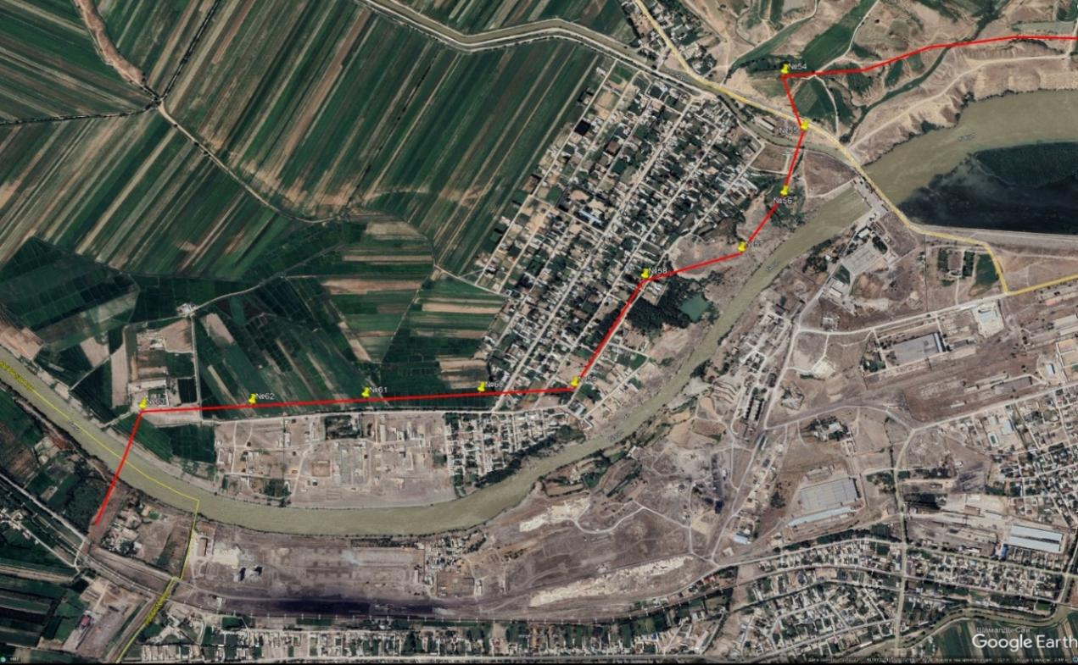

Photo 2. Radius 20m
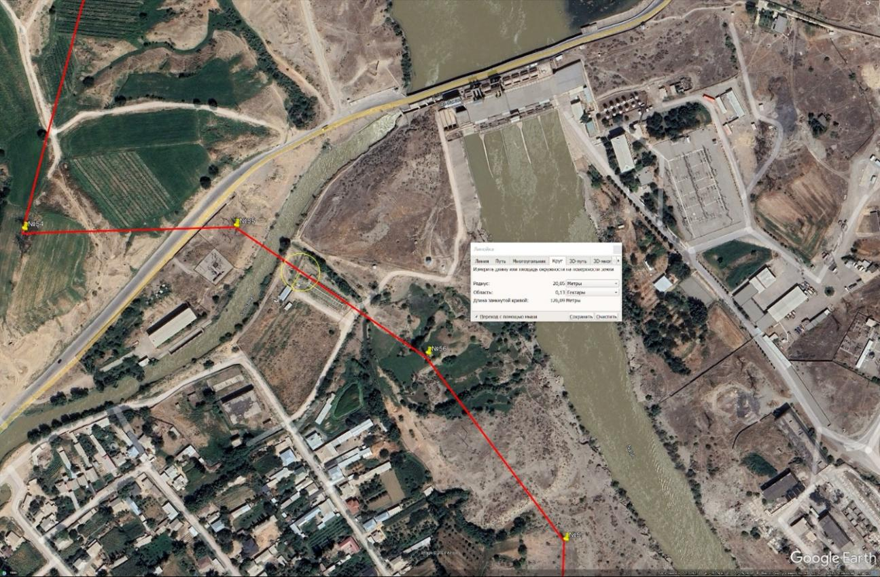

Photo 3. Radius 20.15m
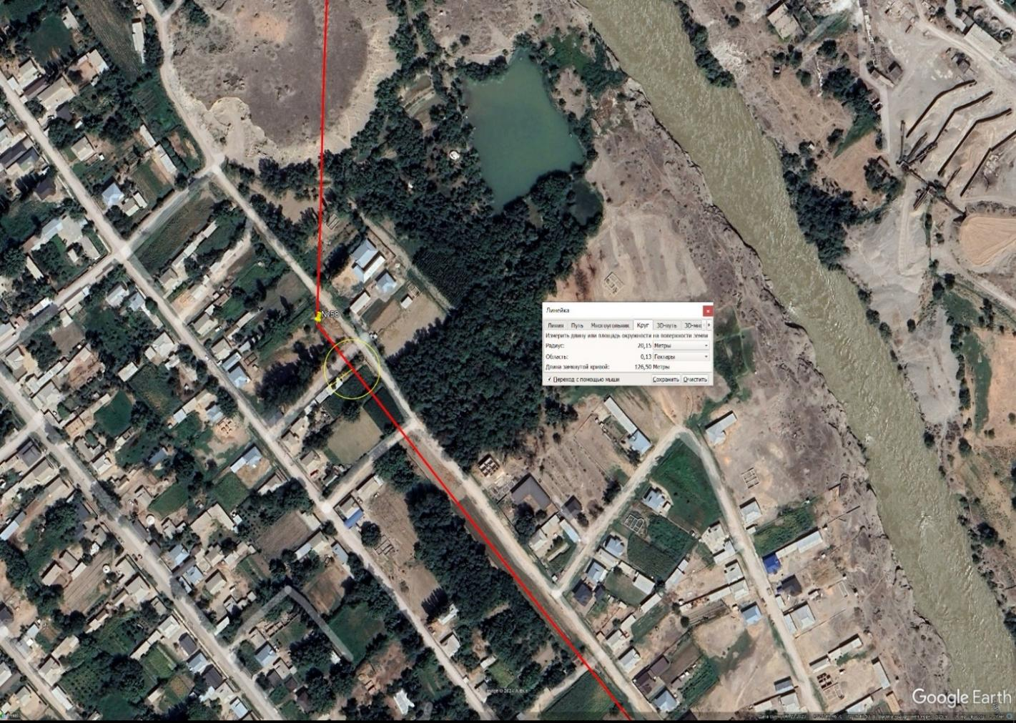

Photo 4. Radius 20.32 m
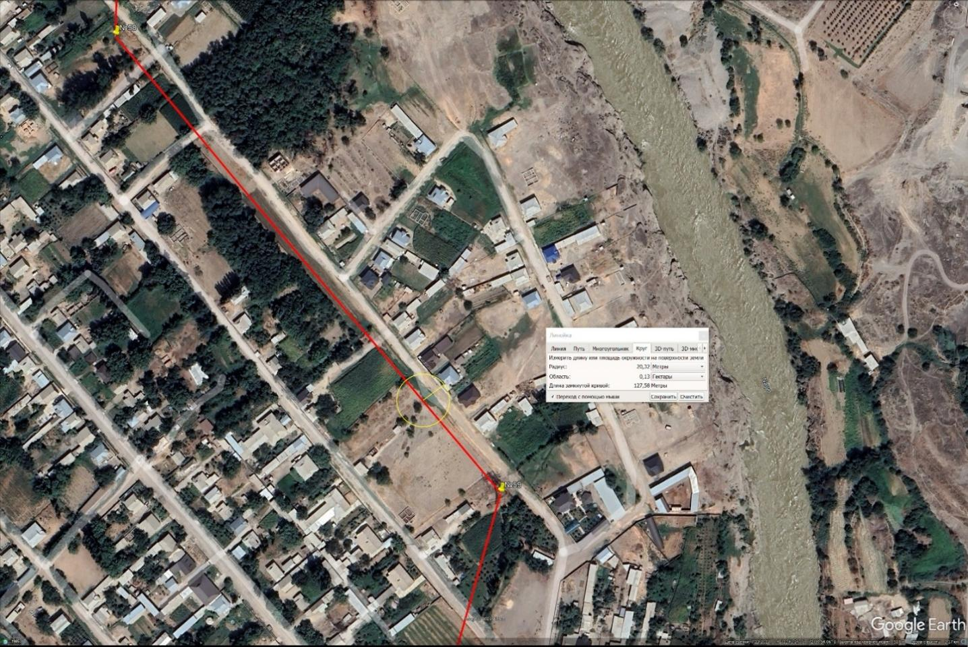

Photo 5. Radius 20.35 m
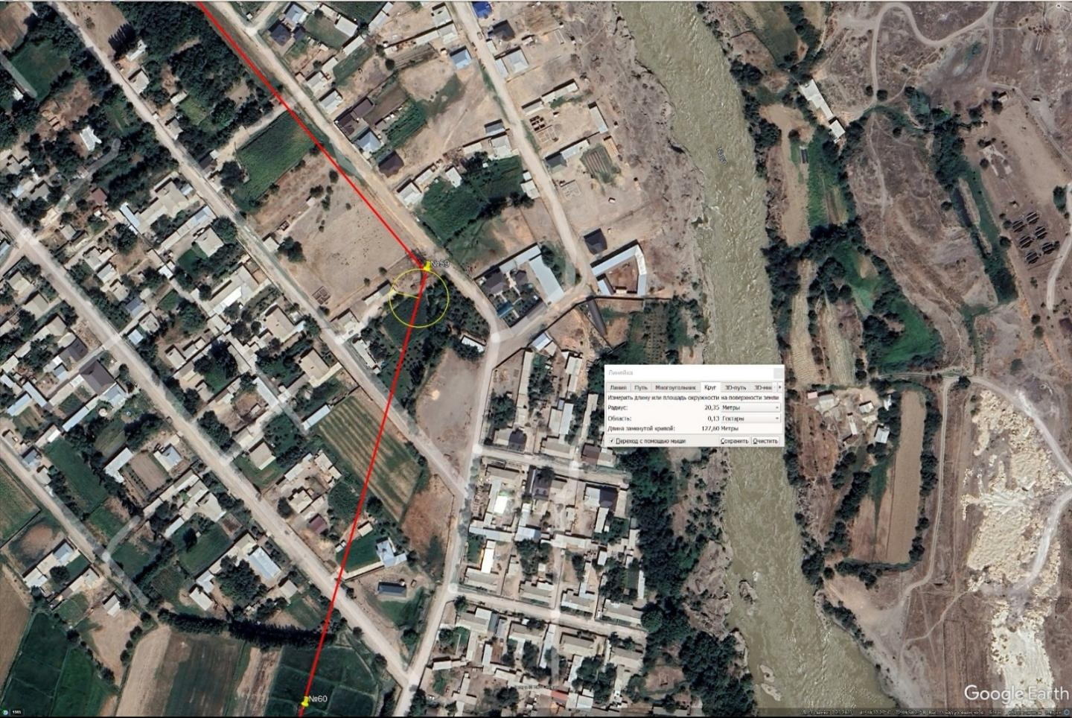

Photo 6. Radius 20m
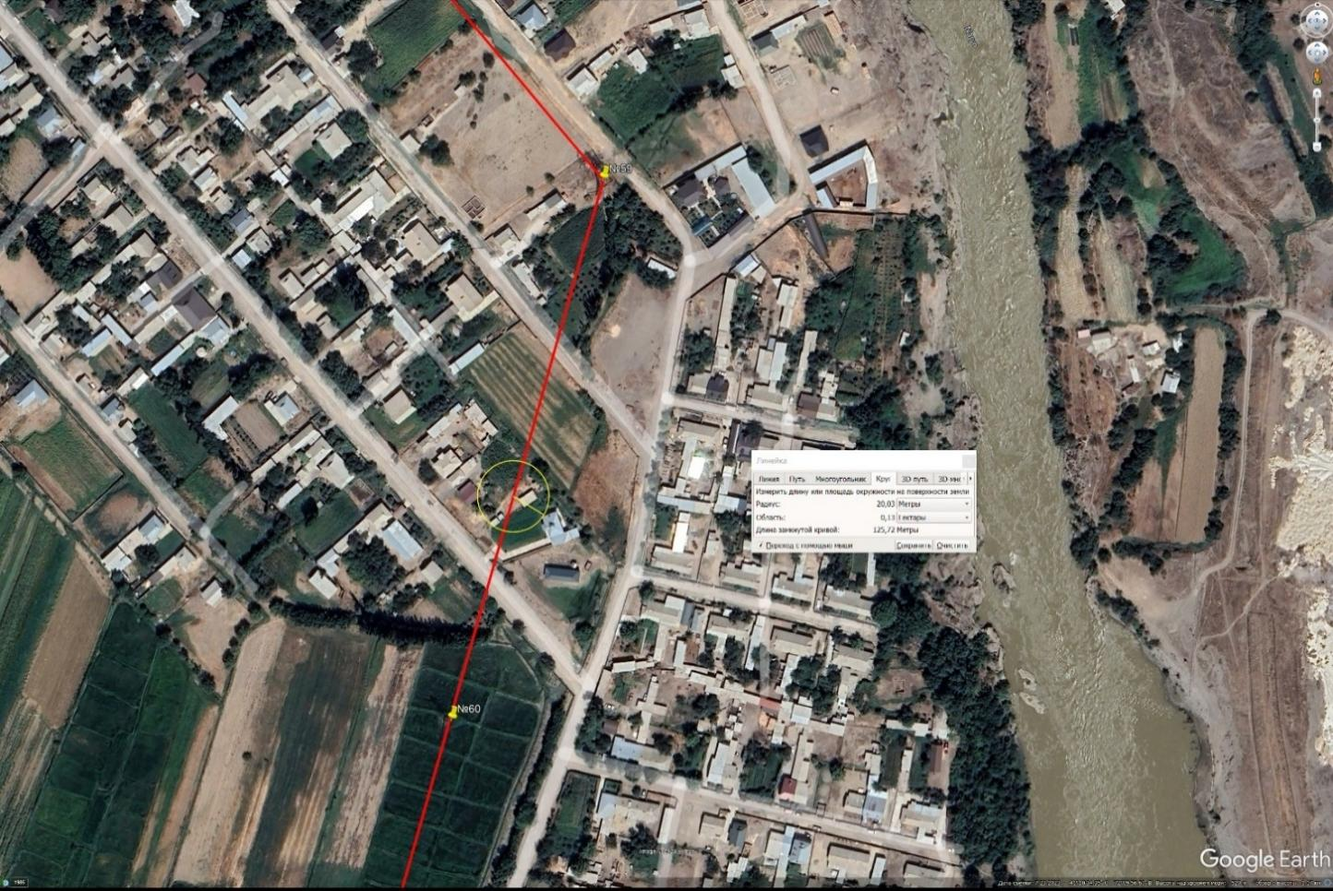

Photo 7. Radius 20.43 m s. Ak-Chabar Suzak AA (Torobaevo substation)
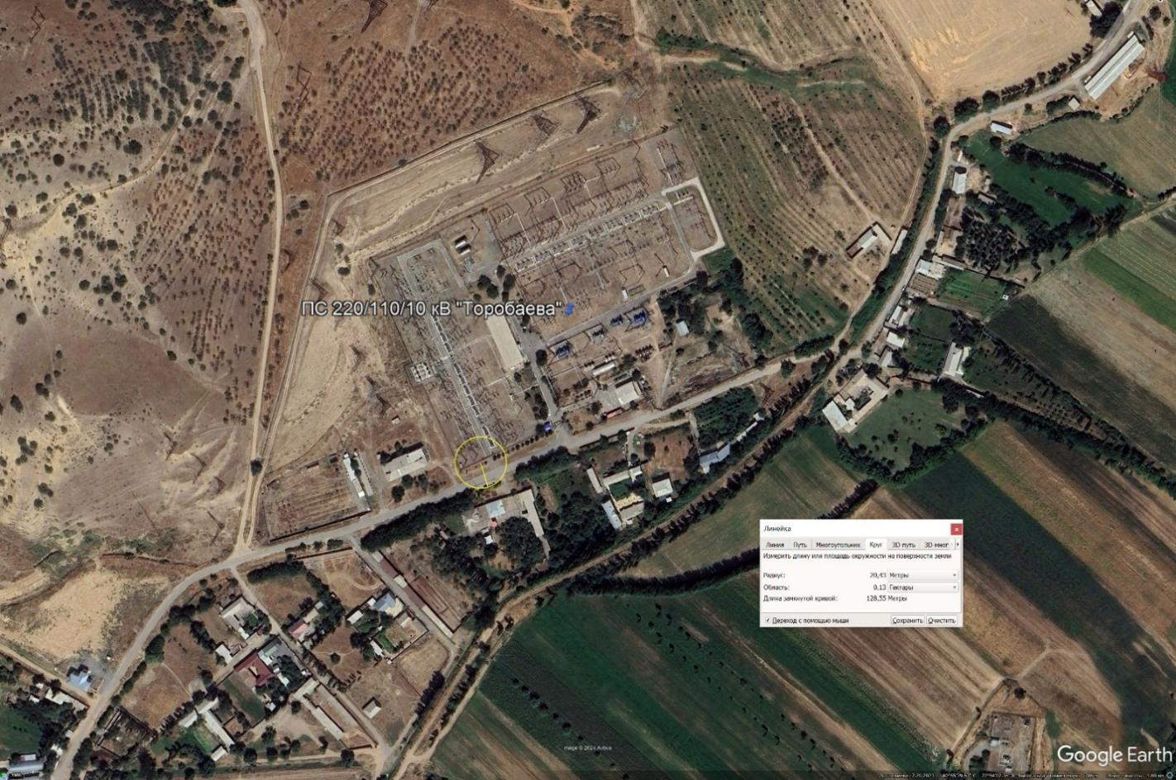

As can be seen from the photographs, there are 6 residential households that may be affected by the reconstruction (an average radius of 20m). In order to minimize the potential impact on residential households in the project reconstruction area, the following measures are envisaged:
- A detailed assessment of the quality of buildings within the impact radius (20m) is carried out to determine their resilience to potential impacts, including vibrations and noise, and to assess the possible risks to residents.
- In order to protect residential buildings from vibrations, noise and temporary inconvenience, the project will develop and implement protective measures. Temporary routes will be organized to ensure unhindered access for residents to their homes in order to minimize disruption to daily life.
- During the implementation of the project, residents will be informed about the work plans, deadlines and safety measures. Consultations will help to take into account their wishes and minimize possible inconvenience, ensuring community participation in the discussions.
In case of damage detected during construction, the project will organize monitoring and will be ready to carry out the necessary repairs to restore damaged property.

Appendix 5. World Bank Environmental and Social Standards (ESS)

ESS 1: Assessment and management of environmental and social risks and impacts
The Bank requires the environmental and social risks and impacts of Bank-funded projects to be assessed and managed to ensure they are environmentally sound and sustainable. ESS1 proposes adopting a hierarchical mitigation approach to anticipate and avoid risks and impacts, minimize unavoidable risks and impacts to acceptable levels, and compensate for significant residual impacts where economically feasible.
This requires the selection of suitable tools, such as:
- ESIA,
- environmental audit,
- risk assessment,
- analysis of social conflicts and other conflicts,
- Environmental and Social Management Plan (ESMP),
- Environmental and Social Management Framework (ESMF),
- Strategic Environmental and Social Assessment (SESA),
- Environmental and Social Commitment Plan (ESCP),
- subsequent monitoring and reporting of problems depending on the complexity of the project.
The level of assessment required would be determined by a screening and scoping exercise.

ESS 2: Labor and working conditions
The ESS 2 on Labor and working condition requires promoting worker-management healthy relationship, developing strategies to improve working condition like fair treatment of workers and vulnerable groups that are involved in the project and preventing all forms of forced and child labors.

This standard is applicable to project workers including full time, part time, temporary, contractual and migrant worker. This standard helps to monitor health of the worker, working condition, hours of work and other necessary requirements including grievance mechanism and measures related to Occupational Health and Safety and shall be complied in accordance with ESS.

ESS3: Resource efficiency and pollution prevention and management
ESS 3 promotes the sustainable use of resources (i.e. Energy, Water, Raw Materials) by identifying, avoiding or minimizing adverse impact both long term & short term caused by different pollutants on Health and Environment. The Standard also includes both Hazardous and Non-hazardous Waste Generation through minimizing and managing risks associated during entire life cycle of the Project.

ESS 4: Community health and safety
The ESS 4 on Community Health and Safety recognizes the exposure to risks and impacts that may cause due to project activities. Therefore, anticipating and avoidance of adverse impact on communities affected by the project from both routine and non-routine circumstances should be done.
Accordingly designs & constructions to be modified that will ensure quality and safety to the community in conformance with climate change. Comprehensive Risk Hazard assessment and emergency action plan should be prepared in coordination with local authorities and affected communities.

ESS 5: Land acquisition, restrictions on land use and involuntary resettlement
The ESS 5 emphasizes for avoidance or minimization of involuntary resettlement or forced eviction to the extent it is feasible by exploring all viable alternative project designs.
Where involuntary resettlement is not viable, appropriate mitigation will be taken in accordance to sustainable development programs to alleviate the adverse impacts on displaced persons by providing timely compensation and at-least restoring their livelihood and improving their living standard to pre-displacement levels or to levels prevailing prior to the beginning of project implementation, whichever is higher. The Resettlement activities shall be executed by providing sufficient investment for displaced person who will be directly benefitted for the project and they should be meaningfully consulted and should have opportunities to participate in planning and implementation of resettlement programs.

ESS 6: Biodiversity conservation and sustainable management of living natural resource
This ESS affirms World Bank’s commitment to protect and support conservation of biodiversity and natural habitat, application of mitigation hierarchy, designing and implementation of remedial measures that affects biodiversity. Sustainable management of the project should be done to provide benefit and to minimize damaging effects of the project as the bank does not support projects that involve significant conversion or degradation of critical natural habitats.
This policy ensures the need to support livelihood of local communities through adoptive practices that can integrate conservation and development of the project area.

ESS 8: Cultural heritage
The ESS 8 on Cultural Heritage recognizes that cultural heritage provides continuity in tangible and intangible forms between the past, present and future. The objective of the standard is to integrate sustainable development and protection of cultural heritage from adverse impact of the project by providing meaningful consultation and promoting equitable share of benefits with reference to the PCR. The standard seeks to preserve physical cultural resources (PCR) and avoid their destruction or damage. PCR includes resources of archaeological, paleontological, historical, architectural and religious (including cemeteries and burial sites, chance finds), aesthetic or other cultural significance, including any material objects of cultural heritage. Accordingly, this standard sets out measures designed to protect cultural heritage throughout the project life cycle.
ESS 10: Stakeholder participation and information disclosure
This standard requires preparation of Stakeholder Engagement Plan (SEP) for Bank-funded projects for open and transparent engagement with Project stakeholders to enhance the environmental and social sustainability of the Project. The effective SEP helps to identify the main stakeholders of the project and mechanism for public consultation and information disclosure as well as grievance redressal system.

Appendix 6. EIA process as per national law
Environmental impact assessment is carried out in accordance with the following rules:
• Regulation on the Procedure for Environmental Impact Assessment in the Kyrgyz Republic (February 13, 2015, No. 60);
• Regulations on the procedure for conducting state environmental expertise in the Kyrgyz Republic (May 7, 2014, No. 248);
• Law "On environmental expertise" No. 54 of 1999 (amended on May 04, 2015),
• Law “On environmental protection No. 53 of 1999 and
• Law “On general technical regulation on environmental safety”. No. 151 of 2009.

Environmental assessment in the Kyrgyz Republic is based on two subsystems: (i) EIA (“Environmental Impact Assessment”) or OVOS (the Russian acronym for “Environmental Impacts Assessment”) and (ii) Environmental Expertise (State Environmental Expertise, SEE). Based on the "list", a project check is carried out to determine whether the project is subject to an environmental assessment or not. Where required, the EIA is carried out by an EIA consultant hired by the project proponent. The environmental assessment continues the EIA documents to be subjected to further reviews.
The resulting EIA/EA is then submitted for public consultation, after which changes are made according to public feedback. Subsequently, the EIA report, the Statement of Environmental Consequences and other supporting documents are submitted for the State Environmental Expert Review (SEE). After that, the project will be approved, rejected or sent for re-examination.
The continuation of the SEE depends on the project, but cannot be more than 3 months after the Project Initiator submits all EIA/EE documents to the SEE. Public Environmental Expert Review (PER) is organized and conducted at the initiative of local residents, local administrations and civil societies registered in the Kyrgyz Republic. The results of the public environmental review are sent to the body that implements the state environmental review, which is responsible for making decisions on the implementation of the objects of the review.
The materials submitted for the State Ecological Expertise to review should reflect (depending on the nature of the planned activity) design solutions for the implementation of the best available technologies.
• rational use and reproduction of natural resources, complex processing and disposal of waste; ensuring effective wastewater treatment, their use for technical needs;
• preservation and restoration of soil cover, flora and fauna, compliance with the status of objects of specially protected natural areas;
• reclamation of disturbed lands;
• ensuring the protection of the population and the environment from the harmful effects of anthropogenic physical, chemical, and biological factors.

The outcome/feedback of the public consultations is also included in the public environmental review (PER), which may be done as part of the EIA or may also be initiated in parallel with the SEE. The duration of the SEE depends on the complexity of the project but should not exceed 3 months after the project initiator submits all EIA documents for the SEE.

Appendix 7. Details of the meeting process with local authorities Tashkumyr
PROTOCOL
Public consultations on informing about the socio-ecological of the project Regional Electricity Market Interconnectivity and Trade (REMIT) in the Jalal-Abad region
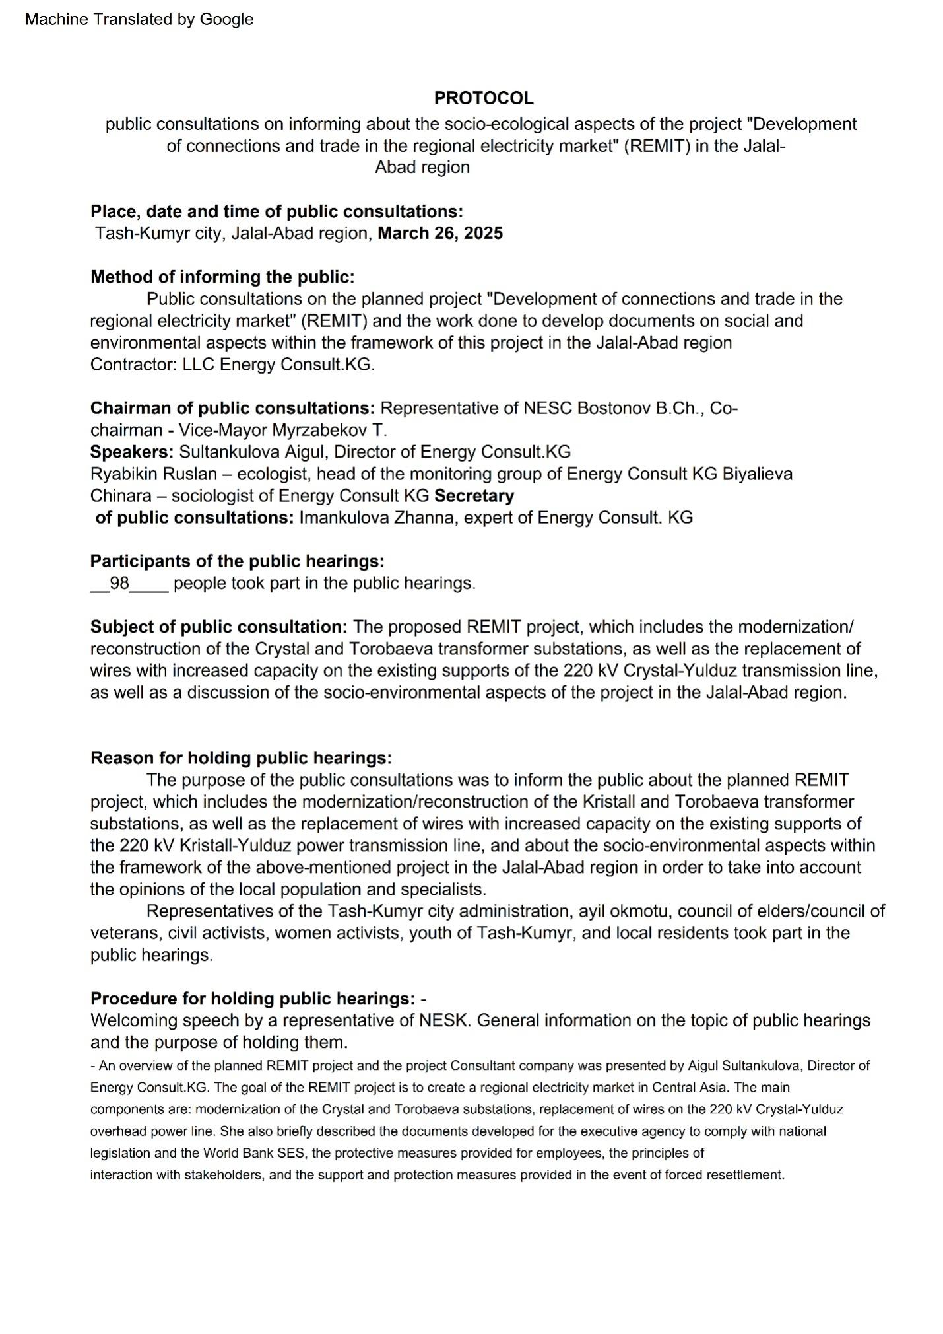
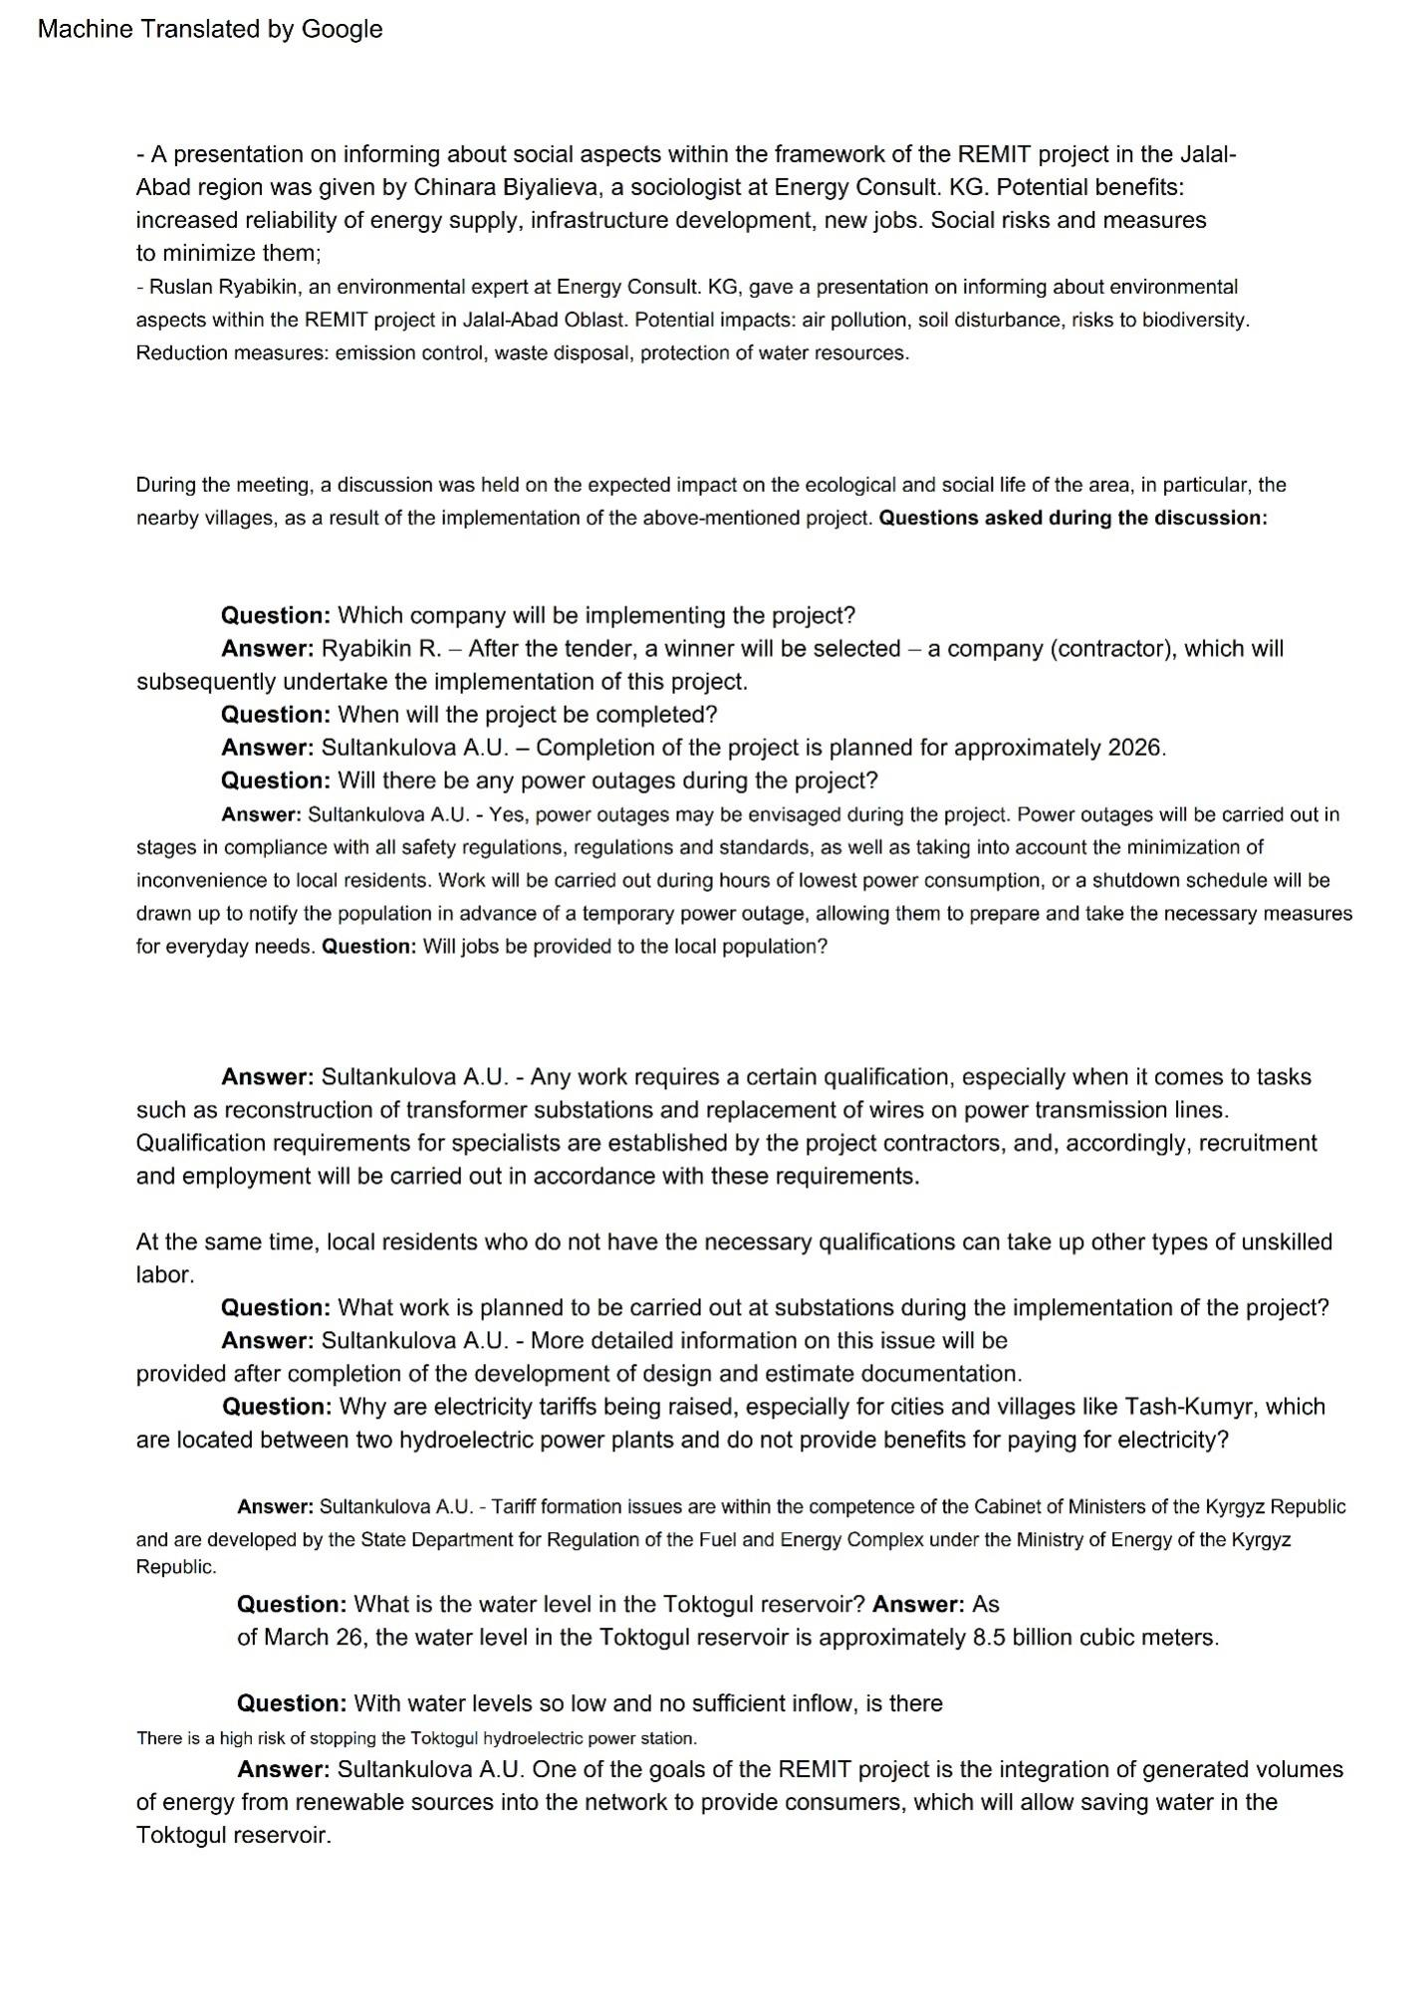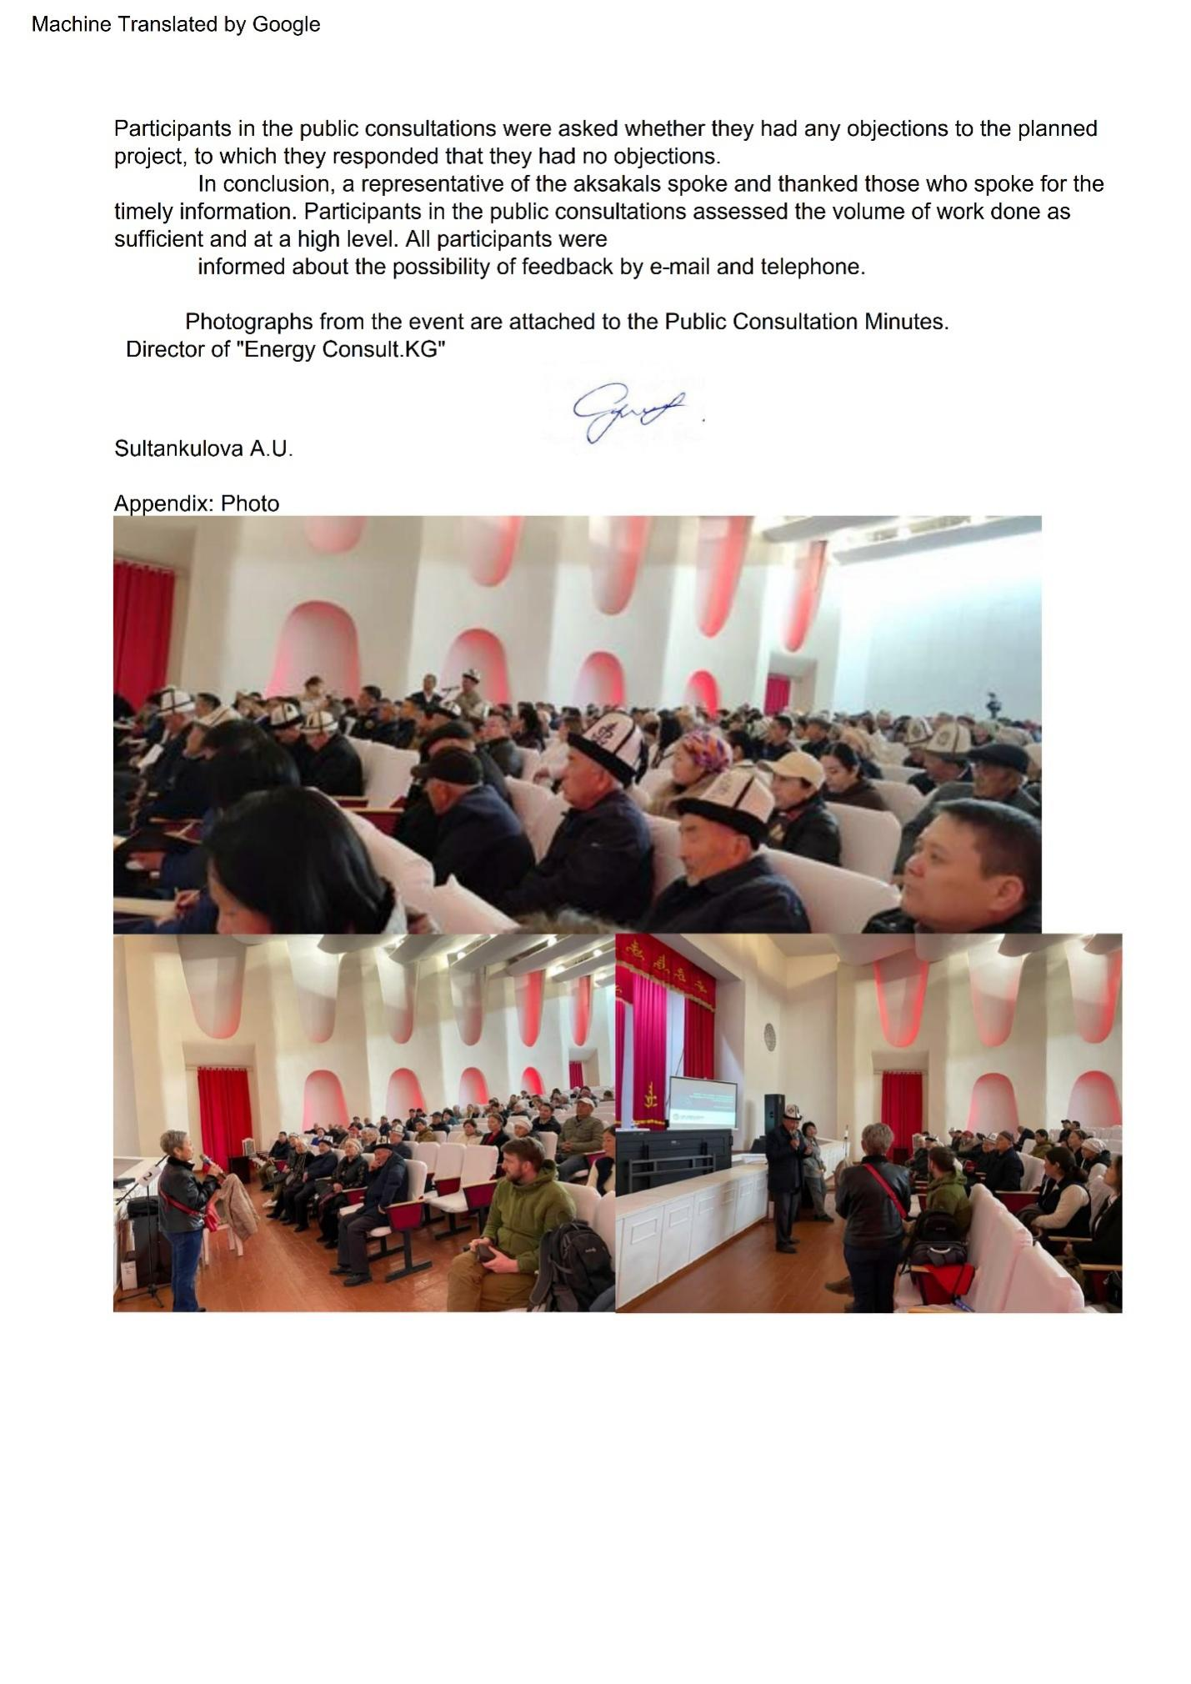

Appendix 8. Details of the meeting process Bishkek
PROTOCOL
Public consultations on informing about the socio-ecological of the project Regional Electricity Market Interconnectivity and Trade (REMIT)
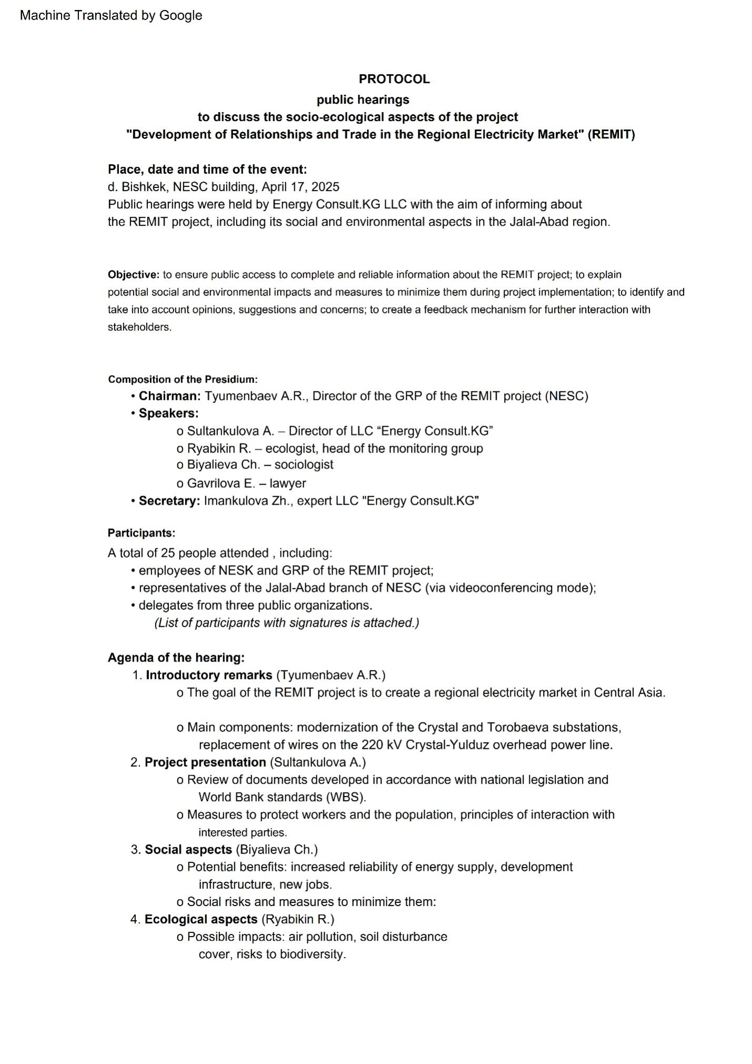
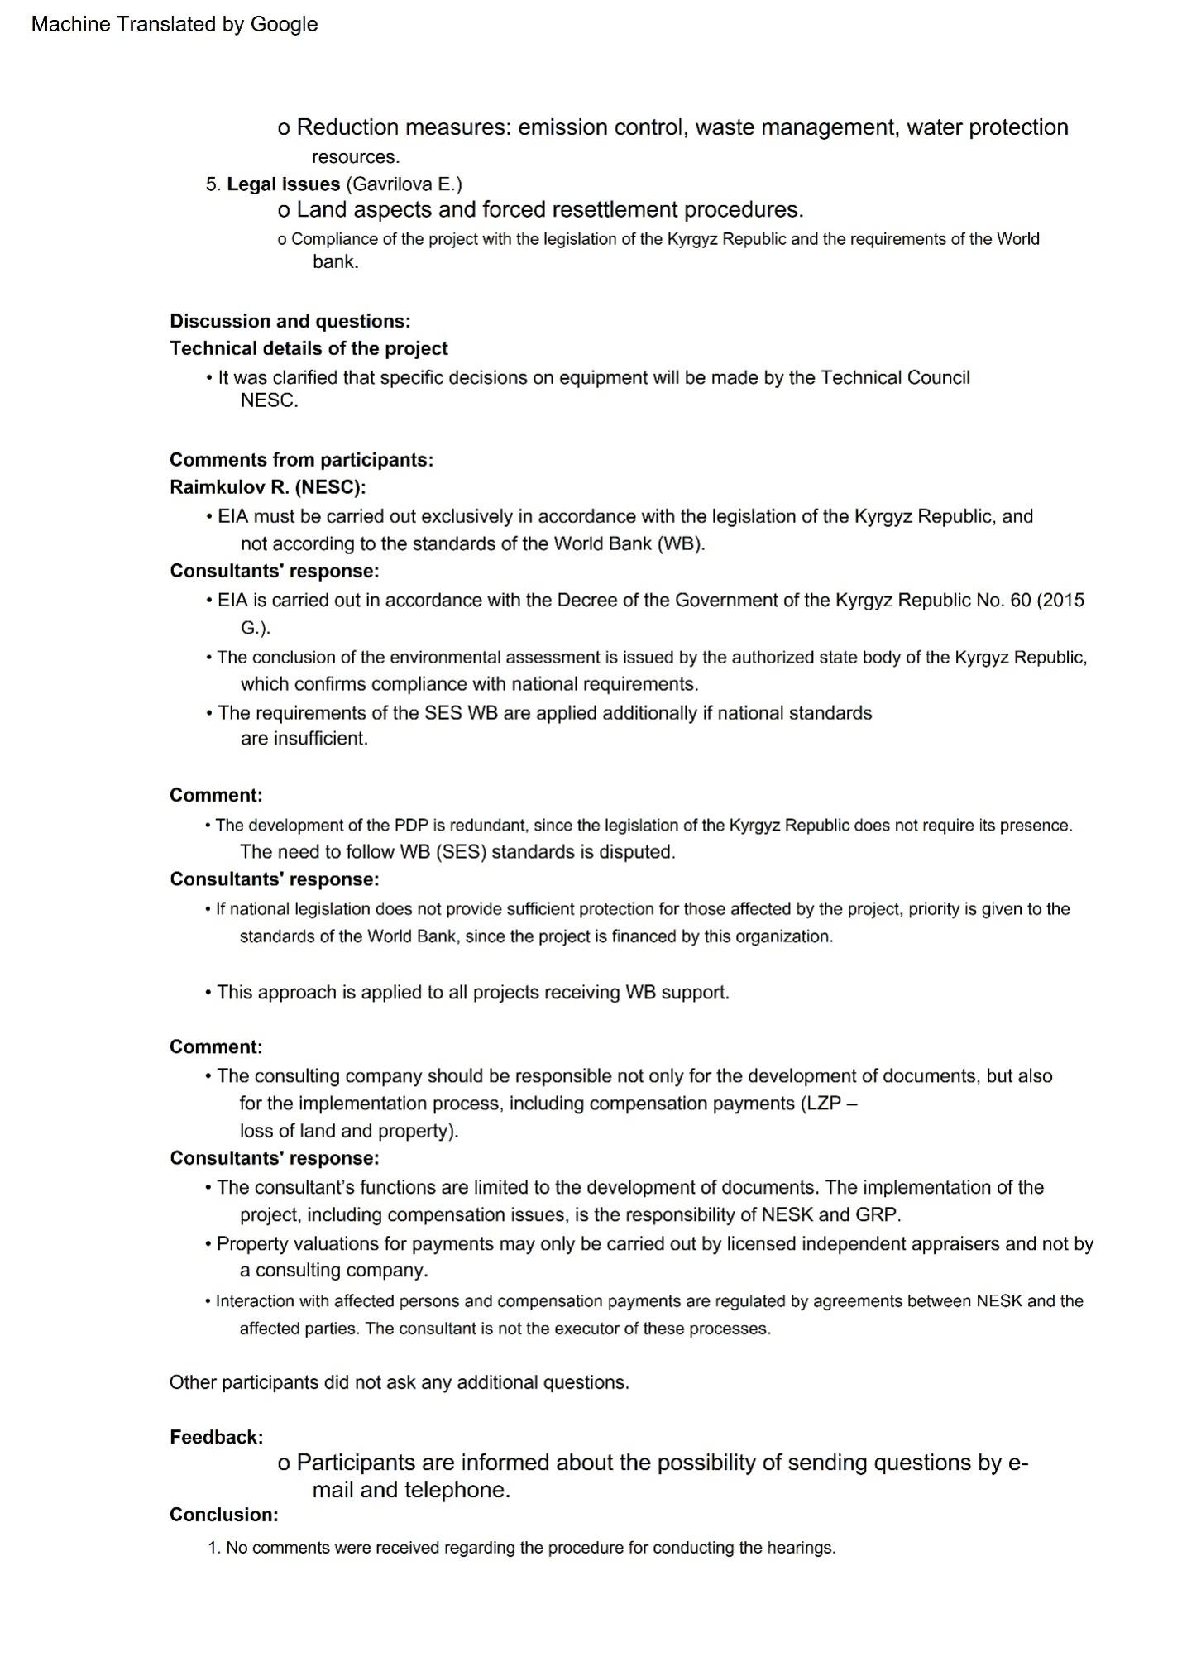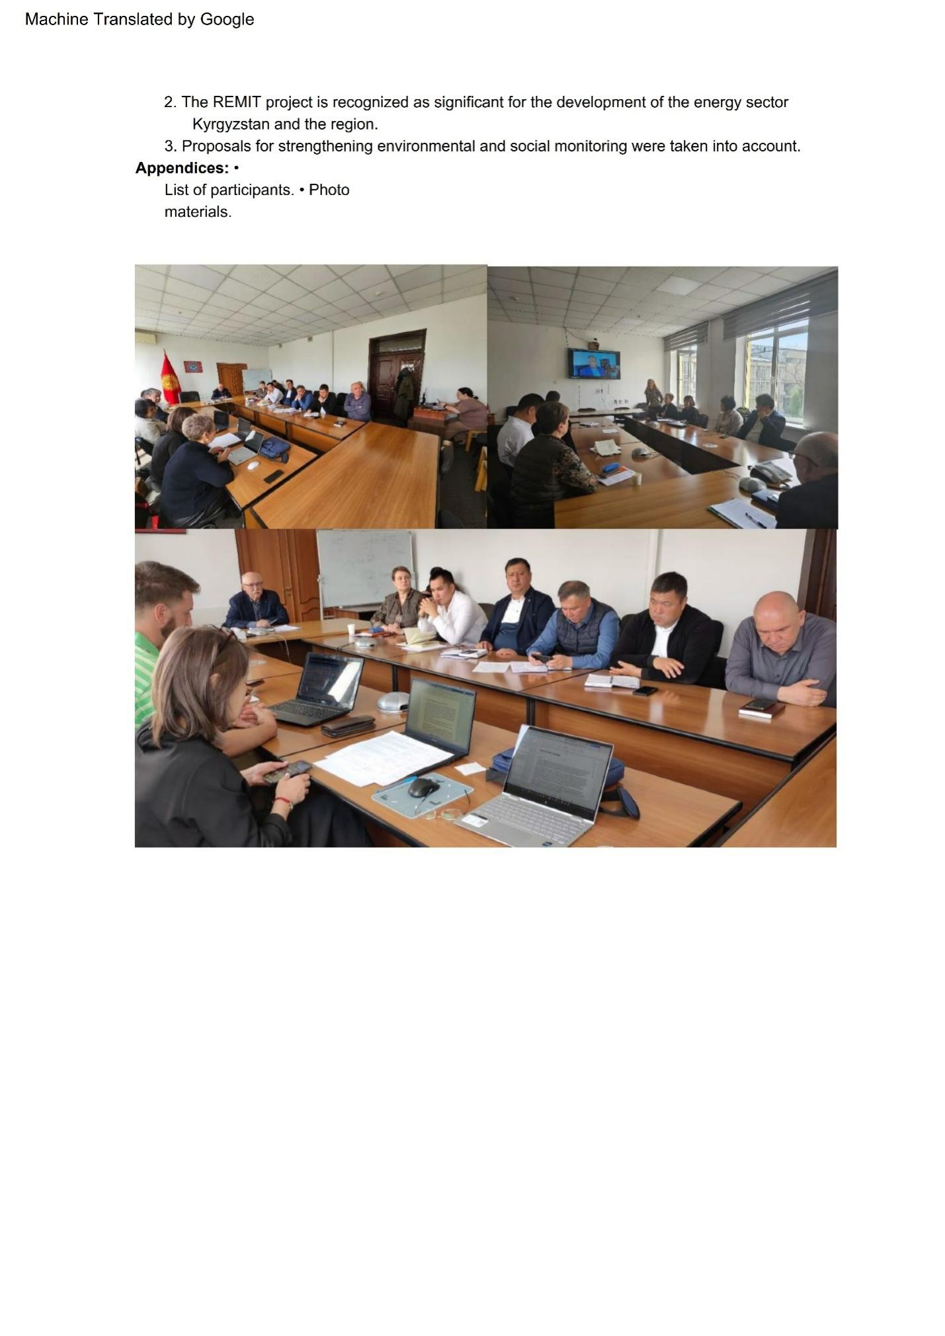

Appendix 9. Lists of meeting participants
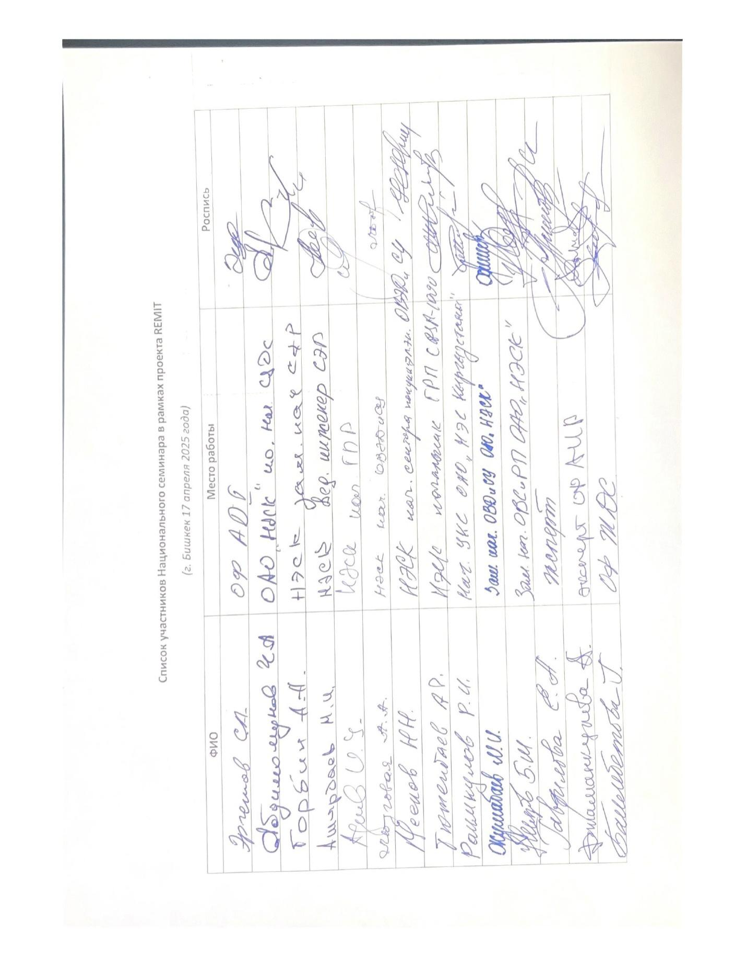
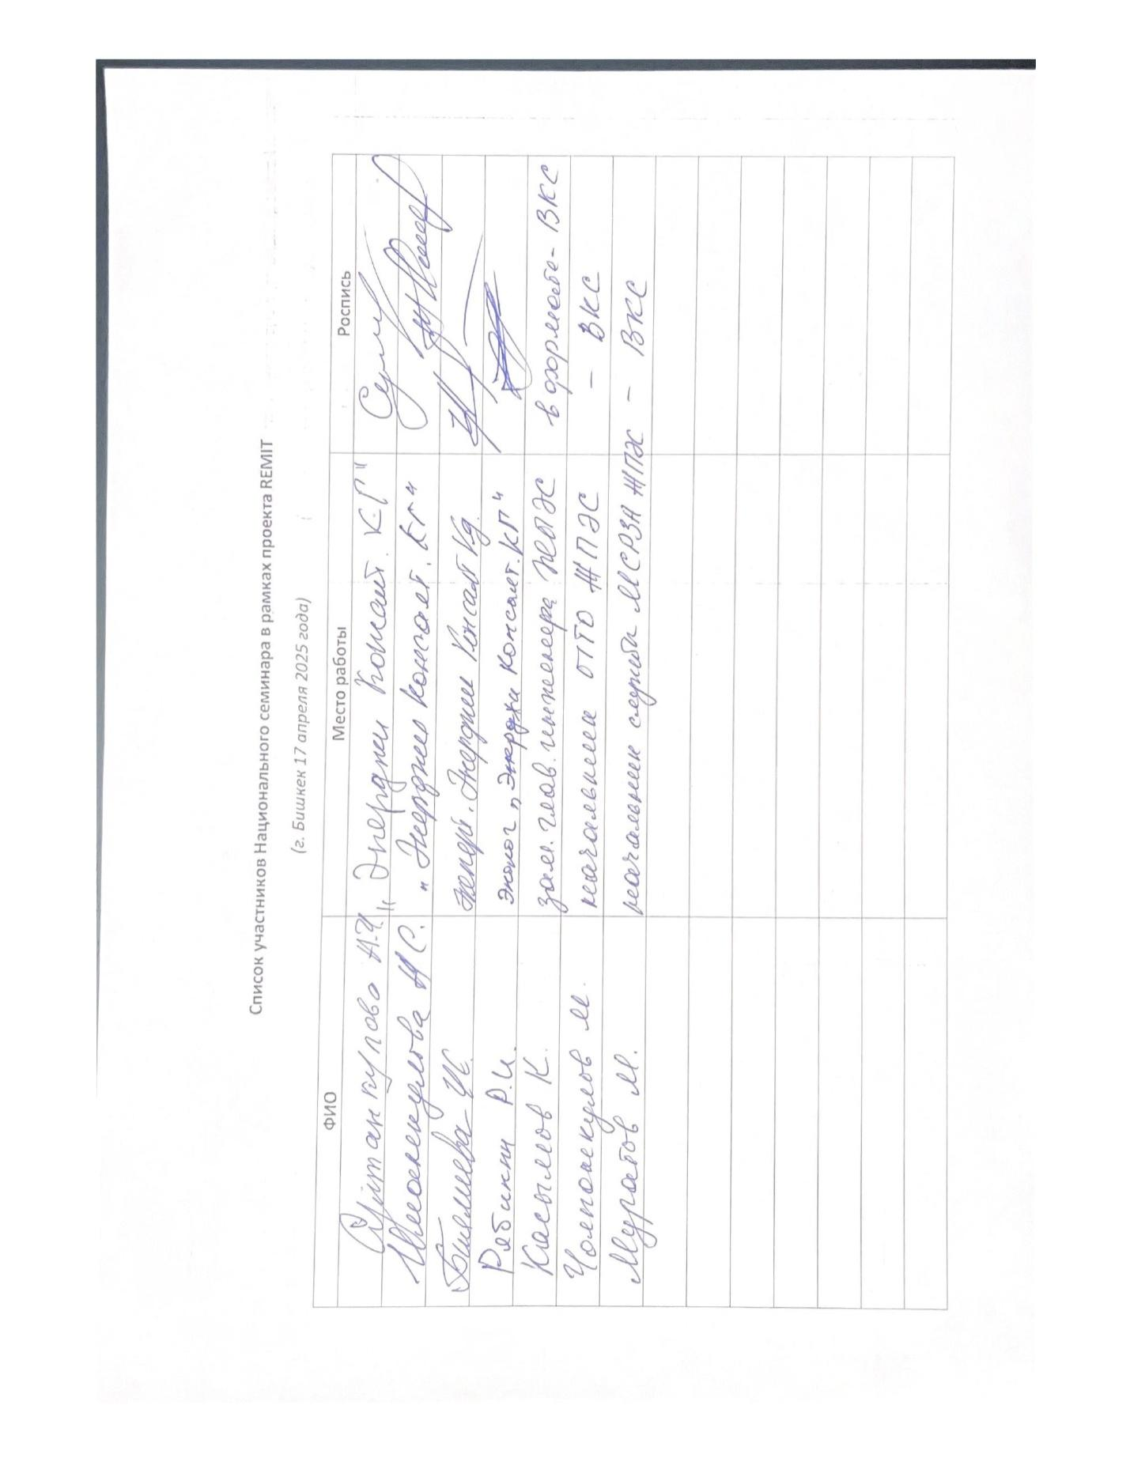

Socio-economic situation of Jalal-Abad region 2017-2021 https://stat.gov.kg/ru/dzhalal-abadskaya-oblast/
Population census 2023 NSC KR. Jalal-Abad region
Kyrgyz Republic and regions I quarter 2024 NSC KR. https://stat.gov.kg/ru/publications/statisticheskij-byulleten-kyrgyzskaya-respublika-i-regiony/
Kyrgyz Republic and regions I quarter 2024 NSC KR. https://stat.gov.kg/ru/publications/statisticheskij-byulleten-kyrgyzskaya-respublika-i-regiony/
The number of poor people. https://stat.gov.kg/ru/statistics/uroven-zhizni-naseleniya/
Socio-economic situation of Jalal-Abad region 2017-2021 https://stat.gov.kg/ru/dzhalal-abadskaya-oblast/
Socio-economic situation of Jalal-Abad region 2017-2021 https://stat.gov.kg/ru/dzhalal-abadskaya-oblast/
Publications: Socio-economic situation of Jalal-Abad region 2024 https://stat.gov.kg/ru/dzhalal-abadskaya-oblast/
"Kyrgyz Petroleum Company"; brick factory CJSC "Stone Processing Plant in Central Asia"; JSC "Kelechek"; JSC "Nur"; JSC "Nasos"; Plant of trade and technological equipment and OP 36/10. Enterprises CJSC "Kyrgyzkhlopok" and JV "Ak-Altyn" LLC "Tura-Ai" and LLC "Aziz-Tabak". Enterprises of the flour-milling industry of the city: JSC "Azrat Aiyb", CJSC PTC "Intershak", LLC "Mariam and Co". CJSC "Jalal-Abad Arak Plant" JSC "Mata" is in operation
Socio-economic situation of Jalal-Abad region 2017-2021 https://stat.gov.kg/ru/dzhalal-abadskaya-oblast/
There too
There too
Law of the Kyrgyz Republic #15, 12 February 2007, "On the Prohibition of Cutting, Transportation, Acquisition and Sale, Procurement and Use, Export and Import in the Kyrgyz Republic of Especially Valuable (Walnut and Juniper) Tree Species."
Safety rules for the construction of power transmission lines and electrical installation work (to the order of the Ministry of Energy of the Kyrgyz Republic dated August 3, 2023 No. 01-13 / 160) https://cbd.minjust.gov.kg/51-485/edition/1273336/ru
Appendix 3. Resolution of the Government of the Kyrgyz Republic No. 201 of April 11, 2016. On approval of acts in the field of public health
Resolution of the Government of the Kyrgyz Republic No. 60 dated February 3, 2017
SF₆ is defined as "electrical gas"
Population census 2023 NSC KR. Jalal-Abad region
Socio-economic situation of Jalal-Abad region 2017-2021 https://stat.gov.kg/ru/dzhalal-abadskaya-oblast/
Socio-economic situation of Jalal-Abad region 2017-2021 https://stat.gov.kg/ru/dzhalal-abadskaya-oblast/
Socio-Economic Situation of Jalal-Abad Oblast, 2017-2021 https://stat.gov.kg/ru/dzhalal-abadskaya-oblast/

